WAKING UP #SOULFAMILY
BOOK III

ASCENSION

COMPILED BY
CHANDERHAS KUMAR (SOUL)

INTRODUCTION
Book 3 of the waking up #soulfamily marks a significant milestone in the growth of our consciousness and the ascension of humanity at large. We are clearly moving in the right direction as more and more people wake up to the illusions created around and in us.
The time of the awakening is marked by apocalypse that is the revelation of more and more information. But that is not all. What is more important in the rise in the global consciousness that makes the planet and individuals fit to receive and understand this information in the right context. The information has always been there. We just have not looked until now.
As the following posts tie in more pieces of information in much the same way accompanied by eye opening videos images and links it is important that we go through the links section to exercise our thought patterns and retune them to our highest benefit.
I hope you enjoy this book and feel inclined to read the others as well. All content is available freely on my site www.wakingupsoulfmaily.com

Table of Contents
1. Remote Healing 6
2. Activating the Soulfamily 7
3. Happy Easter 10
4. Growing up 12
5. Shikhandi 2 13
6. Driving the change we need 15
7. Love vs Fear 17
8. Eight-fold Yoga system 19
9. The New World Order 22
10. More Synchronicities 24
11. Abundant Krishna 25
12. Doing this for you 28
13. The Great Awakening 30
14. Wake up Sleeping Souls 31
15. Spiritual forms 33
16. A second Chance 36
17. Economics of Spirituality 37
18. Security Paradox 40
19. Nostalgia 42
20. Chosen ones 45
21. Soul and Consciousness 46
22. Big Reveal 48
23. The Yugas 50
24. The Big Bang of Creation 52
25. Pick your Battles wisely 54
26. Attachments 56
27. The Value of Memory 58
28. Physicality vs Mentality 60
29. The Vedic Cosmos 62
30. United Conscious Universe 64
31. Supreme Personality Expansions 66
32. Time travel by consciousness 68
33. DNA Activations 70
34. Beware of Propaganda 72
35. For leaders and Lightworkers 74
36. Krishna's Inconceivability 76
37. Raising the Consciousness 78
38. Dharma above all 80
39. Ascension through Unity Consciousness 82
40. Goloka Chart and Frequencies of existence 84
41. Noble Professions 85
42. Ronald Reagan 87
43. Unity in Diversity 89
44. The Galactic Federation 91
45. Multidimensionality 93
46. The Spiritual Body 94
47. The Vedic Science and Unified Theory 96
48. Perfect Questions Perfect Answers 98
49. Proving the Past 100
50. Laws of God and Men 100
51. Interdimensional Travel 102
52. Sun and Time 104
53. Re-membering into Ascension 107
54. The war of Kali-yuga 108
55. Disclosure 110
56. Spiritual DNA 113
57. Materialism is Destruction 115
58. MONEY 116
59. Education system 118
60. Motivations 121
61. The Storm is Coming 123
62. So many Proofs 124
63. Spiritual Warriors 126
64. The Lions Roar 129
65. Its Time 130
66. Meeting #SoulFamily 132
67. Demigods and Demons 135
68. Media and Propaganda 136
69. The Summary 139
70. Call to Action 141
71. One World 143

Remote Healing

The blessings are a part of the good karma that can benefit us in many ways. Miracles never cease to happen. When people voluntarily give blessing or say prayers for our benefit they give their us some of their spiritual merit to help us #soulfamily!
"The verdict of all revealed scriptures is that by even a moment's association with a pure devotee, one can attain all success." - Chaitanya Charitamrita Madhya Lila 22.54
Just as the sun gives out light the spiritual light beings just emit spiritual energy wherever they go and in what wherever they do. This small amount of association in person, or via books or music or mantras keeps us connected to the light. We have lost the understanding and value of these. When we don't understand the subtle workings of the earth, we start to lose the faith in the science of spirituality. Those that can maintain the adherence to continuing tradition knowing the science will follow the science. Blind followers are not immune to benefit either.
"Some perceive the Super soul within themselves through meditation, others through the cultivation of knowledge, and still others through working without fruitive desires.
Again there are those who, although not conversant in spiritual knowledge, begin to worship the Supreme Person upon hearing about Him from others. Because of their tendency to hear from authorities, they also transcend the path of birth and death."
- Krishna (Bhagavad Gita 13.24-27)
The consciousness expanded drives the DNA to matches the frequency of higher realities- thus some feel healing through visualization, some can Astral travel or Remote view and what not.
The prayers and blessings we receive from spiritually elevated beings affects our karma and consciousness. It works on a very different space and time but it works just like the power of the mind. The blessings add to the spiritual merit. As those with material opulence can gift you blessings of material opulence those with more spiritual opulence can bless you with material and spiritual opulence. And everyone is on their own journey.
"Acts of sacrifice, charity and penance are not to be given up; they must be performed. Indeed, sacrifice, charity and penance purify even the great souls." - Krishna (Bhagavad Gita 18.5)
Light workers gain strength from love through prayers and blessings and dark forces gain strength from Fear and negatively.
The remote frequency-based healing machines claim to use Spooky affect is much similar way. Perhaps there is something to the old witches and Druids magic that used a sample of body part to apply magic to the whole.
Could we use the techniques to do self-healing by administration of medicine or prayer on some DNA/ tissues to work on whole body? Can we consciously give our body visualised memory of our healthy self? Believe, conceive and achieve? Some want it to be a science, and some know it to be science of spirituality.
We see awake, We see asleep, We see with 3rd eye. There is more to see!

Links:
Gaia: This Man Lost 220 POUNDS Using Visualization Techniques
https://www.youtube.com/watch?v=SPBNhUH6fzo
PLEIADIANS Explain Dimensions, Densities & Frequencies
https://www.youtube.com/watch?v=XYTVth6svPY
Children With REAL Superpowers (Third Eye)
https://www.youtube.com/watch?v=rC7xZmLcOeY

Activating the Soulfamily

We discussed how the real value of a very long life is in the ability to use it in service of others, for Good and God. We also discussed how in ancient times people had very long and healthy lives and how people in heavenly planets work differently in terms of ages. These attributes can be earned by our actions as per various prophecies we have discussed already. Because we Co-create our reality, there is a self-selection process where we choose our next life and body by our actions. This shows in the level of our consciousness and vibrations. The second part is the approval by God/Krishna without which nothing is possible.
People self-select to be super heroes to destroy the forces of evil and the self-selected Super Villains. Everyone else in the middle is just living day to day burning their karma. Not conscious or interested in anything happening around them. Life is just a one-shot adventure to enjoy the body.
"The living entity in the bodily conception of life is absorbed in the body, which is a combination of the physical elements, the five senses for gathering knowledge, and the five senses of action, along with the mind. Through the mind the living entity suffers three kinds of tribulations — adhibhautika (given by others), adhidaivika (natural calamities) and adhyātmika (of mind and body). Therefore, this body is a source of all miseries.
Therefore, O King Citraketu, carefully consider the position of the ātmā. In other words, try to understand who you are — whether body, mind or soul. Consider where you have come from, where you are going after giving up this body, and why you are under the control of material lamentation. Try to understand your real position in this way, and then you will be able to give up your unnecessary attachment. You will also be able to give up the belief that this material world, or anything not directly in touch with service to Kṛṣṇa, is eternal. Thus, you will obtain peace...
My dear King, in former days Lord Śiva and other demigods took shelter of the lotus feet of Saṅkarṣaṇa. Thus, they immediately got free from the illusion of duality and achieved unequalled and unsurpassed glories in spiritual life. You will very soon attain that very same position.
- Srimad Bhagavatam 6.15.25-27
In each culture we have super hero Demigods and their nemesis the Demons. There could be millions of them many varied societies exist on the planet #soulfamily. How many different types of races and each has their own histories. They were higher beings from the sky or incarnated amongst them but who lived in different places. People worshiped them because they are powerful in different ways, but neither their authority nor power is absolute. God/Krishna has many servants on different positions all over the many Universes.
"Endowed with such a faith, he endeavours to worship a particular demigod and obtains his desires. But in actuality these benefits are bestowed by Me alone."- Krishna (Bhagavad Gita 7.22)
Links:
REPTILE WORSHIP? The Secret of Lizard Gods
https://www.youtube.com/watch?v=7vSYUGd43Y8
America's Secret Space Program and the Alien Connection: Solar Warden
https://www.youtube.com/watch?v=sfRcl5rmydI
योग वासिष्ठ में Time Travel, Multiverse और Aliens! | What is Yoga Vasishtha? | EP-26
https://www.youtube.com/watch?v=ZfsmsK88vV8
Uncover the Shocking Secret of Hanuman’s Power | Sadhguru Revealed! | Sadhguru
https://www.youtube.com/watch?v=X_s7ReXtXLE

Happy Easter

The God conscious are considered to be magnanimous because they see Good in all people. They choose to look at the positives in the dark and this sort of mentality is what is required to continue the journey in the higher consciousness #soulfamily.
Look to forgive but also forget because then we never bear any scars that hurt us more than it hurts others. As long as we continue to remember the stones, we will continue to find a Satan that does not exist. But is it not the darkest that need the most light? To be forgiven and not be cast to into any he'll. Is that not that the Godly quality? But over time too much forgiveness is seen as weakness by those who see no love in God. Hence, the various incarnations of Krishna
"O son of Prtha, in this world there are two kinds of created beings. One is called the divine and the other demonic. I have already explained to you at length the divine qualities. Now hear from Me of the demoniac.
Those who are demoniac do not know what is to be done and what is not to be done. Neither cleanliness nor proper behaviour nor truth is found in them.
They say that this world is unreal, that there is no foundation and that there is no God in control. It is produced of sex desire, and has no cause other than lust.
Following such conclusions, the demoniac, who are lost to themselves and who have no intelligence, engage in unbeneficial, horrible works meant to destroy the world." - Krishna (Bhagavad Gita 16.6-9)
It is Time that creates and destroys in cycles. entire civilizations rise and fall. And surely more exist undiscovered. Only for some faint memories remain and those cannot tell us the complete truth or the complete lie. They just stand there as witness for what once was. Who are we blaming for the stones that show remains?
Some cultures forget the important lessons really quickly and cannot go past a few thousand years. In some cultures, they trace back their history millions of years ago. They have the oldest records so they do know how to remember history. Maybe they just learn to forgive and focus on other things.
Stop fighting and accept that everyone is different with a different mind and body. We too have changed bodies so many times that if we knew our own true history then we may be more understanding of others cultures and beings.
"One who identifies his self as the inert body composed of mucus, bile and air, who assumes his wife and family are permanently his own, who thinks an earthen image or the land of his birth is worshipable, or who sees a place of pilgrimage as merely the water there, but who never identifies himself with, feels kinship with, worships or even visits those who are wise in spiritual truth—such a person is no better than a cow or an ass." - Srimad Bhagavatam 10.84.13
To think spiritually is to rise above bodily conception. To rise in consciousness so that we can see that the Unity in Diversity on the ark is necessary to represent the population off the ark.
Happy Easter!

Links:
The Arcturians 2023 | THE GREAT RESET
https://www.youtube.com/watch?v=1DZSjarwxWs
Who Are The Saptarishi? Seven Celestial Sages
https://www.youtube.com/watch?v=5TRapznlkG8
Strange Coincidence: 7 Mysterious Beings Appeared in Many Ancient Cultures
https://www.youtube.com/watch?v=PtYQD_xYFCM

Growing up

When we are children all we want to do is grow up and as adults we dream of reverse aging into youth.
It is not the time changing that hurts rather its often its symptoms on the aging physical body. Thus, it is only natural that the quest for immortality start with good health and no disease. That does not mean the only solution is that we become machines, we could just be more efficient with tech built-in.
It is a problem that we are trying to solve with modern technology but the ancient histories contain stories of people who lived very long - 100s or 1000s of years in good health.
The Ascended masters called the four Kumaras mentioned are ever young in the bodies of young boys with spiritual potency to knock on the gates of Vaikuntha. They were tasked to be progenitors of the universe but the job was too distracting from spiritual progress. Even though they never grow up or age their time does run out #soulfamily. The lifetime for the sons of Brahma is billions of years and yet there is none to waste for anything other than devotional service.
"When the breeze carrying the aroma of Tulasi leaves from the toes of the lotus feet of the Personality of Godhead entered the nostrils of those sages, they experienced a change both in body and in mind, even though they were attached to the impersonal Brahman understanding (of God).
The Lord’s beautiful face appeared to them like the inside of a blue lotus, and the Lord’s smile appeared to be a blossoming jasmine flower. After seeing the face of the Lord, the sages were fully satisfied, and when they wanted to see Him further, they looked upon the nails of His lotus feet, which resembled rubies. Thus, they viewed the Lord’s transcendental body again and again, and so they finally achieved meditation on the Lord’s personal feature.
This is the form of the Lord which is meditated upon by the followers of the yoga process, and it is pleasing to the yogīs in meditation. It is not imaginary but factual, as proved by great yogīs. The Lord is full in eight kinds of achievement, but for others these achievements are not possible in full perfection.
The Kumāras said: Our dear Lord, You are not manifested to rascals, even though You are seated within the heart of everyone. But as far as we are concerned, we see You face to face, although You are unlimited. The statements we have heard about You from our father, Brahmā, through the ears have now been actually realized by Your kind appearance." - Srimad Bhagavatam 3.15.43-46
From impersonalists to Personalists just by using their senses in small act of devotional service- seeing and smelling. Impersonal consciousness of endless possibilities is not as attractive/important as what's present.
"And of all yogīs, the one with great faith who always abides in Me, thinks of Me within himself and renders transcendental loving service to Me – he is the most intimately united with Me in yoga and is the highest of all. That is My opinion." - Krishna (Bhagvad Gita 6.47)

Links:
The GREAT Awakening Has BEGUN: Rise of a New Era of Humanity REVEALED | Alx Uttermann
https://www.youtube.com/watch?v=ezOkpr-DbrQ
Doctor DISCOVERS How to ACCESS Science-Backed Psychic Abilities | Dean Radin Ph.D
https://www.youtube.com/watch?v=CL2UzXJQgcc

Shikhandi 2

If identifying with the body was not already giving us enough problems or divisions and hate, now we have a bigger problem- people identifying themselves with their mind.
"O learned one, in this iron Age of Kali men almost always have but short lives. They are quarrelsome, lazy, misguided, unlucky and, above all, always disturbed."- Srimad Bhagavatam 1.1.10
The mind is a powerful friend or worst enemy. We have already discussed how uncontrolled mind gets us an animal body. Without human mind and body, we are unable to evolve. It is rare opportunity.
"Those who do not have learning, have no austerity, do not give to charity, have neither knowledge nor character, have no good qualities, no righteousness. They, on this Earth are being who are loads, in the form of people and are animals that simple graze." - Bhartruhari (Neetishatakam)
If people are turning to be animals, then can animals also identify themselves as humans? Would we be able to grant them their civil rights?
"There are many varieties of scriptures, and in all of them there are many prescribed duties, which can be learned only after many years of study in their various divisions. Therefore, O sage, please select the essence of all these scriptures and explain it for the good of all living beings, that by such instruction their hearts may be fully satisfied." - Srimad Bhagavatam 1.1.11
Each being operates at their level of consciousness of body, mind and soul. Sometimes the mind as a part of subtle body may bring in memories and attachments that are too strong as we discussed in post relating to Shikhandi’s vow. We must see the hand of God playing its part in everything, this was the case with Shikhandi as well. She/He became instrumental in winning the battle against mighty Bhishma. The new degraded age of Kali-yuga has brought women trying to take on men’s roles and men who want to be women. This freedom seems like a matter of pride but what does equality mean? We fight for menism/feminism where the lines are blurring. So, who wins?
Everyone has their right to be who they want to be. Each is compelled by the subtle materials mode of nature in the mind, body and soul. Experience but do not attach. The time cycles destroy the old for the new and then the new for the old. Focus not on temporary Time and Matter. But on the eternal Spiritual #soulfamily. Perhaps some are beginning to have a knowing of their past/future lives perhaps. Be steady in God/consciousness.
"After many, many births and deaths one achieves the rare human form of life, which, although temporary, affords one the opportunity to attain the highest perfection. Thus, a sober human being should quickly endeavour for the ultimate perfection of life as long as his body, which is always subject to death, has not fallen down and died. After all, sense gratification is available even in the most abominable species of life, whereas Kṛṣṇa consciousness is possible only for a human being."- Srimad Bhagavatam 11.9.29

Links:
Jesus Christ, There is No Fault. The Only Fault he was Preaching About God - Prabhupada 0938
https://www.youtube.com/watch?v=yy5xyUZ5A_8
A Major ‘OPEN CONTACT’ to Occur on Earth… Q & A with Bashar of the Essassani Race
https://www.youtube.com/watch?v=Hgu03xXeX6M

Driving the change we need

When Krishna appeared in the assembly of wrestlers to fight them and Kansa, everyone saw him in the relationship/personality they desired. Krishna, one responded to everyone in the way they wanted reciprocation.
Each person had tuned into their own frequency with their mind and heart. The attraction based purely on hearing/listening/ reading about him. Krishna/God/Universe was reciprocating by broadcasting the image on the desired frequency. His response was communicated to each through their hearts and minds. Because others did not see what the same thing.
There are many frequencies running around us all the time. With proper device and password, the invisible reality opens up on our individual screens to the reality we are tuned into. At the moment we can only use a small % of our Brain and DNA capacity. But the key to the unlocking the higher frequency of brain is not an external AI technology. Perhaps the unlocking of appropriate antenna happens through the right frequency of the heart. So, who and what information lives in our heart decides the frequency we pick.
Perhaps the 5D reality does already exist around us and we have just not been able to tune into it for a long time. We are oblivious to many things happening all around us, perhaps it is by choice. By hearing/listening/ reading/remembering about these realities we develop faith in them and then we can all start to tune into them consciously. This is the waking up and activating that we need to do to play out part in the greater whole.
As every organization has one leader- shared responsibility but single accountability. The demigods with their federations can only do what they can. The authority of Time is always with God/Krishna. Time dictates the event the events do not dictate the time- there are no chances. The Celestial bodies /Demi gods only move within their own time. Krishna decides the alignment of all realities/frequencies for all living entities. The demigods only know/understand only as much as their level of perception. They hold some and release some to lower ranks. Each perceives their reality based on their level of frequency. Krishna is ABSOLUTE!
“Neither the hosts of demigods nor the great sages know My origin or opulences, for, in every respect, I am the source of the demigods and sages.”- Krishna (Bhagvad Gita 10.2)
The lesson for all God/Krishna conscious Devotees is usually one- PATIENCE. This does not come along with faith easily. Sometimes with Faith comes desire for immediate gratification of wishes.
“A person who has broader intelligence, whether he be full of all material desire, without any material desire, or desiring liberation, must by all means worship the supreme whole, the Personality of Godhead.”- Srimad Bhagvatam 2.3.10
Understanding that God knows best -that is TRUELY surrender #soulfamily. Learning by Doing. Reaching by Teaching/Preaching!
The lecture is Very important.
Links:
How to make Youth - Consistent, Committed and Dedicated SB 1.5.29 @ISKCONNVCCPune
https://www.youtube.com/watch?v=udXFCZjQKa0
The Divine Council Channeled Message: Life is About to Change! | Sara Landon
https://www.youtube.com/watch?v=P4rC6mUpvw4

Love vs Fear

So, I am feeding my Dove friends as I do- a few more now. Many newer ones that I don’t get to bond with but that is OK. The Fearless/attached ones come back in the afternoon too and sit on windows to ask for more- what to do?
“I envy no one, nor am I partial to anyone. I am equal to all. But whoever renders service unto Me in devotion is a friend, is in Me, and I am also a friend to him.”- Krishna (Bhagvad Gita 9.29)
Some new Doves are untrusting and fearful so the come late to the bird food party. At the slightest sign they will fly away and cause a chaos that frightens away others too. Some have learnt from this repeated chaos and they will either not fly away or not stay on the roof too long any more.
“O best among the Bhāratas, four kinds of pious men begin to render devotional service unto Me – the distressed, the desirer of wealth, the inquisitive, and he who is searching for knowledge of the Absolute”- Krishna (Bhagvad Gita 7.16)
That said over time some are becoming used to me and feel protected. They are leaving their flock mentality because they feel no negative vibrations from me. Even though I am not of their species they in some way trust me more than some in their flock who remain on edge- for their reasons/experience.
“Those miscreants who are grossly foolish, who are lowest among mankind, whose knowledge is stolen by illusion, and who partake of the atheistic nature of demons do not surrender unto Me.”- Krishna (Bhagvad Gita 7.15)
What this means is that the trusting ones get more food than others. And are well fed due to shared exchanges of love. The fearful ones then get the less food as the stay away longer.
Now there is no scarcity but two things can happen for the fearful ones. Some may learn the ways of the Devotee Doves and become loving/fearless with some faith in the harmless feeder/protector. They may then decide to be more trusting and loving and thus enjoy like the others and it could be a Kingdom of Heaven for them. And some Doves may find that with less food available it is no longer worth the effort to fly down to my house and thus they decide not to come back. Thus, the timetables/ timelines splits for the Doves. Some eat at my home and some look for after themselves.
Many messages for the discerning here # soulfamily. Krishna is Supreme Personality of Godhead. He is full of all opulence and wants to share if we let him.
“When people properly glorify the Supreme Personality of Godhead or simply hear about His power, the Lord personally enters their hearts and cleanses away every trace of misfortune, just as the sun removes the darkness or as a powerful wind drives away the clouds.”- Srimad Bhagvatam 12.12.48
The relationship with God is private. We do not need to force a change, rather just trust the vibrations that come from the heart. Do not need to leave your flock but just add friends who help you grow. Accept and be accepted and grow the family- Unity in Diversity!
Links:
The Scarcity is Krishna Consciousness So if You Become KC then Everything is Ample - Prabhupada 0902
https://www.youtube.com/watch?v=27N0-ipq-sE

Eight-fold Yoga system

In times of turmoil, we tend to blame, complain and criticise the falling leaders from their high pedestals of material world. It comes nature-ally in our material consciousness that is bombarding our consciousness from all directions. What does not come naturally is a higher vision and thus a higher version of us and our reality #soulfamily
“Learned transcendentalists who know the Absolute Truth call this nondual substance Brahman (All pervading), Paramātmā (within the heart) or Bhagavān (Supreme Personality of Godhead in Vaikuntha).”- Srimad Bhagvatam 1.2.11
Any belief that is only taking one aspect and excluding others risks being corrupted over time and thus the rise and fall of belief systems based on trust in one person or leader. We thus become morose and faithless. We really need to see God/Krishna in everything- the good and the bad and that is ascension over duality. That is how Transformation happens. As discussed previously, your own personal devotional services and personal realisations and reciprocations is what will raise your vibrations.
This love of God can be expressed in many ways. Krishna’s many incarnations have their own mood and that attract different people of different natures. All can live united happily together without harming or offending another.
Yoga or Union is not just about physical postures. It is actually Ashtang (8 limbed Yoga system). The first rule is Yam or what to do. The next rule is what not to do.
1) Yama (moral discipline)
2) Niyama (Restrictions)
3) Asana (physical postures)
4) Pranayama (breathing techniques)
5) Pratyahara (sense withdrawal)
6) Dharana (concentration)
7) Dhyana (absorption or meditation)
8) Samadhi (enlightenment or equilibrium)
Yoga is uniting with God within and looking for guidance from the heart. Over time this knowing is lost. When we don't 'Know' what to do then we have to learn the Rules or Laws which prescribe Niyama (Restrictions) and other exercises to detox our consciousness. Everything else that follows is to control the mind so we may have the knowing again.
"And of all yogīs, the one with great faith who always abides in Me, thinks of Me within himself and renders transcendental loving service to Me – he is the most intimately united with Me in yoga and is the highest of all. That is My opinion." - Krishna (Bhagvad Gita 6.47)
When the entire population has a knows of what needs to be done then no rules are required. This is the quality of Satya Yuga/Golden ages. Time is eternal but in the material world of duality the cyclical symptoms observed with movement of planets affect life and consciousness in many ways for all beings. Since God/Krishna is source of all knowings, we can just engage the mind and senses in devotional service to achieve Samadhi.
“O son of Kunti, all that you do, all that you eat, all that you offer and give away, as well as all austerities that you may perform, should be done as an offering unto Me.”- Krishna (Bhagvad Gita 9.27)
Links:
Seeing Śrī Kṛṣṇa Everywhere | ISKCON Silicon Valley | Amarendra Dāsa
https://www.youtube.com/watch?v=N9HJX1zn2Kg

The New World Order

The Great Awakening or the Great Reset is perhaps the levelling of the world in many ways but primarily that of consciousness. When we as humans realise that we are all actually equal from a spiritual perspective that is in fact the Great Awakening. The Great Reset is perhaps a more material understanding of the resetting that is taking place both in terms of shift of Global power and also the shift in consciousness.
Who them loses out really depends on what we value. Those with superiority complexes of power, wealth, race and whatever reason will with rise in consciousness will be forced to see the equality in any ways. They may find this intolerable and hence the shift in consciousness will hit them harder than it may hit harder than others. There are no real superiors at soul level #soulfamily. We are all fragmental parts of the Supreme Personality of Godhead.
"The living entities in this conditioned world are My eternal, fragmental parts. Due to conditioned life, they are struggling very hard with the six senses, which include the mind." - Krishna (Bhagavad Gita 15.7)
The only perceivable differences exist in the way we perceive our own selves and others. If we perceive another to be superior then we by default will be inferior and vice versa. The perception may be based on attributes that are common to both parties. In the modern world the only common object everyone is trying to change is material wealth and power. When that is taken away it is the size of the intellect or the heart that shows the moral superiority as discussed in previous post. How high is our spiritual vibrations determine how high we are in spiritual potency but at the same time reflects how much we need to fall to remain humble in presence of any adulation.
"The humble sage, by virtue of true knowledge, sees with equal vision a learned and gentle brahmana, a cow, an elephant, a dog and a dog-eater [outcaste] ."- Krishna (Bhagvad Gita 5.18)
The reward for Spiritual growth comes with its own risks too as God/Krishna is always willing to help keep his devotees in check. He crushes those who feel they have become powerful and take to evil ways. But he also crushes the ego of his devotees he favours. Where we sit in either case is dependent on our own consciousness as we are the co-creators of our own reality.
"The Personality of Godhead said: If I especially favour someone, I gradually deprive him of his wealth. Then the relatives and friends of such a poverty-stricken man abandon him. In this way he suffers one distress after another."- Srimad Bhagavatam 10.88.8
The cycles of experiences over cycles of time continue all over the world. There is no monopoly on good fortune. Everyone has their moments of glorious history and falls. The only way to progress to the next level of civilization is not to have One source of power but a united power that supports everyone not just their own/ kind. There are many levels to the Matrix and we rise by our consciousness.

Links:
Indian Kings Lived Like Common People - Explained | Abhijit Chavda
https://www.youtube.com/watch?v=iGJ2KnGVAF8
Michael Salla: Remote Viewing the Atlantic Space Ark with Dick Allgire
https://www.youtube.com/watch?v=pmo9Drt3T5Q
Vedic & Ancient American Civilizations - Are They Related? | #AskAbhijit E7Q7 | Abhijit Chavda
https://www.youtube.com/watch?v=1hK56crc8sA

More Synchronicities

Guided by important synchronicities on this one and thus it follows the previous posts.
Some people may have had a slight discomfort with the new idea of a possible Non-European/US centric New World Order image in my previous post. A New Front in the least to lead the world into a different Direction/Timeline #soulfamily. The new timeline is not of lower consciousness but a higher consciousness that combine ancient hints of diverse Cultures, History, Technology and leaderships for the future.
The idea of Unity in Diversity was something that was lacking a little. Without Unity of Races on the planet we cannot have ascended as a collective on Gaia. At planetary level this effort is necessary to CONSCIOUSLY (Conceive Believe Achieve) to create the united critical mass in favour of light to sufficiently over 51% of the world population to the right Timeline. Where We Go One, We Go All. Gaia ascends in Unity consciousness as people vote for peace in their minds. All you have to do is be in the mode of love and compassion that comes about when we see each other as an equal - IN THE VERY LEAST A FAMILY OF ONE PLANET!!!
As individuals we need to open hour hearts to co-create our reality.
History cannot be controlled by force forever. The Yin Yang of power continues over cycles through ages. Some have been fighting on the side of light for a very long time. They wear many Hats over time. Wars are not a good thing. Advanced technologies do not have to be physical gadgets or extensions.
This strength to fight for the right side takes strength to stand up for the right at risk of standing out. To graduate through fearlessness in service of others. This takes a lot of austerity which means control of mind and senses!! EVEN FOR THE KINGS. They Kings of old could walk on their streets WITHOUT any security because they were loved.
The videos in comments are VERY Important to understand that Service to Others is an important quality to be a LEADER of the future. The leaders of the future does not need force they need strength of HEART. The way of the past will be the way of the future for the evolved societies of Higher consciousness. Advancements in sciences can be available to all under the guidance of such leaders.
We have discussed the four Yoga systems discussed in Bhagvad Gita. Kali-yuga has offered special deals to raise your consciousness quickly - This is by the power of right TRANSCENDENTAL Vibrations/Frequencies of the holy names we have discussed Devotional service/Bhakti many times. 📿
"In this endeavour there is no loss or diminution, and a little advancement on this path can protect one from the most dangerous type of fear."- Krishna (Bhagavad Gita 2.40)
"There is a difference between knowing the path and walking the path." - Morpheus
"He quickly becomes righteous and attains lasting peace. O son of Kunti, declare it boldly that My devotee never perishes."- Krishna (Bhagavad Gita 9.31)
Links:
The Secret of Weekday Sequence | Nilesh Oak | #SangamTalks
https://www.youtube.com/watch?v=L0Gs_S13vfw
Ascension Chronicles Graphic Novel Series - DisclosureComics.com
https://www.youtube.com/watch?v=CE9va7rdgnQ

Abundant Krishna

The situation of abundance is not just one of mind. God is Truly abundant and yet renounced. He is always in the state of Bliss - served by the Devil, the Deep Sea and everything in between.
We on the other hand are always in the state of wanting because we are always dissatisfied with what we have received. Thus, we are rarely in the mood of gratitude or bliss. We cannot be blissful or happy when we always have greed for more of something. The desire to be happy exists in every living being and thus sensory pleasures are sought after by all. But these abundance of material pleasures and treasures sought indiscriminately at the cost of Good and God has repercussions.
"One who is not connected with the Supreme [in Kṛṣṇa/God consciousness] can have neither transcendental intelligence nor a steady mind, without which there is no possibility of peace. And how can there be any happiness without peace?" - Krishna (Bhagavad Gita 2.66)
Ego's constant state of desiring and fighting leads to destruction of others and self and the habit continues over lifetimes. Being in state of devotion brings peace and satisfaction and attracts the happiness and abundance because it communicates vibrations of gratitude. Gratitude to Krishna/God/Source NOT to self!!
The game is certainly one of matching vibrations to reality and we are indeed divine beings with power to co-create but often forget the 'co'. This co is Krishna/God because neither did we create this reality by ourselves for ourselves and nor those that are on higher and lower levels of the Universe Matrix. There are infinite universes and all are being managed perfectly by devotees of the Lord at each level of the Matrix. How can it be otherwise?
"The universe, which measures five hundred million yojanas in diameter, rests on one of His hoods like a mustard seed.
That Ananta Śeṣa is the devotee incarnation of Godhead. He knows nothing but service to Lord Kṛṣṇa."- CC Adi Lila 5.118-119
Our own spiritual strength level is so minute compared to God and his devotees yet we fail to look beyond ourselves and our world that we think there is nothing beyond us. This is why as per last post we should never leave the 'Hand of God'. He works in most wondrous ways to manifest what we may have forgotten #soulfamily.
There are many varieties to his creations. Humans are not the only special ones. All creatures have a divine soul within them. They are connected to each other in their ecosystem. The dependence exists even at higher realms. No one is sovereign or independent of Krishna/God. Hold his hand so he can pull you up to higher consciousness reality. The choice is yours. Freewill always.
"My Lord, if one is favoured by even a slight trace of the mercy of Your lotus feet, he can understand the greatness of Your personality. But those who speculate to understand the Supreme Personality of Godhead are unable to know You, even though they continue to study the Vedas for many years."- Srimad Bhagavatam 10.14.29
Links:
From ORION They Came!... the Ancient Gods of Earth’s Pre-Flood Civilization
https://www.youtube.com/watch?v=TADM0ZWGzY8
Spirituality and Material Ambitions can they go together?
https://www.youtube.com/watch?v=8G4sh1phGLY

Doing this for you

At risk of infamy Arjuna the mighty warrior broke the warrior code to kill Karana even though he was unarmed on instructions of Krishna.
Vasudeva who always spoke to the truth promised to deliver all his children to the evil Kansa yet he delivered Krishna secretly to Gokul.
The dear most Gopis (Cowherd maidens) renounced the laws of society in love for Krishna.
Nanda and Yashoda at Krishna's suggestion broke their long-held family traditions of worshipping Indra to worship Govardhan hill.
No flaw is ever seen in these great personalities for they served Krishna with all their hearts. They remain eternally glorious.
On the other hand Yudhishthira the eldest of the heroic Pandu Brothers and incarnation of Dharma himself immediately felt the impact of disobedience. His chariot that they say never touched the ground because of his exalted character had its wheels taste the dust when he hesitated to lie on the instructions of Krishna. Where was the Total surrender when he refused to heed the instructions of the Supreme Personality of Godhead himself. What could have been more important?
Mode of Goodness is the highest mode of MATERIAL nature, but it is not the highest purpose of human life #soulfamily. The real purpose of life is to transcend the three modes of nature. This happens only when we do something for God/Krishna alone.
"One who engages in full devotional service, who does not fall down in any circumstance, at once transcends the modes of material nature and thus comes to the level of Brahman."- Krishna (Bhagavad Gita 14.26)
A contrasting story to that of King Yudhishthira is that of Demon King Bali who we have discussed before. By Austerities he defeated the reigning Indra to win control of the three worlds. Yet the grandson of great devotee Prahalad threw it all away in disobedience and disrespect to his spiritual preceptor. Renouncing the mode of Goodness for the pleasure of Supreme Personality of Godhead who is above all material ambitions. How can then there be any loss to such a devotee. The Indra of the future.
The Vaishnavas/Devotees are above the four Varnas and they can be from any race, religion and background. They are glorious because they are truly surrendered souls. They ascend to 'Vishudha Sattva' or mode of PURE Goodness, appearing crazy to the world because they are doing that One extra thing that says - "I am not doing this for me I am doing it for pleasure of Krishna."
"Pure attachment will unite us even at the expense of moral and religious duties [Dharma]. Destiny will sometimes bring us together and sometimes separate us.
I shall taste the essence of all these rasas, and in this way, I shall favour all the devotees.
Then, by hearing about the pure love of the residents of Vraja, devotees will worship Me on the path of spontaneous love, abandoning all rituals of religiosity and fruitive activity.” -Chatianya Charitamrita Adi Lila 4.31-33
Giving up FALSE Ego is the TRUE sacrifice required in service of God.

The Great Awakening

We are eternal entities as spirit souls in Spiritual bodies in the SPIRITUAL world and we have access to all the lower worlds. We operate independently because we have advanced from the stage of building things with matter. We now build things through thoughts alone. This is our spiritual potency. This power is available to those who have ascended spiritually. The spiritual powers that are higher than all material ones. Matter is not a facility or a barrier.
The spiritual world is NOT a place that does NOT exist. It’s that spiritual atoms/cells do not need to be recycled. They do exist just like LIGHT does!!!And light can be spread everywhere and then be also concentrated anywhere to focus/solidify and break any solid material. This is the nature of the spiritual body.
“Kṛṣṇa who is known as Govinda is the Supreme Godhead. He has an eternal blissful spiritual body. He is the origin of all. He has no other origin and He is the prime cause of all causes.”- Brahma Samhita 5.1
All material realms are places of rebirth because that is the nature of matter. It needs to recycle itself at various stages.
“From the highest planet in the material world down to the lowest, all are places of misery wherein repeated birth and death take place. But one who attains to My abode, O son of Kunti, never takes birth again.”- Krishna (Bhagvad Gita 8.16)
Everything that is not light is Darkness and is really an illusion or Maya. When we see Krishna broken down into all creations, we ascend to Krishna consciousness reality. The universe is just circles of difficulty levels. Earth is the most difficult level. The question is can we tune into any frequency by power of thought? Can our vibrations change the frequency of the reality we are tuned into? When through the mind some can bend SPACE/Matter they are in position to change a part of their physical reality with their superpowers. And Time is just another dimension. i.e., vibrate physically at the DNA level and regain youth– like exercise. Maybe it’s a matter of practice/mantras/meditation or heal through surrender in gratitude of Devotion.
The physical is light of focused reality. We can change it by our consciousness. This reality has solidified because we collectively observe it #soulfamily. Over time we lose our memory and the ability to travel or transform by FREEWILL. Those with some physical abilities/jurisdiction become demigods and those with lower consciousness become humans or even animals. Each time more of these abilities of higher dimensions are restricted moving us further in lower forms/bodies that are Denser light. Change of KARMA can raise our consciousness towards the path of Highest light reality that is Krishna consciousness. This is the highest platform of consciousness that allows us to perceive ALL lower realities of space and time. This opportunity of human forms is rare. We are able to perceive the point of big fall and rise in consciousness. The Great Awakening!

Links:
Greg Bradden Official: Surviving next Kali Yuga Cycle, as Recorded in the Ancient Puranas
https://www.youtube.com/watch?v=u-LX_SrZlbo
Portals, Stargates, and Time Travel are No Longer Science Fiction
https://www.youtube.com/watch?v=IA4pcgY1y1g

Wake up Sleeping Souls

Continuing from previous important post which you may or may not have understood.
Higher being that can transform their body at will can design their own forms. They may choose to add longer arms or more arms and more fingers. Maybe their mathematics is on base 12. Numbers are in Dozens and Day in Hours, minutes and seconds. Do we need to go lower?
After all the science the ancients find that the design of Time is something perfectly in their control for our higher beings. Then they take to spiritual paths. Understanding that we are a small fragment of creation. There are beings that live on higher places that are more opulent. And the source of all creations is one known by different names. This is the God/Krishna consciousness way. Keeping God in centre we will realise that there are realms higher than ours and understand how they work. This is ascending in consciousness and the Great Awakening!
When people move away from God/Krishna everything seems less than perfect, like there is chaos and great waste and dark matter everywhere. Darkness that covers great spaces of nothing and black holes and that lead to somewhere that we don't know. If according to Big Bang everything can come from nothing then according to black hole everything can go back into nothing. What the science!!!
People unfortunately don't understand is that light is not nothing. It is everything. Light (Brahman) is a form of God/Krishna and he is everywhere and he sees everything and hears everything and feels everything yet he is separate from us in our hearts as a guide (Paramatma) and again he is separate from us as the Supreme Personality of Godhead in various incarnations in Spiritual and material worlds. He creates many beings in many Universes. They are not Aliens they are just like us in higher or lower forms of Krishna's expansions. They are our Soulfamily.
"I am seated in everyone's heart, and from Me come remembrance, knowledge and forgetfulness. By all the Vedas am I to be known; indeed, I am the compiler of Vedanta, and I am the knower of the Vedas.
There are two classes of beings, the fallible and the infallible. In the material world every entity is fallible, and in the spiritual world every entity is called infallible.
Besides these two, there is the greatest living personality, the Lord Himself, who has entered into these worlds and is maintaining them.
Because I am transcendental, beyond both the fallible and the infallible, and because I am the greatest, I am celebrated both in the world and in the Vedas as that Supreme Person.
Whoever knows Me as the Supreme Personality of Godhead, without doubting, is to be understood as the knower of everything, and he therefore engages himself in full devotional service, O son of Bharata
This is the most confidential part of the Vedic scriptures, O sinless one, and it is disclosed now by Me. Whoever understands this will become wise, and his endeavours will know perfection."- Krishna (Bhagavad Gita 15.15-18)

Links:
Srila Prabhupada Expertly Explains: "From Darkness to Light"
https://www.youtube.com/watch?v=l4pUIK4bwoY

Spiritual forms

cont.. Part 3
"O son of Kuntī, at the end of the millennium all material manifestations enter into My nature, and at the beginning of another millennium, by My potency, I create them again.
The whole cosmic order is under Me. Under My will it is automatically manifested again and again, and under My will it is annihilated at the end."- Krishna (Bhagavad Gita 9.7-8)
The Big Bang is Transformation of light energy from Spiritual source to material manifestations in the darker versions #soulfamily.
"Lord Kṛṣṇa’s body is eternal [sat], full of knowledge [cit] and full of bliss [ānanda]. His one spiritual energy manifests three forms.
Hlādinī is His aspect of bliss; sandhinī, of eternal existence; and samvit, of cognizance, which is also accepted as knowledge.
O Lord, You are the support of everything. The three attributes hlādinī, sandhinī and samvit exist in You as one spiritual energy. But the material modes, which cause happiness, misery and mixtures of the two, do not exist in You, for You have no material qualities. ( SB 1.12.69)" - Chaitanya Charitamrata Adi lila 4.61-63
The following excerpt from purport of text 62 is important.
' The Viṣṇu Purāṇa confirms this as follows:
sattvādayo na santīśe yatra na prākṛtā gunāḥ
sa śuddhaḥ sarva-śuddhebhyaḥ pumān ādyaḥ prasīdatu
“The Supreme Personality of Godhead, Viṣṇu, is beyond the three qualities goodness, passion and ignorance. No material qualities exist in Him. May that original person, Nārāyaṇa, who is situated in a completely transcendental position, be pleased with us.” In the Tenth Canto of Śrīmad-Bhāgavatam (10.27.4), Indra praises Kṛṣṇa as follows:
viśuddha-sattvaṁ tava dhāma śāntaṁ
tapo-mayaṁ dhvasta-rajas-tamaskam
māyā-mayo ’yaṁ guṇa-sampravāho
na vidyate te ’grahaṇānubandhaḥ
“My dear Lord, Your abode is viśuddha-sattva (Pure Goodness), always undisturbed by the material qualities, and the activities there are in transcendental loving service unto Your feet. The goodness, austerity and penance of the devotees enhance such activities, which are always free from the contamination of passion and ignorance. Material qualities cannot touch You under any circumstances.”
When not manifested, the modes of material nature are said to be in goodness. When they are externally manifested and active in producing the varieties of material existence, they are said to be in passion. And when there is a lack of activity and variegatedness, they are said to be in ignorance. In other words, the pensive mood is goodness, activity is passion, and inactivity is ignorance. Above all these mundane qualitative manifestations is viśuddha-sattva. When it is predominated by the sandhinī potency, it is perceivable as the existence of all that be.'
The material world is a third of spiritual worlds. Their nature is such that the vibrations never fall into even the mode of goodness because everything is only in relation to and for the love of God/Krishna who is beyond the three modes of Material nature.

Links:
When the Soul Misuses the Independence, then he Falls Down. That is Material Life - Prabhupada 0953
https://www.youtube.com/watch?v=2fjTLm4gJdQ
Chaitanya Charitamrita
https://vedabase.io/en/library/cc/adi/4/

A second Chance

Everyone is on the internet all the time. We don’t have to go anywhere to see anyone due to video calls. Further, with 3D technology holographic/Virtual realities can be easily created. We can even project our body anywhere using holograms. The enjoyment of Reality is fading.
The parallel organic technology is Akashic records and Astral travel, which uses in-built technology using consciousness. Travelling by a subtle body is one way to meet beings on subtle planes who may not be desirous of lowering consciousness to be visible on 3D plane.
Ability to transform Astral body structure into organic form and vice versa this is quality of higher consciousness beings who have a greater degree of Mastery over matter through Mastering of self. Thus higher consciousness yogis and demigods interact freely in Unity consciousness #soulfamily.
Studying the brain parts related to emotions and memory is useful for those who go the Tech way. They too want consciousness with a phantom Brain. Everything that is not visible can still exist in energy forms. In the ascended spiritual forms, the physicality of senses are on a different platform that cannot be controlled by radio Brainwaves technology!! They can materialise at will, when and where- Like Teleporting. We have discussed this in many stories from the Mahabharat Ramayana and Srimad Bhagvatam Puran.
The Matrix of Maya/illusion is relevant even for the Demigods because despite their longer lives and scientific/spiritual technology/superpower they are still prone to forced change of body. When their credits run out, they fall back to Earthly planes.
"We are now living in the heavenly planets, undoubtedly as a result of our having performed ritualistic ceremonies, pious activities and yajñas and having studied the Vedas. However, our lives here will one day be finished. We pray that at that time, if any merit remains from our pious activities, we may again take birth in Bhārata-varṣa as human beings able to remember the lotus feet of the Lord. The Lord is so kind that He personally comes to the land of Bhārata-varṣa and expands the good fortune of its people."- Srimad Bhagvatam 5.19.28
They ask this because they themselves have seen even higher beings of Vaikuntha planets- who are eternal. The Vaikuntha are the enumerable Spiritual planetary systems. Their residents are free to roam this universe helping Devotees in need as we discussed in the story of Ajamila. Just by calling his son named Narayana (another name of Krishna), he was saved from the Yamadutas (messengers of death) and received a second chance at life. He became a devotee and at the end be taken away on the spiritual plane by Vishnu Dutas (messengers of Krishna/Vishnu) from Vaikuṇṭha. Similarly, in story of Gokaran many planes came down to take those who heard Srimad Bhagvatam with due love and attention. These are all Histories not Mythology!
Let's not waste our first or second chance. Raise your vibrations to Krishna consciousness.

Links:
Those Who Do Not Recognize My Nature, Fall Down by Srila Prabhupada Bhagavad gita 9 24 26 on 12 12 6
https://www.youtube.com/watch?v=HGqiXKw5CuY
Michael Salla: Bringing Anti-gravity & Quantum Healing technology to the World
https://www.youtube.com/watch?v=t5ykulJXFxg
Exorcism in the Himalayas: A Buddhist Monk's Experience
https://www.youtube.com/watch?v=nDoTAE9DoaU

Economics of Spirituality

The economics of spiritual powers and its impact on finance and economy can be important.
We spoke eight siddhis that the great yogis were able to obtain. It's important not what they can do. And there are many less powerful ones too.
Aṇimā: Ability to reduce one’s size
Mahima: Ability to increase one’s size
Garima: Ability to become heavier
Laghima: Ability to become lighter
Prāpti: Ability to Obtain anything
Prākāmya: Ability to fulfill your desires
Iṣiṭva: Lordship over creation
Vaśitva: Control over everything
You can imagine the dependency of these sages on the economy or politics around it. The sages lived simple lives with high spiritual technology for benefit of others and not for profit or to destroy/conquer anyone. This attitude is required from the ascended population to live in peace.
Enlightenment is more light, light comes from the Sun. Light transports all knowledge. Sun is the source of all light to the planet. Be not like water but like light because it can flow in any direction #soulfamily.
Imagine if a large population of the world suddenly got enlightenment in one big event. What happens to the Global consciousness?
What happens to the global technology. What now use is of any medical healing devices and any transportation industry. There is money in people being asleep to their spiritual qualities.
Om Bhur Bhuvaḥ Suvaha
Tat-savitur Vareñyaṃ
Bhargo Devasya Dheemahi
Dhiyo Yonaḥ Prachodayāt
We meditate on that most adored Supreme Lord, the creator, whose effulgence (divine light) illumines the three realms. May this divine light illumine our intellect.- Gayatri mantra
"Of the Adityas I am Visnu, of lights I am the radiant sun, I am Marici of the Maruts, and among the stars I am the moon." - Krishna (Bhagavad Gita 10.21)
We have discussed that Time determines events and not the other way round. The movements of the stars and planets is controlled by the Sun. There is only one central Sun according to Vedic universe. It can make them change their movements at his will.
"After thus offering prayers to the Supreme Personality of Godhead, Lord Viṣṇu, the Transcendence, all the demigods, with Lord Brahmā and Lord Śiva before them, returned to their homes in the heavenly planets."- Srimad Bhagavatam 10.2.42
Because all physical /celestial bodies are just spaceships of higher versions. Some beings control the physical environment some are controlled by it. The sages had the powers greater than the Demigods hence even they need teachers and Gurus and Spiritual masters of ascended calibre. Their bodies were capable of moving between various worlds and assisting the development of various civilizations. Even above the Heavenly/Svarga loka planets in the Universe are the realms of these great Sages (Satya, Tapa, Jana, Mahar). Higher still are the Spiritual Vaikuṇṭha planets where Krishna/God is served by devotees in his many incarnations personally.

Links:
Wasting Human Form of Life by Srila Prabhupada SB 6 1 20,Honolulu, May 20, 1976
https://www.youtube.com/watch?v=pslm8mmBhjQ
MOST INSANE MOMENT ON TRS - Creating A Rudraksha Out Of Thin Air | Sri M
https://www.youtube.com/watch?v=6-IzKRCt4fU
578 Alba Weinman - The Separation of Humanity (with Sabrina Etheridge)
https://www.youtube.com/watch?v=OQ-wue-elf0
Kundalini Fire Ritual For Spiritual Progress - Tummo Meditation Explained
https://www.youtube.com/watch?v=-MUujxAvmtM

Security Paradox

It is strange that the very thing that we create to make us more secure makes us insecure!
We received more money and created greed we received more food and created gluttony, We received more rights and less duties and created lust, We made things easy and created sloth, We received powers of technology and this brought pride before the fall – then with Artificial Intelligence we received more ability to create and this is making some envious of God. They think Krishna/God who created everything does not even exist.
This is taking us further into digital prisons and not back into Nature, Good and God. We are at a point of division and yet diversity. In this Diversity is the Unity that we need. It is Time for Love not Fear.
So how does one truly become fearless. To be Truly fearless we must be Truly surrendered. When we feel protected by God at all times then we are Truly fearless. The names of the Lord are powerful even more than the lord himself. We discussed thus already in the story of Hanuman.
“In this Age of Kali there is no other means, no other means, no other means for self-realization than chanting the holy name, chanting the holy name, chanting the holy name of Lord Hari”- CC Adi lila 17.21
Taking example of my Doves - A cat appeared on the scene yesterday and hiding. Of the 60 odd Doves on my roof many flew away. Some stayed on the roof when I came. I did not know of the Cat until later. I threw their grains and some came down Knowing that there was a Cat in the bushes. The Cat could not sense Anxiety in me as I did not know. The Fearless Doves feeling my presence and Calmness began to come down too. They had more faith in me than I had in myself. Then the Cat left! It is then I spotted it leaving. These realisations that God is protecting even though we can’t see him is only possible in human birth and thus it is very rare. God/Krishna consciousness is even rarer.
"After many births and deaths, he who is actually in knowledge surrenders unto Me, knowing Me to be the cause of all causes and all that is. Such a great soul is very rare." - Krishna ( Bhagavad Gita 7.19)
Krishna made the lost knowledge again himself when he spoke Gita at Kurukshetra. And put forth conditions for sharing.
"Abandon all varieties of religion and just surrender unto Me. I shall deliver you from all sinful reactions. Do not FEAR.
This confidential knowledge may never be explained to those who are not austere, or devoted, or engaged in devotional service, nor to one who is envious of Me."
- Krishna (Bhagavad Gita 18.66- 67)
But Chaitanya Mahaprabhu appearing 500+ years ago made no such distinctions #soulfamily
yāre dekha, tāre kaha ‘kṛṣṇa’-upadeśa
āmāra ājñāya guru hañā tāra’ ei deśa
“Instruct everyone to follow the orders of Lord Śrī Kṛṣṇa as they are given in the Bhagavad-gītā and Śrīmad-Bhāgavatam. In this way become a spiritual master and try to liberate everyone in this land.”- Chaitanya Mahaprabhu, Chaitanya Charitamrata Madhya 7.128

Links:
Greg Bradden: The ‘SHIFT of the AGES’: The Ancient Prophecy of Humanity’s Awakening from the Exile in Darkness
https://www.youtube.com/watch?v=Cx61ErKHMN4
I May Try to Become Happy, but if Krishna Does Not Sanction, I'll Never be Happy - Prabhupada 0908
https://www.youtube.com/watch?v=5Ql05nKTsOg

Nostalgia

In very uncertain future everyone is reminiscent of the old normal. The old normal can be different for everyone but a Traditional normal has many common themes in it no matter which country or race or religion we belong too #soulfamily.
I can remember a time as a very young child when we lived in a community around gully/small street. There were not much in way of privacy because houses are close together. People could hear what went around in each other’s house. So, sharing of love and grief was never an issue. We didn't have to look for people - the just came. Came not to take but to Give!
Every so often they came to borrow sugar, salt or food. So did the beggars or holy men and even animals like cows and dogs etc. We had pets without requiring a registration. The community looked after everyone.
Everyone stayed in their neighbours house a lot. Sunday mornings were about getting together to watch Ramayana or Mahabharata in one house that had TV. No invitations required.
Cousins were raised together so the parents, uncles/aunties, grandparents and neighbours all had equal rights. You had to respect everyone, and everyone had the right to correct or punish you or get their small chores. There was no real separation because love was abundant.
Because the transport was not easy, friends and relatives living far away were not connected all the time like we are on internet/social media. Handwritten letters were a joy and collectible. Stamps were a thing. When the relatives came it was an effort and therefore a pleasant surprise and a huge affair. Lots of stories to share and do together. Toys and TVs were few so creativity was high.
Restaurants were not big but people and temples were willing to feed travellers for free as charity was big. In fact the Langars/ Bhandaras were so many that sometimes we could pick our favourite menu- eating Fresh and Free!! If we are lucky we even got paid for eating there!!
The relatives could be with us for days, weeks or months. There was no shortage of heart either way so there was never shortage of space in the house. Being a joint family there were plenty of people in the house all ready.
To top it up there were festivals almost every month. Celebrating God and relationships, and every time there was a token taking and giving of gifts. So much food and colour that you could not be lonely and depressed even for a moment.
“Offering gifts in charity, accepting charitable gifts, revealing one’s mind in confidence, inquiring confidentially, accepting prasāda and offering prasāda are the six symptoms of love shared by one devotee and another.”- Nectar of Instructions 4
Difference between Traditional vs modern society seems that one is busy sharing and the other is just busy collecting. We can balance tradition and technology by focusing on Good and God not things.
“For one who sees Me everywhere and sees everything in Me, I am never lost, nor is he ever lost to Me.”- Krishna (Bhagvad Gita 6.30)
Links:
HOPI PROPHECY - Two Paths: Destruction or Survival
https://www.youtube.com/watch?v=-UkHwjz4i1k

Chosen ones

This is important and relates to my previous few post as it touches on family history and protection. We feel protected when our family is around us. Some of us are just ‘Personalists’ by nature. We want a family around us that loves us and protects us. We feel even our ancestors love us and still protect us. This is why Asian cultures offer their ancestors even after they die. Then as We go higher and higher in that family tree we come to Krishna. It is up to us to ascend in consciousness to the level by your own attachments to that family tree. It is love that protects and love that helps you ascend. Just as Dharma protects us. The Soul is Love/Bliss, complete knowledge and eternity and needs engagement. That is how we learn and evolve. Should it be any other way? We exchange loving relationship with our immediate and extended friends and family. Then there are people who match or challenge our vibrations who may be part of wider universal family.
Some desire to merge into impersonal God. That is their Conceiving Believing Achieving. They are observers of personalist temporary world but feel permanent world is impersonal. All varieties are accepted in Vedic civilisation.
“Those who worship the demigods will take birth among the demigods; those who worship ghosts and spirits will take birth among such beings; those who worship ancestors go to the ancestors; and those who worship Me will live with Me.”- Krishna (Bhagvad Gita 9.25)
Then there are those who think there is no God and there are no saviours. Does that extend to family? Not everyone can conceive evolving from monkeys. The ultimate sanctioner of decisions in a family is the head of that family - single accountability. Democracy doesn’t really work that well to create an order of things. If the Supreme ancestor, other ancestors or Spiritual masters do not claim the faithless then where do they go? They have total independence and freewill to choose their actions/karma. And thus, be creators of their individual/sovereign reality. How can they be Chosen ones #soulfamily? Still..
“By showing mercy to all living entities, being satisfied somehow or other, and restricting the senses from sense enjoyment, one can very quickly satisfy the Supreme Personality of Godhead, Janārdana/Krishna.”- Srimad Bhagvatam 4.31.19
We need to be accepting of all differences. No conditions or exclusions and no hate and no fear. Everyone has free will to choose their consciousness. We can open our heart to Diversity of the creator and his creations in material nature and beyond with knowledge that everything is connected to him. Then all beings can live in unity no matter their race, religion or family.
"Learned transcendentalists who know the Absolute Truth call this nondual substance Brahman (all pervading), Paramātmā (localised supersoul in the heart of everyone) or Bhagavān (Supreme Personality of Godhead in Spiritual worlds) ."- Srimad Bhagavatam 1.2.11

Links:
You Shall Never be Happy - PERFECT INSTRUCTION - Unless You Go Back to Godhead - Prabhupada 1048
https://www.youtube.com/watch?v=f3VW1LCPP-c
VIDURA NITI Session -1 | HG Govind Das | Wisdom from the Mahabharat | ISKCON Chowpatty
https://www.youtube.com/watch?v=QIOBrwZoLUc

Soul and Consciousness

We discussed individual and a collective consciousness in a Family and the value of a Head.
"The light of one candle being communicated to other candles, although it burns separately in them, is the same in its quality. I adore the primeval Lord Govinda who exhibits Himself equally in the same mobile manner in His various manifestations."- Brahma Samhita 5.46
All beings are parts and parcels of God/Krishna yet independent. Based on our desire and abilities we are awarded the level of consciousness and authority. Animals have soul but the consciousness is reduced. Similarly, in Demons and Demigod the consciousness is awarded according to their desire. In the higher world our consciousness level is perfect as we are in direct personal service of God.
The godly powers brings desire to create independently of Krishna and Lord it over. Hence, in that envy our consciousness falls down from place of humility. Then we fall to the temporary material planes and the memory is lost. We get the opportunity to build on the activities that suit our desire. Hence, we are captured by the three modes of nature and take various forms to experience the dreamlike reality of material worlds. This is called Maya and is illusion because it is clearly temporary. It is the Spiritual God/Krishna soul that splits and the consciousness gives awareness to life.
In present reality we have memory of the body we are conscious of. Within that body we become conscious of our higher and lower states. This may be based on our emotions and knowings/ wakefulness. Our physical abilities through various physical satellites/senses inform us of temperature, smell, taste and sound etc to the reality we are tuned into as discussed previously. That said we still do not have complete knowledge of our own individual body or working of the collective world. For most part we are in darkness. There are many levels to waking up in an ascended consciousness.
When Krishna creates multiple versions of himself each expansion contains his fractal in its Soul DNA. He is always with us. The DNA of physical being is a small part of the total DNA history. Matter cannot operate without a personal spiritual soul whose subtler aspect is consciousness/awareness.
When we are asleep our soul is still in the body but our senses are asleep. The subtle/astral body does not need a recharge. It is conscious of different realities on Astral planes that are Co-created for our experience too. The two bodies are still connected. A soul fractal is present in one body at a time in its various reincarnations. But mind and memories are part of subtle consciousness body that can explore various other dimensions connected to our #soulfamily.
In all physical and astral cases we are never in total control or creators of our destiny. The nature of soul is to be of service to Good and God. All realities of creator mentality without God are of a lower consciousness and matching physical states.

Links:
SP- Passing Krishna’s exam
https://www.youtube.com/shorts/bThfksPLp9o

Big Reveal

Not everyone who is in a jail is a captive. Not everyone in an Earth school is a student. Some are teachers and staff and visitors etc. They are not bound by the rules of the institution. They may be there just to observe or help in the transformation and reformation process.
Krishna and his devotees incarnates to achieve certain objectives.
"Fools deride Me when I descend in the human form. They do not know My transcendental nature as the Supreme Lord of all that be."- Krishna (Bhagavad Gita 9.11)
We have discussed many examples of great devotees who are born on Earth and then ascended in various fashion. Human birth is a rare opportunity to choose our future birth. Our attachments dictate the future path. Some find affinity to nature, some to higher beings of different natures, some to the impersonal light and some to devotion to various personal forms of Krishna/God himself.
"Inimical kings like Śiśupāla, Pauṇḍraka and Śālva were always thinking about Lord Kṛṣṇa. Even while they were lying down, sitting or engaging in other activities, they enviously meditated upon the bodily movements of the Lord, His sporting pastimes, His loving glances upon His devotees, and other attractive features displayed by the Lord. Being thus always absorbed in Kṛṣṇa, they achieved spiritual liberation in the Lord’s own abode. WHAT THEN can be said of the benedictions offered to those who constantly fix their minds on Lord Kṛṣṇa in a favourable, loving mood?"- Srimad Bhagavatam 11.5.48
We hear so many stories in Srimad Bhagavatam and other Puranas and Itihaasas (Histories) but we do not believe. Faith is a powerful thing it tests our attachments. When the attachments begin to fade then Histories become mythological. Some fantasy stories of unreal times. But what is real and what is unreal is really a matter of being able to perceive the reality. Having the qualifications to perceive that reality is determined by our own vibrations. This is the law of attraction is it not? Then how can everyone be qualified to see what they do not believe? Yet there are Histories recorded because some were able to see and some were able to hear and some had to take the word of authority and believe.
"In the Vaikuṇṭha planets all the residents are similar in form to the Supreme Personality of Godhead. They all engage in devotional service to the Lord without desires for sense gratification."- Srimad Bhagavatam 3.15.14
This leniency in Kali-yuga is by the mercy of God and devotees to make the path to higher worlds so simple.
"My dear King, although Kali-yuga is an ocean of faults, there is still one good quality about this age: Simply by chanting the Hare Krishna maha-mantra, one can become free from material bondage and be promoted to the transcendental kingdom."- Srimad Bhagavatam 12.3.51
The stories seem unbelievable. But would we believe it if we saw it? Would it be reality or holo technology. There is more to the universe than meets the eye. Discernment #soulfamily!

Links:
PraveenMohan: The 𝐁𝐀𝐍𝐍𝐄𝐃 𝐅𝐈𝐋𝐄𝐒 of Tirupperunturai Temple
https://www.youtube.com/watch?v=mmp4uEr6GhY
11 Unsolved Mysteries of The Universe That Will Blow Your Mind! | Abhijit Chavda
https://www.youtube.com/watch?v=3o6rvLZyJJ4

The Yugas

We fear what we do not understand. What is understood presents little uncertainty. When the uncertainty does not exist, anxiety does not exist and fear is not prevalent.
Change is ongoing process continuous both within the body and outside in the macro world. Time is eternal and integral part of cyclical changes. Each cycle brings with it certain revisions so nothing is exactly the same on the space time or time space continuum. Think of it not like a wheel rather spirals that move up and down to expand and contract within itself. Itself being Krishna the Source and Supreme Personality of Godhead.
"At the beginning of Brahma’s day, all living entities become manifest from the unmanifest state, and thereafter, when the night falls, they are merged into the unmanifest again.
Again and again, when Brahma’s day arrives, all living entities come into being, and with the arrival of Brahma’s night they are helplessly annihilated.
Yet there is another unmanifest nature, which is eternal and is transcendental to this manifested and unmanifested matter. It is supreme and is never annihilated. When all in this world is annihilated, that part remains as it is."- Krishna (Bhagavad Gita 8.18-20)
The yuga cycles manage the various cycles of creation maintenance and destruction of various planes of existence. All working on slightly different gears. All is connected because nothing is truly independent in a cyclical movement. Only thing that is independent is that which sits outside of cycles.
Similarly, larger macro-organism that we are part of sleeps and wakes up on its cycles of day and night. Sleeping is the mode of ignorance that is the quality of the Kali-yuga. Whereas as sleeping is a slow conscious exercise waking up is not. It is sudden or quick by the way of an alarm or body clock. The Sun moves at its own time slowly and continuously but that is not the nature of embodied beings of material world.. It is the nature of waking up #soulfamily. This is as per the authority of Srimad Bhagavatam
"When Lord Vāsudeva, the Supreme Personality of Godhead, appears in their hearts in His transcendental form of goodness, the remaining citizens will abundantly repopulate the earth.
When the Supreme Lord has appeared on earth as Kalki, the maintainer of religion, Satya-yuga will begin, and human society will bring forth progeny in the mode of goodness.
When the moon, the sun and Bṛhaspatī are together in the constellation Karkaṭa, and all three enter simultaneously into the lunar mansion Puṣyā — at that exact moment the age of Satya, or Kṛta, will begin.
Thus I have described all the kings — past, present and future — who belong to the dynasties of the sun and the moon."- Srimad Bhagavatam 12.2.22-25
Alarming changes in the world may be waking people to God consciousness. If all time exists simultaneously, the shift in consciousness shifts our frequency of reality we experience. Some in dream state and some waking to a new dawn. Two worlds in one.

Links:
The sun is available to all
https://www.youtube.com/shorts/oGkkwX5ftF4
Greg Bradden: The ‘SHIFT of the AGES’: The Ancient Prophecy of Humanity’s Awakening from the Exile in Darkness
https://www.youtube.com/watch?v=Cx61ErKHMN4
Michael Salla: Escape from Communist Romania, Portals to Inner Earth, Bucegi Hall of Records & ET Contact
https://www.youtube.com/watch?v=E06XtJz2uwY

The Big Bang of Creation

The big bang of creation is the consciousness of Supreme. Everything is manifested in the mind before it becomes a reality. As discussed previously, It is the consciousness that creates the field of reality around us. To experience this field, it activates the various senses. The consciousness is the energy of the soul is the experiencer. The OBJECTIVE reality is felt, heard, seen etc. through the dull matter of body that is invigorated by the power of the senses. The SUBJECTIVE aspects are rules by the mind and intelligence to guide towards the end goals.
"The working senses are superior to dull matter; mind is higher than the senses; intelligence is still higher than the mind; and he [the soul] is even higher than the intelligence.
Thus, knowing oneself to be transcendental to material senses, mind and intelligence, one should control the lower self by the higher self and thus—by spiritual strength—conquer this insatiable enemy known as lust." - Krishna (Bhagavad Gita 3.43)
The supreme goal is to focus on the transcendental because what is material is temporary and although one may feel we are here to experience this reality of human/animal experience, this experience is neither novel nor pleasurable for most part.
The question is who really wants to go through the process of birth, old age, disease and death. But these exist in all forms of material life. In the higher realms disease and aging after a certain point does not occur. In fact, birth of a child itself happens not by pure physical chance but by conscious desire for it to happen. The children can be born or manifested by power of mind alone. But they do have to be reborn because all graduations to various realms can only occur from Earth- Karma loka.
These sages/progenitors born in higher realms create the diversity of flora and fauna of the planetary systems to be experienced by souls who are caught in cycles of reincarnations. It is a job to do and creativity to apply and be Lords of material world in some form of authority. But they at least have pleasure of direct association with Krishna/God and the end goals in sight if they can control their mind and senses in luxurious circumstances. Hence, they too want to be born on Earth to earn their qualifications.
At school we are quarantined to a sand box. The freewill becomes limited at every level of lower consciousness created.
Karma just keeps us coming back for more gains and repayments. The key out is ascending in consciousness. We are eternal servants of Krishna and we use our abilities for various services #soulfamily. The path to ascension is through the higher subtle energies.
"Deluded by the three modes [goodness, passion and ignorance], the whole world does not know Me who am above the modes and inexhaustible.
This divine energy of Mine, consisting of the three modes of material nature, is difficult to overcome. But those who have surrendered unto Me can easily cross beyond it."- Krishna (Bhagavad Gita 7.13-14)
Links:
Who is free?
https://www.youtube.com/shorts/9KuByBTAFSE
Truly Bizarre ALIEN Abduction Memories of a Man Who Was Obsessed with Time & Clocks
https://www.youtube.com/watch?v=fwyCqFpXh0k

Pick your Battles wisely

We are at war in many ways. What seems to be True is never really the fact. This is true in so many ways and not just in case of the propaganda machines that operate our TV and social media. The problem is not the enemy alone we bear some responsibility for being unconscious.
As discussed previously the world is full of dualities. They so not just exist they define our existence. We cannot sit on the fence for our convenience. If we hold nothing sacred then we have no standard of morality.
"The Supreme Personality of Godhead said: O sinless Arjuna, I have already explained that there are two classes of men who try to realize the self. Some are inclined to understand it by empirical, philosophical speculation, and others by devotional service.
Not by merely abstaining from work can one achieve freedom from reaction, nor by renunciation alone can one attain perfection.
Everyone is forced to act helplessly according to the qualities he has acquired from the modes of material nature; therefore no one can refrain from doing something, not even for a moment." - Krishna (Bhagavad Gita 3.3-5)
The battle thus is for our consciousness because the historical Devasur sangram (war between Demons and Demigods) is not a mere myth or even an historical event. It is a continuous struggle. Humans are merely live pawns on the chess table. What then should we do to hold our own and win this battle of consciousness #soulfamily?
"One who restrains the senses of action but whose mind dwells on sense objects certainly deludes himself and is called a pretender.
On the other hand, if a sincere person tries to control the active senses by the mind and begins karma-yoga [in Kṛṣṇa consciousness] without attachment, he is by far superior.
Perform your prescribed duty, for doing so is better than not working. One cannot even maintain one’s physical body without work.
Work done as a sacrifice for Viṣṇu/Krishna has to be performed; otherwise work causes bondage in this material world. Therefore, O son of Kuntī, perform your prescribed duties for His satisfaction, and in that way you will always remain free from bondage."- Krishna (Bhagavad Gita 3.6-9)
But what is a prescribed duty?
It depends on your nature and what you deem as your identity. Spiritual beings are above all material designations. When we understand this then all dualities collapse in unity consciousness. Everyone thus acts not for their own senses but for the benefit of all.
"As the ignorant perform their duties with attachment to results, the learned may similarly act, but without attachment, for the sake of leading people on the right path.
So as not to disrupt the minds of ignorant men attached to the fruitive results of prescribed duties, a learned person should not induce them to stop work. Rather, by working in the spirit of devotion, he should engage them in all sorts of activities [for the gradual development of Kṛṣṇa consciousness]"- Krishna (Bhagavad Gita 3.25-26)
Pick your battles wisely.
Links:
You Have Got Zeroes. Put Krishna. You Become Ten - Prabhupada 0906
https://www.youtube.com/watch?v=NtmJXtC6_Es
Don't Be Fooled by American Media - Former R&AW Chief Reveals Shocking Truth
https://www.youtube.com/watch?v=yZIhEh8OvUI
Hare Krishna🙏🏼❤️✨Russia,Ukraine,Israel & China in Mayapur🇷🇺🇺🇦🇮🇱🇨🇳 #harekrishna #hindu #shorts
https://www.youtube.com/watch?v=GwoWWe1Lwfo

Attachments

It is the attachments that keep us bound to a place or view that should be rejected. We keep tugging and pulling for some form of gain/occupation that would lead to some form of perceived happiness from planting foot on the greener grass (or not) on the other side. Each day makes us older but not wiser if we continue to be attached to wrong goals.

Detachment on the other hand is a strong and powerful display of discipline and control over the mind. If we can be detached from the hunger of more money, power and land then we can live in the here and now. If anything is to be learnt from the collapsing traditions and power structures of the past then it must be one thing that change is permanent and the evolution is real. On what side of evolution, we choose to be depended on our attachments and detachments.
"A man must elevate himself by his own mind, not degrade himself. The mind is the friend of the conditioned soul, and his enemy as well.
For him who has conquered the mind, the mind is the best of friends; but for one who has failed to do so, his very mind will be the greatest enemy."- Krishna (Bhagvad Gita 6.5-6)
The mind and body these days doesn't seem to align and the eternal soul and its goals are not even considered. The challenges and lessons are not new.
“Seeing the kings of this earth busy trying to conquer her, the earth herself laughed. She said: “Just see how these kings, who are actually playthings in the hands of death, are desiring to conquer me.
Great rulers of men, even those who are learned, meet frustration and failure because of material lust. Driven by lust, these kings place great hope and faith in the dead lump of flesh called the body, even though the material frame is as fleeting as bubbles of foam on water.
Kings and politicians imagine: ‘First I will conquer my senses and mind; then I will subdue my chief ministers and rid myself of the thorn-pricks of my advisors, citizens, friends and relatives, as well as the keepers of my elephants. In this way I will gradually conquer the entire earth.’ Because the hearts of these leaders are bound by great expectations, they fail to see death waiting nearby.
After conquering all the land on my surface, these proud kings forcibly enter the ocean to conquer the sea itself. What is the use of their self-control, which is aimed at political exploitation? The actual goal of self-control is spiritual liberation.
O best of the Kurus, the earth continued as follows: “Although in the past great men and their descendants have left me, departing from this world in the same helpless way they came into it, even today foolish men are trying to conquer me.” – Srimad Bhagvatam 12.3.1-6
Our true happiness is attached to our eternal identity which is attached to eternal God. When we are in God/Krishna consciousness happiness follows us. Law of attraction for happiness is to serve the All attractive-Krishna and source of everything. Nothing conscious is happy away from its natural habitat.
Links:
The proper way
https://www.youtube.com/shorts/6M2ijMs1TVY

The Value of Memory

Memory was important part of education once. The light of knowledge remained in our heads and we were bright and could see the world for what it was. Unfortunately, as phones and machines get smarter humans lose their brain capacity. This is devolution of the human body and mind. We are now being compensated by technology by trying to copy what was natural. We have memory of better times but the new normal seems so comfortable. Could we wake to the old/new possibilities again?
To harness nature's energy and live better quality life in harmony with others and nature. Living to be of service rather than strain is a personal and collective commitment. It must be part of our science and our spirituality to be embedded in the culture for eons. This is how our nature ascends- as within so without. And without has as many invisible layers too.
Sometimes facts are stranger than fiction. Perhaps conditioning to well-presented fiction just makes the fact easy to swallow. It allows it to be hidden in plain sight. We can only perceive 1% of what is around us. Lower consciousness means we are uninterested and unable to see past the veils.
Latest Technology is just Re-Searching and discovering the Ancient. Then just suppressing the natural for the profitable artificial. And then trying to make artificial conscious. Going around in circles of Time.
Everyone has their likings and pathways- horses for courses. Spiritual or Material the prime directive is that the advanced beings/civilizations do not interfere unless Prayed to. The highest of all beings is God/Krishna the Supreme Personality of Godhead. He is the force behind all creations and their respective laws. May this force be with us all #soulfamily.
"Kṛṣṇa who is known as Govinda is the Supreme Godhead. He has an eternal blissful spiritual body. He is the origin of all. He has no other origin and He is the prime cause of all causes."- Brahma Samhita 5.1
The Bhagvad Gita provides 4 paths to our evolution in the human form.
Karma Yoga or Unity with God through work in renunciation.
Gyan Yoga or Unity with God through trying to acquire knowledge of Him. All knowledge leads to God. Paths are different but Source is always one.
Dhyan Yoga or meditation by looking for God and Spiritual connections within
Bhakti Yoga throughout the path of devotional services rendered to God/Krishna.
The Yoga or union process complete in its education goals. It teaches disciplined/responsible approach to both the material and the spiritual goals.
"In the minds of those who are too attached to sense enjoyment and material opulence, and who are bewildered by such things, the resolute determination for devotional service to the Supreme Lord does not take place."- Krishna (Bhagvad Gita 2.44)
Detachment/Renunciation can be easily achieved by dovetailing everything to service of God. Yoga or Unity in God/Krishna consciousness is the end goal. With that path to ascension can come divine intellect, memory and sight!

Links:
Vedic Cosmology (Part 1)| Wed, 17.06.20 | Ghanashyam Govinda Dasa
https://www.youtube.com/watch?v=pYhm080PwUU
Most Dangerous Thing About AI - "General Artificial Intelligence" Explained
https://www.youtube.com/watch?v=QZKVB1W10_E

Physicality vs Mentality

Why are the higher beings not depicted as strong bulky muscled figures in Vedic scriptures. The artificial imagery is perhaps figment of imagination. The demigods and spiritual beings are not beasts of burden. They are beautiful beings with spiritual powers. Would they have need for large muscles for themselves or to impress others? They are beyond the physical high-density existence. Hence, they eat very light, are physically light and mentally enlightened
The possessors of various mystic abilities do not rely on artificial technology for everything they interact with is consciousness. They have no use for crude physical weapons with debris. The work with energy in different frequencies.
"I worship Govinda, the primeval Lord, who is adept in playing on His flute, with blooming eyes like lotus petals with head decked with peacock's feather, with the figure of beauty tinged with the hue of blue clouds, and His unique loveliness charming millions of Cupids.
I worship Govinda, the primeval Lord, round whose neck is swinging a garland of flowers beautified with the moon-locket, whose two hands are adorned with the flute and jewelled ornaments, who always revels in pastimes of love, whose graceful threefold-bending form of Śyāmasundara is eternally manifest.
I worship Govinda, the primeval Lord, whose transcendental form is full of bliss, truth, substantiality and is thus full of the most dazzling splendour. Each of the limbs of that transcendental figure possesses in Himself, the full-fledged functions of all the organs, and eternally sees, maintains and manifests the infinite universes, both spiritual and mundane.
I worship Govinda, the primeval Lord, who is inaccessible to the Vedas, but obtainable by pure unalloyed devotion of the soul, who is without a second, who is not subject to decay, is without a beginning, whose form is endless, who is the beginning, and the eternal puruṣa; yet He is a person possessing the beauty of blooming youth."- Brahma Samhita
Those working on extending the abilities with artificial technologies are lower consciousness and lower still are those that work with physical labour. There are levels of civilizations in the universe. Some more awakened than others with developed Organic Yogic powers where form and size does not matter. They could be among us and we may not even know it #soulfamily.
We are entering their higher frequency as Gaia ascends again. Perhaps we will be able to raise our frequency to match for cohabitation. The astronauts sculpted at ancient sites and temples are telling signs of a similar HISTORY. If we do not vibrate at the same level as that of the planet then we need special suits and our vision is limited. Home is where we can live natur-ally and those that match our frequency are family.
Krishna the all attractive is the highest being who is source of all families - the Supreme Personality of Godhead. He lives in Krishna loka the highest of all Lokas in the Vaikuṇṭha realms in bliss.
Links:
Vedic Cosmology (Part 3)| Wed, 22.07.20 | Ghanashyam Govinda Dasa
https://www.youtube.com/watch?v=UIunsLKFdT0

The Vedic Cosmos

There Vedic version shares a single Geo-centric (also God centric) UNIverse that has its central star that goes around on its gear like chariot wheel. It is basis of the ancient calendar for events and eclipses used from 1000s of years.
Modern science proposes an Ego-centric universe where there seen to be billions of stars in an ever-expanding universe. But no inhabitable planets. Parallel universes are lost/ found in black holes.

The Vedic view of the universe is like a Gyroscope with layers of water and land bodies that balance on a pin axis. Over time the land sections of the universe are divided amongst future kings. Earth/Bharat Varsha is one such globe like island balanced on south pole- like a fruit.
“There are 900,000 species living in the water. There are also 2,000,000 non-moving living entities (sthavara), such as trees and plants. There are also 1,100,000 species of insects and reptiles, and there are 1,000,000 species of birds. As far as quadrupeds are concerned, there are 3,000,000 varieties, and there are 400,000 human species.” - Vishnu Puran
Every major Vedic ceremony starts be stating the location from which the vibrations are being transmitted. GPS address for the demigod being invited goes like this -' We are based on the south side of smallest central island of Jambudweep in Bharat Varsha (Earth) and Bharat Khand (India) which happens to be in South of Meru mountain.'
Furthermore, our genealogical location is provided as well by reading the names of our ancestors and parents before our own. The physical and metaphysical information is all in the DNA.
It's then we realise how expanded all over the universe the family a Manu is. And then there those who work on God/Krishna's behalf are called Deva/Demigods/Sura. All in subterranean realms not of godly qualities are called Asuras.
"..Superior to animals are human beings, and superior to human beings are ghosts because they have no material bodies. Superior to ghosts are the Gandharvas, and superior to them are the Siddhas. Superior to the Siddhas are the Kinnaras, and superior to them are the asuras(Demons). Superior to the asuras are the demigods, and of the demigods, Indra, the King of heaven, is supreme. Superior to Indra are the direct sons of Lord Brahmā, sons like King Dakṣa, and supreme among Brahmā’s sons is Lord Śiva.." - Srimad Bhagvatam 5.5.21-22
Then there are spiritual beings from Vaikuṇṭha planes. Above all time and space. We discussed story of devotee Dhruva Maharaj who ascended in body to a position even higher than that of Brahma. His Dhuv loka/ POLE Star!! is the central poke around which the stars rotate. It is Vaikuntha planet within the material universe. It is never destroyed by Earth, Water or Sun changes #soulfamily.
Krishna/Vishnu's devotees serve from this station based on their qualifications and desires and they look just like him. More detailed descriptions is in previous post.
4 part Video series + Q&A on Vedic cosmos in comments

Links:
Vedic Cosmology (Part 4)| Wed, 29.07.20 | Ghanashyam Govinda Dasa
https://www.youtube.com/watch?v=rUsXY3VO5MY

United Conscious Universe

We discussed in great detail of the different beings, bodies and worlds is a Matrix of levels of consciousness.
We have also the paths to ascension as Disclosed by Bhagvad Gita in this Universe as per Srimad Bhagvatam. The Kali-yuga is a fortunate time because the process is devotion through chanting of the holy names.
We are always ever conscious of one body while in the physical realm this is the material restrictions as part of the DNA locks. This experience takes away our ability to connect telepathically to other beings who are living a different life in different bodies in the Matrix. They are here for a different experience based on the Karma or choice.
Those who through light of knowledge, love and compassion in work, meditation and devotion rise to higher consciousness within the 3D become to Translators/Empaths/Emissaries downloading vibrations for the matching collective consciousness realm. Thus, they can facilitate between two worlds like super power or miracles. They can see Unity in diversity at various levels of the Matrix and the presence of the Supreme creator in all. When a mass consciousness ascension happens as Gaia ascends it results in major shift in frequency of many civilizations at Godspeed!
The world around us is real and multidimensional but we have lost the ability to see it. We can see what we are tuned into. There are so many descriptions in scriptures, histories and folk tales of creatures and powers of Magic. But we keep wanting to explain it metaphorically rather than live the magic that is in God's creations. We continue to sink into explaining the science and numbers that we lose sight of the essence that is God/Krishna.
This is for you #soulfamily, the seekers who have Conceived a world beyond and Believe in a higher power/World/God. And you really want to Achieve him through logic of science. The supreme personality of Godhead Krishna is witnessed by creator Brahma. He looks like youthful Bluish black boy who can do anything at any Space and Time. Everything in his Vrindavan is provided for by Magical nature, like Garden of Eden. We had to go up the path in darkness in many ways to come to a conclusion you can see with third eye before you see it manifested.
"I worship Govinda, the primeval Lord, who is adept in playing on His flute, with blooming eyes like lotus petals with head decked with peacock's feather, with the figure of beauty tinged with the hue of blue clouds, and His unique loveliness charming millions of Cupids." Brahma Samhita
Who wants to be alone? Even in the darkness begins an act of charity out of love and from there the light grows in darkness. Krishna is absolute. He does not lose anything on expansion and Sri Radha is all loving potency of Krishna. And as Balram and his creations he felicitates experiences for Radha and Krishna. Yin Yang is complete in the one whole. The spiritual 1+1 =1 at a higher level of consciousness.
Achintya bheda Abheda Tattva!
Unity in Diversity!

Links:
"Connecting to 5th Dimension" (Eye of Horus Activation)
https://www.youtube.com/watch?v=v64z1Li2qi4
Bashar's STUNNING Message You Need To LISTEN to TODAY! | Darryl Anka
https://www.youtube.com/watch?v=5lOHuqDbpoc

Supreme Personality Expansions

Continuing. here is more detail on expansions of Krishna in Spiritual and Material worlds. Levels of Realities WITHIN a Reality #soulfamily.
"Lord Śrī Kṛṣṇa is the absolute Personality of Godhead, and His first expansion ..is Śrī Balarāma.
Beyond the limitation of this material world is the spiritual sky, paravyoma, which has many spiritual planets, the supreme of which is called Kṛṣṇaloka. Kṛṣṇaloka, the abode of Kṛṣṇa, has three divisions, which are known as Dvārakā, Mathurā and Gokula. In that abode the Personality of Godhead expands Himself into four plenary portions — Kṛṣṇa, Balarāma, Pradyumna (the transcendental Cupid) and Aniruddha. They are known as the original quadruple forms.
In Kṛṣṇaloka is a transcendental place known as Śvetadvīpa or Vṛndāvana. Below Kṛṣṇaloka in the spiritual sky are the Vaikuṇṭha planets. On each Vaikuṇṭha planet a four-handed Nārāyaṇa, expanded from the first quadruple manifestation, is present. The Personality of Godhead known as Śrī Balarāma in Kṛṣṇaloka is the original Saṅkarṣaṇa (attracting Deity), and from this Saṅkarṣaṇa expands another Saṅkarṣaṇa, called Mahā-saṅkarṣaṇa, who resides in one of the Vaikuṇṭha planets. By His internal potency, Mahā-saṅkarṣaṇa maintains the transcendental existence of all the planets in the spiritual sky, where all the living beings are eternally liberated souls.
Outside of the Vaikuṇṭha planets is the impersonal manifestation of Śrī Kṛṣṇa, which is known as Brahmaloka. On the other side of Brahmaloka is the spiritual kāraṇa-samudra, or Causal Ocean. The material energy exists on the other side of the Causal Ocean, without touching it. In the Causal Ocean is Mahā-Viṣṇu, the original puruṣa expansion from Saṅkarṣaṇa. Mahā-Viṣṇu places His glance over the material energy, and by a reflection of His transcendental body He amalgamates Himself within the material elements.
As the source of the material elements, the material energy is known as pradhāna, and as the source of the manifestations of the material energy it is known as māyā. But material nature is inert in that she has no independent power to do anything. ..
Mahā-Viṣṇu again enters every universe as the reservoir of all living entities, Garbhodakaśāyī Viṣṇu. From Garbhodakaśāyī Viṣṇu expands Kṣīrodakaśāyī Viṣṇu, the Supersoul of every living entity. He also has His own Vaikuṇṭha planet in every universe, where He lives as the Supersoul or supreme controller of the universe. Garbhodakaśāyī Viṣṇu reclines in the midst of the watery portion of the universe and generates the first living creature of the universe, Brahmā...
On the Vaikuṇṭha planet in every universe is an ocean of milk, and within that ocean is an island called Śvetadvīpa, where Lord Viṣṇu lives... In the Śvetadvīpa within every universe is a Śeṣa form of Godhead who serves Viṣṇu by assuming the form of His umbrella, slippers, couch, pillows, garments, residence, sacred thread, throne and so on."- Summary of Chapter 5, Chaitanya Charitamrata Adi lila

Links:
The Vedic Sky: Puranas already indicated other lives in Universe
https://www.youtube.com/watch?v=x-ZomoV6xhs
Glories of Lord Nityananda Balaram- Vedabase
https://vedabase.io/en/library/cc/adi/5/
Gregg Braden: Heavenly Plan to Reverse Humanity’s Fall from Grace - Ascension into the 5th Dimensional Frequency
https://www.youtube.com/watch?v=37ME0-INvz4

Time travel by consciousness

Recalling the post on ISRO scientists talking about Time travel that a person's consciousness is unique in their memories and thought patterns which presumably is downloadable. The soul is all aware/ consciousness and is aware of the past present and future because that is the soul contract for that life/ body for certain work experience or lessons.
Like radio signals move over space, with higher consciousness subtler elements of mind/intelligence are able to send and receive signals over dimension of TIME? We could see life experiences/lessons that helped shape us and the trajectory based on our choice/karma may show the next available experiences available. Sometimes we become teachers and sometimes we become students. This is the higher consciousness of looking past dualities and at lower levels we forget.
Thus, we are time travelling in another form (higher individual self/soul) presiding over lifetimes and altering our karma to the desired paths through INNER guidance of connected consciousness. As we rise to higher dimensional space, we are able to communicate better with our inner voice and others on that frequency #soulfamily. Human birth is thus rare as it allows for progressive leaps by amalgamation of our higher consciousness within ourselves.
As discussed in the ISRO scientist interview video in comments, information packets can be sent through quantum tunnelling and received in the future. Yogis/Sages with advanced consciousness could see into the future and affect them by their spiritual power/blessings or curses. We have discussed this in many stories. Demigods and higher beings work on very long timelines too. We have discussed relativity of time. Going in past is a multiverse theory and complicated.
Quantum entanglement of their physical/etherical DNA could be used to send memory and thought pattern packets into the future/distant present to be collected by someone on that DNA/vibrational frequency match. Thus, their KNOWING is Transferred or REBORN into their highest version in that time and they have ASCENDED in consciousness that have more than one life of learnings available.
If planetary future follows the trajectory of the collective conscious, then Time dimension is fluid and adjustable. A planetary shift of timeline requires a significant positive collective consciousness of love and compassion instead of fear.
Demons and Demigods are in continuous Spiritual war for collective consciousness and thus the timelines. Kali-yuga is the most beneficial Time on Bharat Varsha/ Earth as it allows people to easily qualify for liberation from rebirth cycles in material worlds and is thus very busy. This highest collective timeline is eternal and is available through God/Krishna consciousness.
“ In this age of quarrel and hypocrisy, the only means of deliverance is the chanting of the holy names of the Lord. There is no other way. There is no other way. There is no other way. ” - Chaitanya Charitamrata Madhya 6.242

Links:
Greg Bradden: Deciphering Human Design: Unlocking Genetic Secrets with the 64 Gene Key System
https://www.youtube.com/watch?v=VJ5ZDLlyhDM
BeerBiceps: ISRO Scientist On UFOs, Crop Circles, Multiverses & More | Jijith Nadumuri | The Ranveer Show 292
https://www.youtube.com/watch?v=HnRrA8ay_Ro
Whistleblower Reveals Real Portal Technology... Ley Lines of the Universe!#shorts
https://www.linkedin.com/in/chanderhas-kumar-24095844/recent-activity/all/

DNA Activations

We discussed the war over collective consciousness and how positive or negative information can flow from Demigods and Demons to the mind of human beings in the endless wars for power and control. Good thoughts and deeds driven by love and compassion create positive vibes favourable to Demi gods and fear and hate based thoughts and events create negative vibrations favouring negative entities.
We also discussed physical portals in terms of Cows (which is residence of all Demigods) and Brahmanas/priests/Sages with powers to call upon higher beings. In pure consciousness they work for the benefit of collective.
We also discussed subtle energy portals of prayers that transcendental all other vibrations. The fire sacrifices allow communication and reciprocations with heavenly realms. These are opened under certain celestial alignments and festivals. Various festivals where offerings are made to God/Krishna, Demigods or Ancestors etc.
"Acts of sacrifice, charity and penance are not to be given up but should be performed. Indeed, sacrifice, charity and penance purify even the great souls."- Krishna (Bhagavad Gita 18.5)
This knowledge and actions were preserved by the intellectuals and Priests of the old who have over time been destroyed or their purity is lost. Fallen constantly can lead to such powers being used for negative reasons. Spiritual Leaders destroyed by Money managers is symptomatic of Kali-yuga or the fallen age.
"Whatever action is performed by a great man, common men follow in his footsteps. And whatever standards he sets by exemplary acts, all the world pursues."- Krishna (Bhagavad Gita 3.21)
The mind is driven by desires of senses. It is the intelligence that controls the mind. If we let the mind and senses go out of control then we trample everything in the way. We cannot feel our love and compassion. Without a heart the head is misguided. How can it choose the right path?
"For one who has conquered the mind, the Supersoul is already reached, for he has attained tranquility. To such a man happiness and distress, heat and cold, honor and dishonor are all the same."- Krishna (Bhagavad Gita 6.6)
Much like the physical resistance training for muscles, the beings of higher world come here to the Earth school to practice resistance training for the mind. There are various distractions of the senses and mind to wonder but the task of the mind is to find its way home through connecting with our Heart and Soul.
When our senses and mind are in control then we are not in anxiety. It allows us to meditate on deeper meaning of life and its purpose. We think of our true home. And by this intent the information flows from us to our #Soulfamily.
Our DNA is activated within us and we start to receive guidance through our true intuitive nature. Then synchronicities results in new information and paths. Portals and stargates begin to open. Our frequency based on our karma/choice opens paths to new knowledge and realities!

Links:
Michael Salla: Gamma Brainwaves the key to Teleportation, fly-by-thought tech & Space Ark activation
https://www.youtube.com/watch?v=Is6ZVAtCtvg

Beware of Propaganda

We fail to wonder at how the banks link to insurances that link to pharmaceutical that links to food. Anyone who has investments in all these areas is making gold if not hearts.
When people live in fear all the time, wealth and power is mode of control. A closed society closes its hearts to love, compassion, personal relations, traditions and virtues sinking into controlled Matrix where formless Artificial Intelligence is the authority.
God/Krishna is all attractive in both the personal and impersonal forms, nevertheless the path of devotion to personal form is considered far easier and most perfect.
"The Supreme Personality of Godhead said: Those who fix their minds on My personal form and are always engaged in worshiping Me with great and transcendental faith are considered by Me to be most perfect.
But those who fully worship the unmanifested, that which lies beyond the perception of the senses, the all-pervading, inconceivable, fixed, and immovable-the impersonal conception of the Absolute Truth-by controlling the various senses and being equally disposed to everyone, such persons, engaged in the welfare of all, at last achieve Me.
For those whose minds are attached to the unmanifested, impersonal feature of the Supreme, advancement is very troublesome. To make progress in that discipline is always difficult for those who are embodied. "- Krishna (Bhagavad Gita As it is 12.2-6)
The world has been divided by agendas and wars. Maybe a lot of it is not even True. Some people believe information 'only if they see it on TV/phone'. The propaganda machines is as old as politics. Let the heart illuminate your consciousness for proper the understanding of your reality.
We are all one Earth family and there is a bigger #soulfamily of the universe. Are we ready to embrace Unity in Diversity - To infinity and beyond or its just for movies?
Imagine a Krishna conscious society that does not have various industrial complexes for population control. They share values of love, compassion and spirituality and are thus in the highest vibrations! They have controlled their senses and are not attracted to material gains or vices. Such society can work selflessly for the Supreme Goal. Their consciousness can help lift the consciousness of others in the world too. All activities are Spiritualised through Devotional services and thus accrue spiritual merits instead of Gold or digital tokens.
"For one who always remembers Me without deviation, I am easy to obtain, O son of Pṛthā, because of his constant engagement in devotional service.
After attaining Me, the great souls, who are yogīs in devotion, never return to this temporary world, which is full of miseries, because they have attained the highest perfection.
From the highest planet in the material world down to the lowest, all are places of misery wherein repeated birth and death take place. But one who attains to My abode, O son of Kuntī, never takes birth again."- Krishna (Bhagvad Gita 8.14-15)

Links:
THE LAST CARD -- Patty Greer
https://rumble.com/v2af65c-the-last-card-patty-greer.html
Srila Prabhupada Memories Interview with Social worker
https://www.youtube.com/watch?v=soYOx36_gUE

For leaders and Lightworkers

The short lecture is Very important for all Leaders Lightworkers and Social reformers. Do watch to the end #soulfamily. Especially if you didn't get the post and imagery yesterday.
To maximize our happiness derived from our relationships it has to be with the most perfect person. Logically it has to be the Supreme personality of Godhead who is All attractive Krishna. Krishna can take many forms and be even formless for those that would like it that way.
Each chooses their attachments to material world or Spiritual worlds. We have discussed all the worlds in so much detail. The personal relationships in Spiritual atmosphere are the best way to feel the love and show the loving Devotional services/ Bhakti in surrender. They are based on unconditional love and are karma free.
To be able to see God in each and every living being and be in long meditations is not practical for most. Thus, we must focus on a common Supreme Deity who personally descends for us in form of Various Avatars! This focuses our love light and the potency in collective prayers increases.
"In order to deliver the pious and to annihilate the miscreants, as well as to re-establish the principles of religion, I advent Myself(Descend) millennium after millennium."- Krishna (Bhagavad Gita 4.8)
Star seeds have concern and attachments to their current or previous births. There are various planets of various beings that look different. Both in material and spiritual worlds e.g., Narsimha, Kurma, Ganesha and Shesha.
"The form of the Lord that descends into the material world to create is called an avatar, or incarnation.
All the expansions of Lord Kṛṣṇa/ Avatari (Source of all Avatars) are actually Residents of the spiritual world. But when they descend into the material world, they are called incarnations [avatāras]. To glance over that material energy and empower her, Lord Saṅkarṣaṇa first incarnates as Lord Mahā-Viṣṇu."- Chaitanya Charitamrata Madhya 20.263.265.
Balaram and Krishna are the Sun and Moon that feed the Knowledgeable Earth school. Human birth in Kali-yuga is rare opportunity to avail education from enlightened beings and ascend in consciousness.
Material energy is an expression of Sri Radha who is the loving potency of Krishna. She never leaves Krishna and Vrindavan. Thus, mood in Vrindavan is always Joyful!! They are served by Gopas/ Vishnu's and Gopis/Laxmis and their expansions. The loving service flows down in discipline succession of the Teachers of Material world namely Brahma, Laxmi, Siva and the four Kumaras.
"O lotus-eyed Lord, by concentrating one’s meditation on Your lotus feet, which are the reservoir of all existence, and by accepting those lotus feet as the boat by which to cross the ocean of nescience, one follows in the footsteps of mahājanas [great saints, sages and devotees]. By this simple process, one can cross the ocean of nescience as easily as one steps over the hoofprint of a calf."- Srimad Bhagvatam 10.2.30
Links:
Srila Prabhupada Memories Interview with Social worker
https://www.youtube.com/watch?v=soYOx36_gUE

Krishna's Inconceivability

The SumTotal and conclusion of our analysis and interpretations when it comes to understanding God is the inconceivability. Because we can even only imagine as per our abilities and those who are more advanced than us.
So, when it comes to understanding God/Krishna the best place to start is the Bhagvad Gita because it Truly is word of God.
When we speak of ascension as a mental or physical Construct/improvement then as discussed, many times both can be achieved in one human life. But there are two factors that need to be considered.
Firstly, the point at which we are. Secondly, the point which by our perception, seems like growth and an ascension in position. How we understand it from our perspective can be varied for different people. This is why morals and Unity in God consciousness becomes important.
The level to which we understand what is good for us determines our efforts and commitment to that cause to produce a desired effect. Because in the end everyone is picky about their choice. Thus, this post based on some guidance and synchronicities is about expanding on what did not seem important or relevant.
To a child an ascension of consciousness is to be like a grown up based on his assessment of information. An old man would want quite the opposite, desiring youth and carefree life. The attraction is lost when you get there. Birds don't necessarily enjoy flying, it's just what they do.
The ascension then is using what we have well and developing greater abilities- Not losing one for others. More of what determines if we are capable of a positive response to that ability and with maturity carry out the responsibilities appropriate for that higher level.
"From the mode of goodness, real knowledge develops; from the mode of passion, grief develops; and from the mode of ignorance, foolishness, madness and illusion develop.
Those situated in the mode of goodness gradually go upward to the higher planets; those in the mode of passion live on the earthly planets; and those in the mode of ignorance go down to the hellish worlds.
When you see that there is nothing beyond these modes of nature in all activities and that the Supreme Lord is transcendental to all these modes, then you can know My spiritual nature.
When the embodied being is able to transcend these three modes, he can become free from birth, death, old age and their distresses and can enjoy nectar even in this life." - Krishna (Bhagavad Gita 14.17-20)
Even though we may believe the logic and science of these words we continue to chase impersonal consciousness. If the universe is a mental construct, then whose mental construct operated by certain Laws and Principles then Whose mind created these laws #soulfamily? The one who is transcendental to the three modes of nature. He does NOT have a cause!
"But those who worship Me with devotion, meditating on My transcendental form-to them I carry what they lack and preserve what they have."- Krishna (Bhagavad Gita 9.22)

Links:
Clairvoyance: The Secret Alchemical Practices of Rosicrucians
https://www.youtube.com/watch?v=s4TrKm7hJxc

Raising the Consciousness

We have discussed many dualities. Of all the dualities that seem to exist together are the Personalists vs Impersonalist God consciousness. Then there are Atheists too. Similarly, there is a world divided into those that believe in Particle physics and the those that believes in the Universe as energy or waves and those that believe everything is waves until its observed. All three theories competing against each other on one platform- One physical platform.
It's possible because we allow ourselves the various belief systems. We believe our reality is physical and hence we exist but we also believe that we are energies in the cosmos of consciousness driven by intents, abilities and prayers. Our energy and consciousness is more than the physical. In dreams it takes other forms.
We are thus impersonal and personal at the same time. Impersonal in energetic non-physical form not perceived but is understood as an expression of SumTotal of all our possibilities on any platform. But we are Not the PLATFORM. All manifestable possibilities on any platform are within the energy of God and we also remain individual part and parcel of God/Krishna. Why should we then struggle to understand that God/Krishna/All attractive can be both too #soulfamily? And he is infinitely powerful. He can speak through anyone and also represent himself as Bhagavan.
Achintya bheda abheda tattva
Inconceivable Oneness and Differentness!

Spiritual transforms to material energy and then into many other forms that can converge back into source
"Deprived of its quality of aroma by the wind, the element earth is transformed into water; and water, deprived of its taste by that same wind, is merged into fire.
Fire, deprived of its form by darkness, dissolves into the element air. When the air loses its quality of touch by the influence of space, the air merges into that space. When space is deprived of its tangible quality by the Supreme Soul in the form of time, space merges into false ego in the mode of ignorance.
My dear King, the material senses and intelligence merge into false ego in the mode of passion, from which they arose; and the mind, along with the demigods, merges into false ego in the mode of goodness. Then the total false ego, along with all of its qualities, merges into the mahat-tattva.
I have now described māyā, the illusory energy of the Supreme Personality of Godhead. This illusory potency, consisting of the three modes of material nature, is empowered by the Lord for the creation, maintenance and annihilation of the material universe. Now, what more do you wish to hear?"- Srimad Bhagavatam 11.3.13-16
We are already part of a bigger macro environment/ ecosystem of matter. When it transforms Spiritually, we transform with it. With time mother Earth changes to higher/lower state of consciousness that is affected by even larger cycles of the Sun. Thus, we feel the connection with the cosmic collective whilst being individuals of our own minds and freewill.

Links:
Krishna's Definition of Knowledge by Srila Prabhupada Bhagavad Gita 13 3 on 110873 at Paris
https://www.youtube.com/watch?v=AQjB4UAv0ts
Michael Salla: Extraterrestrials in History and their Implications Today for Human Evolution
https://www.youtube.com/watch?v=uJCV3djCDvs
Most DETAILED Near Death Experience Ever Recorded; Woman is given TOUR of the Universe! Venia Hill
https://www.youtube.com/watch?v=k8G2Z5y_wX8

Dharma above all

We feel strength in numbers. It is a good thing what is better is strength in virtues and good actions. Actions speak louder than words and if we act consistent with our nature and our Dharma life becomes easier. Going with flow can get people in trouble sometimes. Hence, to disregard your own intelligence and intuition is in some way giving up your connection with your own self. The self that helps us guide us to our virtues/duties/ Dharma.
Dharmo Rakshati Rakshitah.
"Dharma protects those that protect Dharma"-Mahabharat

So, if follow the virtuous path then we are protected. There are many moral virtues indeed. But the Dharma of the eternal soul as discussed many times is God/Krishna consciousness. When you follow that truly and thus the word of God then all flows through from the same positive source.
Gathering numbers against God for an atheistic society did not help the Kauravas in the battle of Mahabharat. The odds in terms of the numbers were in favour of the Villains by 11:7. Did the numbers help? Despite the most powerful of warriors in the Kaurava army they all perished. Not at the hands of the Mighty Arjuna but by the hands of the Supreme Personality of Godhead who charted his course to Victory.

"Among all means of suppressing lawlessness I am punishment, and of those who seek victory I am morality. Of secret things I am silence, and of the wise I am the wisdom.
Furthermore, O Arjuna, I am the generating seed of all existences. There is no being – moving or nonmoving – that can exist without Me.
O mighty conqueror of enemies, there is no end to My divine manifestations. What I have spoken to you is but a mere indication of My infinite opulences.
Know that all opulent, beautiful and glorious creations spring from but a spark of My splendor.
But what need is there, Arjuna, for all this detailed knowledge? With a single fragment of Myself I pervade and support this entire universe."- Krishna (Bhagavad Gita 10.38-42)

Lawlessness is Adharma, not following the word of God. Considering the demigods like Lord Siva or the creator of the Universe Brahma to be equal to Krishna is considered an offense then what to speak of people who think they are Gods. What humility ever arose from people Considering themselves God or independent of God/Krishna.
History speaks of Hiranyakashipu whose powers had no equal due to a rare boon by Brahma. But then he began to consider himself God. He forgot that God controls all Time. He knows all paths and loopholes #soulfamily. He protects and destroys. He controls all realities simultaneously from within and without. He is all the numbers he needs.

"The living entities in this conditioned world are My eternal, fragmental parts. Due to conditioned life, they are struggling very hard with the six senses, which include the mind.
The living entity in the material world carries his different conceptions of life from one body to another as the air carries aromas.."- Krishna (Bhagavad Gita 15.7-8)

Links:
Wake Up Sleeping Souls | Srila Prabhupada | Bombay Class | Bhagavad Gita
https://www.youtube.com/watch?v=aiy6IqoBZgk

Ascension through Unity Consciousness

Unity brings us together and divisions divide our strength into smaller pieces of the Earth and then even smaller pieces by countries. The more we divide the more transactions we make the more taxes we pay and the worse off everyone seems to get.
Fusions can generate energy too. Economies of scale. Imagine if the world was united as one. Would there be hunger? Or poverty? Ruled by the wise not the greedy.
If two theoretical timelines meet, would they create fusion of two lifetimes of the same person? Is an energy release/transformation observable? Will the practice of control of mind and senses help in the realisation process?
Sometimes expansion of consciousness results in people beginning to see themselves powerful and others weak they take to negative ways. They do not see a witness and provider God/Krishna and law of karma. They follow the path of greed and not need. Those that take the path of God/Krishna consciousness unite all resources in service of God/Krishna. Surrendered to the will of the lord they are protected and those that believe that they are creators of their own destiny can live in that timeline.
Every timeline that takes a negative path lands up getting destroyed. A part of the undestroyed timeline would always try to turn back the clock using Time travel. To a time/space that is most favourable to them. They would try to communicate with their past or the future.
"Whatever you wish to see can be seen all at once in this body. This universal form can show you all that you now desire, as well as whatever you may desire in the future. Everything is here completely"- Krishna (Bhagavad Gita 11.7)
When they are at same exact frequency match with or without technology/aid of some kind then they are able to unite with that highest self sub-consciously. Every future may choose to assist in the unity with the positive timeline that allows for best chances for highest goal. But because they are from the future time and space in the Astral realms, we cannot MEAT them yet. Some people are more proficient at lifting the veils of space and time to communicate than others.
When the people of two timelines meet it is a rare event of ascension of consciousness through match of vibrations in this LIMITED UNIVERSE! Would you be able to handle the fusion/union with your higher consciousness or require an aid? The God/Krishna conscious collective loves to work in the service of God. Strength in Unity! And Unity in Diversity!
We avoid all negative possibilities by uniting in higher consciousness and Uniting in Diversity in service of God/Krishna consciousness. This gives wisdom and families of two worlds #soulfamily.
This ascension through Unity in Diversity of consciousness is perhaps the telepathically sent ideas of possibilities that seem more believable than others to the point the become De javu! Something we are attracted to. So how does your family look like? What do you love to do? What frequencies are you resonating at?
Links:
UAMN TV: Pleiadian Hybrid Explains the Inter-Dimensional Soul Alchemy… Generational Contact Activation
https://www.youtube.com/watch?v=6g7HWveOofo

Goloka Chart and Frequencies of existence

I think I am getting censored again. LinkedIn seems to delete this link in comments so I thought I should just put a post on it #soulfamily.
#sacredgeometry

The series has a few more videos. They are very useful

Links:
GOLOKA CHART_Seminar_Part-1 ( 4 part series)
https://www.youtube.com/watch?v=jAE-SsdSltU
https://www.youtube.com/watch?v=Qa9VQa8B4zg
https://www.youtube.com/watch?v=NqDMXK_v328&t=3111s
https://www.youtube.com/watch?v=SxgR9inF0Yg&t=3969s

Noble Professions

Growing up many Children wish to take up noble causes, take up noble professions and help the world. They are all about the heart and spirituality that is built in. Uncorrupted and unconditional it is free. Free in so many ways.
Do they lose the empathy or do the shift their priorities growing up? Some fear the system of endless rules and self-preservation kicks in. Noble causes and virtues seem to be given up for the love of the carrot or the fear of the stick.
When we look at what seemed to be Noble professions like Doctors, Lawyers and Judges, Teachers, perhaps scientists looking to improve the world or even leaders of countries in politics or armed forces. To persevere in education and discipline for the right way that benefits others. Does the current world reflect this value of sacrifice?
The goals of the heart get watered down by the head or purchased by those who would throw the money for the ability rather than values. Following scripts and towing the line of a certain unknown master. The heart grows callous to the pains or griefs of others. What nobility remains when we fight for protection of status quo rather than for virtues?
These new recruits of the material nature try to become demigods of the world making big decisions based on hypothetical scenarios. Wealth and power bending the will of the heart- for a greater cause that is bereft of the fundamental of creation - love.
The confusion about Spiritual identity seeps into the culture and all that remains is desire for Material gains and control of ever fleeting time in power. All that is spiritual is long lost what is remaining is really the heartless shell of a body that wants to enjoy for itself. It feels nothing spiritual.

"Those whose intelligence has been stolen by material desires surrender unto demigods and follow the particular rules and regulations of worship according to their own natures.
I am in everyone’s heart as the Supersoul. As soon as one desires to worship some demigod, I make his faith steady so that he can devote himself to that particular deity.
Endowed with such a faith, he endeavors to worship a particular demigod and obtains his desires. But in actuality these benefits are bestowed by Me alone.
Men of small intelligence worship the demigods, and their fruits are limited and temporary. Those who worship the demigods go to the planets of the demigods, but My devotees ultimately reach My supreme planet.
Unintelligent men, who do not know Me perfectly, think that I, the Supreme Personality of Godhead, Kṛṣṇa, was impersonal before and have now assumed this personality. Due to their small knowledge, they do not know My higher nature, which is imperishable and supreme." - Krishna ( Bhagavad Gita 7.20-24)
The journey of a mile starts with a single step. See God in your heart and cleanse the temple of the heart. The Supreme Personality Krishna is supremely potent and he helps from the heart #soulfamily. Cleanse the heart. Raise your vibrations.

Links:
All Problems Are Illusion by Srila Prabhupada (SB 01.07.06) at Geneva, May 31, 1974
https://www.youtube.com/watch?v=W9qsvmqm-Uw
Close Encounters of the Fifth Kind: Contact Has Begun - Dr. Steven Greer, Documentary
https://www.youtube.com/watch?v=Wi3v1VF95q0

Ronald Reagan

"..Cannot swords be turned to plowshares? Can we and all nations not live in peace? In our obsession with antagonisms of the moment, we often forget how much unites all the members of humanity. Perhaps we need some outside, universal threat to make us recognize this common bond. I occasionally think how quickly our differences worldwide would vanish if we were facing an alien threat from outside this world. And yet, I ask you, is not an alien force already among us? What could be more alien to the universal aspirations of our peoples than war and the threat of war?.." - Ronal Reagan at UN
Following from my previous post. One does wonder if the Divide and Rule policies of some insider threat continues to restrict the freedoms of the world. Only we do not know it. We are so bogged into the entertainment or distractions of the screen that we let the world pass by. Pass by into the hands of fake realities
The freedom struggles are never over; both within and without because our own demons do not rest let alone the ones above us. We seem to fight for the basics every day. We look at the walls/cages of our screens more often than we look at the world around us. And we call ourselves free! We fight for ourselves and our family against those that seemingly protect us from our enemies or diseases or vices. We are aliens to our own human civilisation. Lacking empathy, love and compassion for our own in the most basic sense of Humanity and we seem to worry about what Aliens may do.
The modern human has not only parted ways with courage but also the intellect to discern what is appropriate and what is not. The ever-changing world changes so slowly that we didn't realise what Normal really means. What it means to be free of stress of any kind, what it means to feel genuine compassion and what appropriate behaviour of human should be. We are bogged down into what is a Politically correct behaviour. Does the innocence of a child demand/supply a Politically correct response?
The differences are the beauty of nature, to be respected and appreciated not feared or hated. It is the minimal spiritual growth to have peace and harmony #soulfamily. We need to realise that source of all in One. What you call him is just as varied as the colour of the skin or the language we speak in. How many words exist just to describe the word, Unity?

"The seven great sages and before them the four other great sages and the Manus [progenitors of mankind] come from Me, born from My mind, and all the living beings populating the various planets descend from them.
One who is factually convinced of this opulence and mystic power of Mine engages in unalloyed devotional service; of this there is no doubt.
I am the source of all spiritual and material worlds. Everything emanates from Me. The wise who perfectly know this engage in My devotional service and worship Me with all their hearts."- Krishna (Bhagavad Gita 10.6-8)

Links:
EYE-OPENING LIVE Channeling of the ASCENDED MASTERS! You NEED to HEAR This | Ruth Rousseau Clothier
https://www.youtube.com/watch?v=Mv08SboHPUU
Bamboo - like miserable pleasures & Sugarcane - like Spiritual bliss
https://www.youtube.com/watch?v=OeSUuSBkxgU

Unity in Diversity

"By Me, in My unmanifested form, this entire universe is pervaded. All beings are in Me, but I am not in them."- Krishna (Bhagavad Gita 9.4)
This is the Brahman understanding of God.
As living we may love one another or we may not love others or may love them in different ways. We cherish different types of relationships don't we? But do we really WANT to hate each other ? When we do not see God/Krishna in everyone we can cause harm and destroy each other. But when we see God in everyone we cannot hate them or harm them !! The same God is in us too. Hence - Namaste! (I bow down to the Divinity with you!). This is the Paramatma understanding of God.
"I am seated in everyone's heart, and from Me come remembrance, knowledge and forgetfulness. By all the Vedas am I to be known; indeed I am the compiler of Vedanta, and I am the knower of the Vedas." - Krishna (Bhagavad Gita 15.15)
What relationships we want with him is what we may get. Everyone sees different names, shape or form. Can God not be all Supremely powerful for different people? Can he not reciprocate in that manner? What restricts God in doing so? Krishna married 16,108 wives and lived with each one in his perfectly expanded and independent forms. The spiritual worlds can have many forms? Understanding this is understanding the 'Bhagavan'/Supreme Personality form of the God.
All people have to choose is to be United in the form they most desire to see and the qualities of that personality. And also be accommodating of the others choice in doing that too. IS THAT TOO HARD for the GROWN UPS?
Vaishnavas/Hare Krishnas unite under Krishna/Vishnu who is also called Neelan (One whose complexions like a Blue sapphire). They see Krishna as the Supreme Deity in that form who is enjoying his pastimes in nature with simple duties is loved by everyone. He incarnates in this world for reminding everyone of his home.
The higher lokas are of Brahmans and transcendentalists. They do not like to be disturbed. Not much happens there. They are in mode of Goodness; The mode of passion begins in the heavenly realms and extends to Earth. Devotees and engaged in all forms of services. But the direct servants of Krishna stay in Dhruva loka amidst those in mode of passion for the benefit of the wider universe. This is spiritual work station/Branch within material world. Some devotees/light workers/Star seeds are born from here again and again to uplift Humanity in different ways. Evolving in devotion is a slow but cherishable journey. Greater ability to learn in the eternal life.
"O almighty Lord, I have no desire to accumulate wealth, nor do I desire beautiful women, nor do I want any number of followers. I only want Your causeless devotional service, birth after birth." - Sri Sishtakam
Deeper sub terranean realms remain in mode of Ignorance. Mode of ignorance does not mean they are ignorant. There are great devotees living there too #soulfamily. As discussed, some have been here for thousands of years.

The Galactic Federation

Imagine how ChatGPT works. It's given a set of data and that data is the source of the universal underlying of that Universe. Everything is connected as pieces of interlinked information. At any one point that information can be searched through interlink information. They are stationary in that universe until NEW information is added in the BODY of that universe perhaps externally. This information can be restrictive/rules/ lesser connections od DNA or more connections. Any question within that is within that Universe can be answered based on the rules of THAT universe or dimension or realm of information. This is how rules of a Matrix or Metaverse operate. The same rules may not apply in other dimensions or planetary systems. So, for those who have DNA upgrades interplanetary travel can be in blink of an eye- if you knew how. Like the great yogis the don't need planes.
We discussed how Sage Durvasa went to Vaikuntha to meet Lord Vishnu within 6 months. That Vaikuntha is the Dhruva Loka. It is not possible to go to the Spiritual world with Physical body. So, Dhruva loka is for Devotees who are provided the ability of two worlds the Spiritual world within the Material world. This is the ascension Dhruva Maharaj received. He could travel between two worlds freely. He could be reacquainted with his new/Old family. There are many such higher and lower planets within the Material world. We discussed many times that the Vedic scriptures mention 400,000 species of Humans.
The ability to upgrade a consciousness means to have access to higher dimensional knowledge. This NEW knowledge can come in many forms #soulfamily. The main thing to do is open your heart to love and be accepting of others ..just as if they were you. We could be them in last lives and 'They are Us'. Because imagine if all the 400,000 species became visible in one day. Would that be the Great Awakening??
"This divine energy of Mine, consisting of the three modes of material nature, is difficult to overcome. But those who have surrendered unto Me can easily cross beyond it."- Krishna (Bhagvad Gita 7.14)
Find to love one another now despite the differences because we are all one family. The senses and mind continue to be source of information but the senses are stuck in dense emotions for MATERIAL desires. When they rise to see God/Krishna in different shapes and forms those open minded will be able to share their world with others. They will live for relationships and people not things. This is happiness and is truly living light (many puns intended). Living in Love not fear.
What do we want to attract? Are you open different looking people around you? Do you see God in everyone? Because we can realise God in 3 different ways. Some are happy to feel God/Krishna some happy to just see but some actually want to work/play with him in different ways. Thus, accepting of diversity in God/Krishna consciousness everyone can rise in consciousness quickly
Links:
Michael Salla: Investigating Daniel Salter’s USAF & NRO Career and UFO/ET Revelations
https://www.youtube.com/watch?v=nVxdQ-fQXck
Ancient Aliens: 4 Mysterious Links Between World Religions and Otherworldly Beings
https://www.youtube.com/watch?v=SwI2d5rcznY

Multidimensionality

I think we covered most things in my posts and books available for Free on www.wakingupsoulfamily.com

The information is spread across our internet and ancient Histories. All you have to do is seek!!
Athato Brahma Jigyasa
"Now is the time to enquire about the absolute Truth." Vedānta-sūtra 1.1.

We have discussed the Absolute Truth is many forms and have discussed Krishna as the Supreme Personality of Godhead. We have the DNA of that Krishna within all of our creation. Invisibly all creation is connected in different ways. Once it goes in a single consciousness it goes everywhere. Raise your vibrations!!

"Learned transcendentalists who know the Absolute Truth call this nondual substance Brahman, Paramātmā or Bhagavān.
The seriously inquisitive student or sage, well equipped with knowledge and detachment, realizes that Absolute Truth by rendering devotional service in terms of what he has heard from the Vedānta-śruti.
O best among the twice-born, it is therefore concluded that the highest perfection one can achieve by discharging the duties prescribed for one’s own occupation according to caste divisions and orders of life is to please the Personality of Godhead.
Therefore, with one-pointed attention, one should constantly hear about, glorify, remember and worship the Personality of Godhead, who is the protector of the devotees.
With sword in hand, intelligent men cut through the binding knots of reactionary work [karma] by remembering the Personality of Godhead. Therefore, who will not pay attention to His message?
O twice-born sages, by serving those devotees who are completely freed from all vice, great service is done. By such service, one gains affinity for hearing the messages of Vāsudeva.
Śrī Kṛṣṇa, the Personality of Godhead, who is the Paramātmā [Supersoul] in everyone’s heart and the benefactor of the truthful devotee, cleanses desire for material enjoyment from the heart of the devotee who has developed the urge to hear His messages, which are in themselves virtuous when properly heard and chanted.
By regular attendance in classes on the Bhāgavatam and by rendering of service to the pure devotee, all that is troublesome to the heart is almost completely destroyed, and loving service unto the Personality of Godhead, who is praised with transcendental songs, is established as an irrevocable fact." -Srimad Bhagavatam 1.2.11-18

Are you feeling enlightened @. #soulfamily ??
Do check the previous post!

Links:
Sacred Geometry, Biogeometry, and the Mechanics of the Universe | EP 253 | Robert Gilbert
https://www.youtube.com/watch?v=c-62t4OJ8IU

The Spiritual Body

As discussed in the previous post the material world is a combination of Siva (Male energy/Purusha) and Prakriti (Female energy/ Material nature) .The material world is thus female energy of illusion called Maya . The energy is in control of the controller without which he is not the controller. All his energy comes from Spiritual potency through Devotion.
The Personalities Radha and Krishna are never in contact with the material energy. The Spiritual world are protecting by layers of marginal energy between the Spiritual and Material worlds. This region is controlled by Sada Siva who is expansion of Sankarshan who is also a plenary expansion of BalaRam in Vaikuṇṭha. As Maha Vishnu is the spiritual potency that drives creation and he lies in the causal ocean of the energy. Lord Siva predominates Mahat-tattva the source of all material energy.
Sada Siva resides in the marginal area of between the impersonal Brahma jyoti and also faces the material world. Thus, he is seen to be in constant meditation on activities of Lord Ram/Krishna and acting on physical platform in charge of mode of Ignorance. He is also partnered with his energy that faces both Vaikuṇṭha/Spiritual planes and Material planes. The energy that faces Vaikuṇṭha and assists in all spiritual activities is called Yog Maya and the same facing material world it is called Maha Maya. As Krishna is source and Radha is loving potency. Lord Siva in Material shakti/energy is called Durga.
"Lowest of all is located Devī-dhāma [mundane world], next above it is Maheśa-dhāma [abode of Maheśa]; above Maheśa-dhāma is placed Hari-dhāma [abode of Hari] and above them all is located Kṛṣṇa's own realm named Goloka. I adore the primeval Lord Govinda, who has allotted their respective authorities to the rulers of those graded realms."- Brahma Samhita 5.43
People see their expansions in each universe as Shambhu/Siva and Parvati/Shakti. The cosmic dance is between but they remain ignorant of spiritual DNA source of all material energy. There is no meditation on past or future all-pervading consciousness. Everyone is in the present moments of eternal life busy in serving personally the infinite direct expansions of Radha Krishna.
The physical DNA can upgrade to many levels within material world but the spiritual DNA is Absolute/ Nitya Svarupa/Eternal form. There is no difference between the soul and the body.
Brahma the creator of the Universe and Lord Siva pray to Krishna and Radha in Brahma Samhita and Radha Kripa Kataksha stotra. So even though there are three Lords/Ishvarah of the material world, Krishna is considered Supreme as all attractive. Sri Radha is engaged in 'Aradhana'/ loving Devotional exchanges to attract the all attractive.
"Kṛṣṇa who is known as Govinda is the Supreme Godhead. He has an eternal blissful spiritual body. He is the origin of all. He has no other origin and He is the prime cause of ALL causes."- Brahma Samhita 5.1
This is complete understanding #soulfamily.

Links:
I love Mayapur: We made a Bike Tour with friends to a very special place! (Where are you from?)
https://www.youtube.com/watch?v=8tEXJLY6t8Q

The Vedic Science and Unified Theory

We touched upon the ancient Vedic science and Spirituality from many different angles including the Mantras, Yantra and Tantra and Vimanas. The science ties closely to the fundamentals that we are investigating now. All about frequencies and various realms and realities and Consciousness etc. The following video provides great insight into the Vedic perspective from some of those angles and also covers the science of Ayurveda. As discussed previously everything is connected.
The Vedas have been studies overtly or covertly by various scientists but we barely find mention of the Vedic civilization in the ancient studies. Perhaps because they are not a LOST civilization. It should be a testament to its foundational structure, Richness, Freeness and thus continuity that is both Central in its Spirituality and decentralized in their realisations.
"Eternal among the ephemeral, conscious among the conscious, who, being one, dispenses desired objects to many, the intelligent who see him seated in their selves, to them, eternal peace, not to others."- (Katha Upanishad 2.2.13)
One living force is supplying all the demands of all other living entities is God/Krishna. He is considered complete in all ways. Nothing exists outside him.
"Everything animate or inanimate that is within the universe is controlled and owned by the Lord. One should therefore accept only those things necessary for himself, which are set aside as his quota, and one should not accept other things, knowing well to whom they belong.
One may aspire to live for hundreds of years if he continuously goes on working in that way, for that sort of work will not bind him to the law of karma. There is no alternative to this way for man." - Sri Isopanishad 1,2
We discussed how Vedas and other scriptures were compiled by Veda Vyas. He also documented the Mahabharata in which Krishna's Bhagavad Gita was spoken. Krishna declared himself as that Supreme Personality of Godhead.
"I am seated in everyone’s heart, and from Me come remembrance, knowledge and forgetfulness. By all the Vedas, I am to be known. Indeed, I am the compiler of Vedānta, and I am the knower of the Vedas."- Krishna (Bhagvad Gita 15.15)
Yet, Vyas remained unsatisfied by his efforts to help people of Kali-yuga. Thus, on inspiration of his Spiritual Master he documented Srimad Bhagavatam.
Śrī Nārada said: You have not actually broadcast the sublime and spotless glories of the Personality of Godhead. That philosophy which does not satisfy the transcendental senses of the Lord is considered worthless...
Those words which do not describe the glories of the Lord, who alone can sanctify the atmosphere of the whole universe, are considered by saintly persons to be like unto a place of pilgrimage for crows. Since the all-perfect persons are inhabitants of the transcendental abode, they do not derive any pleasure there."- Srimad Bhagavatam 5.1.8-10

Without Devotion all knowledge is destructive #soulfamily

Links:
Dr.John Hagelin: Veda and Physics: The Science and Technology of the Unified Field
https://www.youtube.com/watch?v=4u3f7_p1i8c
Greg Bradden: Supressed Sciences of UFOs, Anti-Gravity Propulsion & a Free Energy Economy Revealed!
https://www.youtube.com/watch?v=2RKdJdegXDQ

Perfect Questions Perfect Answers

"Judge a man by his questions rather than his answers."- Voltaire
The judgements may be indicator of quality intellectual ability but that is not the same thing as quality of Character. A man of lesser intelligence but stronger character may in his humility follow the right path with much more diligence and eventually achieve greater hights. A proud intellectual may question endlessly to prove their intellectual might and never make a start.
We seem to copy, refine a little and export again to claim the title of 'Place of Origin'. The origin of all knowledge is the creator as the source of everything then those that follow him. This knowledge is/should be passed down as is. We cannot bend and modify or interpret to suit our needs the way we do with man-made laws.
There are many philosophers and Teachers of spiritual topics. Knowledge that has been acquired and then modified to claim Patent/Rights over the slightest modifications. How many types of Yoga and breathing techniques exist these days? Questions have been asked and answered 1000s of years ago already. A popular philosopher of modern times has been discussed in the following video. Not very favourably, you can take what you will.
As discussed on previous post with Robert Gilbert's video, there needs to be a growth in consciousness before higher knowledge can be sufficiently assimilated in our system. If our consciousness/Vibrations do not match because our character and behaviours do not support a certain level of realisation then we will naturally be drawn to outcomes that we can rationalise by our mind and intellect.
"The senses, the mind and the intelligence are the sitting places of this lust, which veils the real knowledge of the living entity and bewilders him."- Krishna (Bhagvad Gita 3.40)
This is why we need a Teacher who is an Acharya (One who Practices what he preaches) and has realised higher consciousness. The Acharya becomes a Guru (Also meaning Heavy or Firm). Only when a person of higher consciousness coaches us through strict discipline are we motivated to grow and evolve into a better version.
Teachers of a society are the ones that create the future of a society. It is unfortunate that modern education system is lacking the right Teachers of right motivation and character. The ideologies being pushed through education system/Teachers are not conducive to moral and spiritual growth. Without which neither Gyaan /Theoretical knowledge nor Vigyaan/ Realized knowledge can be cultivated. What then can be the future of such a society!
The leaders that honour the past with humility can be torch bearers and Acharya for the future generations. Else its blind leading the blind #soulfamily.
"Just try to learn the truth by approaching a spiritual master. Inquire from him submissively and render service unto him. The self-realized soul can impart knowledge unto you because he has seen the truth."- Krishna (Bhagavad Gita 4.34)

Links:
Perfect Questions Perfect Answers -- Interview -- Srila Prabhupada -- Philadelphia 1975
https://www.youtube.com/watch?v=-8JrEmBH6vI

Proving the Past

Slowly but surely, we are getting there #soulfamily
As discussed, many times before, the history of planet is One. Over time the roots are lost and the consciousness falls and memories of histories fade.
Very interesting guests and insightful discussions.

Links:
Perfect Questions Perfect Answers -- Interview -- Srila Prabhupada -- Philadelphia 1975
https://www.youtube.com/watch?v=-8JrEmBH6vI
Respecting Guru
https://www.youtube.com/watch?v=0NuEtq_328w

Laws of God and Men

Not all worlds/countries/realms are made equal. We are in an Earth school as it is called karma loka. We are judged by our karma. It is no inconsequential. Learning and evolving into better/worse versions comes with rewards and punishment. Some want to live and let live or care and share. Some want more than others and in that mode of passion they work hard and employ their resources to enjoy life more than others. As long as we go by applicable laws this is permissible. But when harm is done to others for self-love and personal gains, laws are broken.
Those in mode of Ignorance do not feel guilty and their vibrations do not fall maybe because that is their higher nature and purpose based on their qualifications.
"Eating, Sleep, Fear and Sex ; these habits are common between human beings and animals. It is the Dharma/God consciousness which is the special quality of the human beings. Without the Dharma, they are similar to the animals" - Mahabharat
The nature and existence of a Law means a higher authority at play and it separates the evolutionary paths for the same. The animals work on law of nature and thus incur no karma. But the humans are intelligent beings and their society recognizes laws of God and laws of land. What value does law of karma have if it is not associated with a benefit or a punishment.
Could/Should sovereignty be taken if others violate our rights and we can do the same for others? And what is the value of sovereignty if everyone has to fight for it. Hence common laws.
"Those situated in the mode of goodness gradually go upward to the higher planets; those in the mode of passion live on the earthly planets; and those in the mode of ignorance go down to the hellish worlds."- Krishna (Bhagvad Gita 14.18)
We understand these laws and the practice of jails and atonement. Similarly, there are natural laws of God based on karma. This is why the scripture mention of the existence of hellish planets that people do not want to believe in. We discussed that karma is of a few different types. Sometimes not all karma can be paid off in one lifetime hence the existence of atonement processes called the hellish planets described in all religions. Do they or should they exist? Do we have a process of atonement? God is the only truly sovereign being #soulfamily and he alone is above all laws.
"I adore the primeval Lord Govinda, who burns up to their roots all fruitive activities of those who are imbued with devotion and impartially ordains for each the due enjoyment of the fruits of one's activities, of all those who walk in the path of work, in accordance with the chain of their previously performed works, no less in the case of the tiny insect that bears the name of indragopa than in that of Indra, king of the devas."- Brahma Samhita 5.54
Everything is his property and he has his laws- to love all beings and everything is provided for. Do not try to Lord over material nature as there are higher lords and applicable laws already.

Links:
"Krishna Needs Us-Why" by Srila Prabhupada (SB 7.9.11) Mayapur, February 18, 1976
https://www.youtube.com/watch?v=yJq6ekjUvP8
Ancient Aliens: the Progenitors of the Human Race - Who Are They & Where Are They Located?
https://www.youtube.com/watch?v=23HlKQGFHuc

Interdimensional Travel

The art and science of Interdimensional travel is not a new science. Portals/Stargates and Spaceships are not a new thing and have been mentioned on various scriptures. The Science of Spirituality is older than Spirituality of Science. The material manifestations are expansions of Spiritual worlds and dimensions. But we often get lost and stuck in the denser realities of materialism, hence we need to guided back home through revelation of scriptures and then some.
We have discussed that in the ancient times our skies were open to beings from other planets and demigods. They would freely intermingle. Even so far as Supreme Personality of Godhead has appeared in his original form and also brought his entourage. But people fail to recognize the difference. As Technology progresses people decide to become Gods and Spirituality dissipates. People don't recognize God/Krishna as independently and supreme. Thus, Krishna appears again and again and proves himself as Supreme Personality of God and sets the standard but only few devotees can ever recognize him.
We also discussed how Dhruva Maharaj and Ajamila ascended on Spiritual planes, We discussed, similar stories of Heavenly planets and their spaceships/People, appearing and disappearing in different realms/planets quickly. They were capable of changing forms and size at will. We also discussed Relativity of time for Space/Time travel described through story of Muchukunda and Balaram. The Ramayana mentions how Mother Sita went through a fire portal. Similarly, Draupadi in Mahabharata appeared from Fire sacrifice/Stargate/Portal.
If we are acquainted with our Planetary history, we should not have problems accepting Diversity of the Universe and such Time travellers. Raise your vibrations to lift the planetary veil and attract beings of higher consciousness #soulfamily.

"It is very much regrettable that unfortunate people do not discuss the description of the Vaikuṇṭha planets but engage in topics which are unworthy to hear and which bewilder one’s intelligence. Those who give up the topics of Vaikuṇṭha and take to talk of the material world are thrown into the darkest region of ignorance.
Lord Brahmā said: My dear demigods, the human form of life is of such importance that we also desire to have such life, for in the human form one can attain perfect religious truth and knowledge. If one in this human form of life does not understand the Supreme Personality of Godhead and His abode, it is to be understood that he is very much affected by the influence of external nature.
Thus the great sages Sanaka, Sanātana, Sanandana and Sanat-kumāra, upon reaching the above-mentioned Vaikuṇṭha in the spiritual world by dint of their mystic yoga performance, perceived unprecedented happiness. They found that the spiritual sky was illuminated by highly decorated airplanes piloted by the best devotees of Vaikuṇṭha and was predominated by the Supreme Personality of Godhead."- Srimad Bhagavatam 3.15.23-26

Links:
Hare Krsna TV: One Has To Live In God SB 01.05.14 on June 16, 1969, New Vrndavana
https://www.youtube.com/watch?v=Qbet3t2mVXY
Michael Salla : The Role of Celestials in Guiding Humanity with Extraterrestrial Contact
https://www.youtube.com/watch?v=L5jfbeMa6KE

Sun and Time

Sun stops does not mean Time stops. It does not mean people are frozen? We observe Time by movement of celestial but what if they are forced to stop? How does time flow when it is not governed by the Sun?
A story is mentioned in Markandeya Puran (History) and repeated in Skanda Puran that touches on this. There is a story of a chaste woman called Sandili who was married to a Brahmana called Kaushik. The Brahman was debilitated but the loyal wife served him in the best possible way and accrued great spiritual merit and potency. One fine day she was walking in the dark carrying her husband. Not noticing a sage on the way, she accidentally kicked him. The sage thus being offended and not understanding the plight of the woman cursed her husband to not see the dawn of the next day.
But the Sandili was not an ordinary person. She was highly elevated and potent in spiritual powers. She thus cursed back- if her husband was not to see the next day then there would be no next day. The universe shall be covered in darkness. And so it was. The Demigods thus disturbed too appeared and prayed to the powerful wife of the Brahmana but she would not yield. She was only pacified by another chaste woman Anusuya whose story we have already discussed. Anusuya the wife of Sage Atri by dint of her powers promised to let the Brahmana live and restore his good health in return for letting the Sun move again.
The spiritual powers mentioned in scriptures are way more power than any technology hence the humans are a valued life even for the celestials. But only if we use it in the right way. Simple living and High thinking was the way ancients lived.
Time governed by movement of matter across space is not really a definition of all Time. It is just relative. As the heavenly planets have 1 day equal to one year the Subterranean realms have a relatively different time. So, to travel from one realm to another is in a way Time travel as well.
People in Spiritual world live in the moment. The most important thing in association/connection to God/Krishna and to serve him with full attention in that moment. The symptoms of passing time as day or night may play out for spiritual activities or pastimes. The aging of any being or anything never really happens because everything in spiritual world is alive and conscious and is not material and hence prone to depreciation. We have already discussed how Krishna and Arjuna went to the end of the universe to see Lord Vishnu to save the children of a Brahmana and returned on the same night. The relative time and movement of the Sun have no bearing as God/Krishna as all realms both material and spiritual are within him #soulfamily.
"Brahmā and other lords of the mundane worlds, appearing from the pores of hair of Mahā-Viṣṇu, remain alive as long as the duration of one exhalation of the latter [Mahā-Viṣṇu]. I adore the primeval Lord Govinda of whose subjective personality Mahā-Viṣṇu is the portion of portion."- Bramha Samhita 5.48

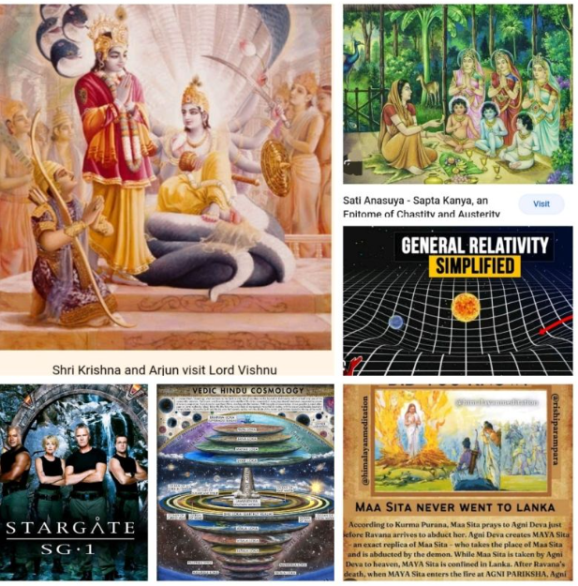
Links:
The story
gods - Who was the wife of Kaushik who stopped the Sun from rising to save her husband's life? - Hinduism Stack Exchange
Michael Salla: The Role of Celestials in Guiding Humanity with Extraterrestrial Contact
(114) The Role of Celestials in Guiding Humanity with Extraterrestrial Contact - YouTube
Oxford Physicist PROVES The Universe Isn't REAL; We LIVE in a Cosmic Hologram | Jude Currivan PH.D
(114) Oxford Physicist PROVES The Universe Isn't REAL; We LIVE in a Cosmic Hologram | Jude Currivan PH.D - YouTube

Re-membering into Ascension

Continuing from our previous post supported by synchronicities we understand that the Vedic perspective has answered the questions long before modern science even understands the question.
Time is in cycles and old is certainly gold.
"I owed—my friend and I owed—a magnificent day to the Bhagavat Geeta. It was the first of books; it was as if an empire spoke to us, nothing small or unworthy, but large, serene, consistent, the voice of an old intelligence which in another age and climate had pondered and thus disposed of the same questions which exercise us." - Ralph Waldo Emerson
The Sanskrit word Maya is taken as illusion or that which is not. It doesn't mean that it does not exist or is not real. Life is certainly real but the nature of an illusion is that it is a temporary reflection of something that is more substantial. As mentioned in Bhagvad Gita and Srimad Bhagvatam the material world is temporary and illusory world. It needs to understood in proper light of knowledge for all its miseries and attempts must be made to attain perfection.
"After attaining Me, the great souls, who are yogīs in devotion, never return to this temporary world, which is full of miseries, because they have attained the highest perfection.
From the highest planet in the material world down to the lowest, all are places of misery wherein repeated birth and death take place. But one who attains to My abode, O son of Kuntī, never takes birth again. By human calculation, a thousand ages taken together form the duration of Brahmā’s one day. And such also is the duration of his night."- Krishna (Bhagavad Gita 8.14-15)
One day of Brahma is about 4.32 billion years. Holograph or Maya or another word suitable to reflect life is not to minimize the value of life rather to understand that to encourage focus on spiritualising everything we do. This is done by dovetailing all our activities in service of God/Krishna who is the source and the Lord of the spiritual worlds. When we practice that service, we earn some spiritual merit to request mercy of the Lord to accept our consciousness back in Krishna consciousness and our eternal nature. Something the scientists are just beginning to figure out and finding courage to speak about just as the scientists/Sages of the old times. We are Re-membering our history and Ascending in consciousness #soulfamily!!
"O son of Kunti, all that you do, all that you eat, all that you offer and give away, as well as all austerities that you may perform, should be done as an offering unto Me. In this way you will be freed from all reactions to good and evil deeds, and by this principle of renunciation you will be liberated and come to Me."- Krishna (Bhagavad Gita 9.27-28)

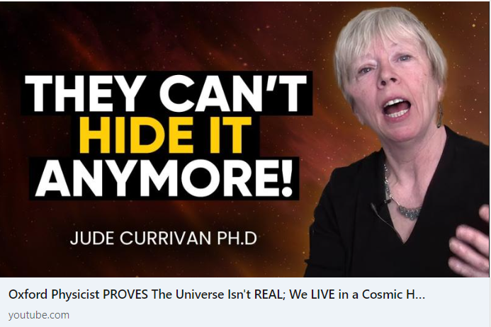
Links:
Oxford Physicist PROVES The Universe Isn't REAL; We LIVE in a Cosmic Hologram | Jude Currivan PH.D
(114) Oxford Physicist PROVES The Universe Isn't REAL; We LIVE in a Cosmic Hologram | Jude Currivan PH.D - YouTube
STIGMATA: The True Story of George Bongioinini and the Secrets of Fatima
(114) STIGMATA: The True Story of George Bongioinini and the Secrets of Fatima - YouTube

The war of Kali-yuga

Time/God/Universe plays no favourites. We are sentient beings and small creators in our own way. We study the sciences and the laws and act accordingly. We have a head and intelligence to evaluate, heart to feel and various working senses to dedicate ourselves to a cause or action. All our actions are called Karma. When the actions are done in alignment with God's laws/scriptures there is no violations and hence not subject to karmic laws. These are considered Akarma. Anything contrary to God's words that is not in favour of Dharma is Vikarma.
In any age and time there exists a variety of people in the universe and God has to reciprocate with all in the manner they understand and choose by their vibrations. Those who follow the path of peace understand in the language of love. Those who follow the path can only follow the path of fear. This is why the peaceful devotees in every culture know the art of war too. God does not incarnate all the time. Like Arjuna they have to fight else the devotees are considered weak and crucified. It is not desired path God consciousness, but it has been necessary. The history of all civilizations shows the faithful and the faithless and the war in between them.
The yuga cycles over time are progressive degradation of Dharma and its reinstatement. The Bull of Dharma stands on the four legs of Truth, Austerity, cleanliness and Mercy. As discussed many times, those who do not follow Dharma are not protected by Dharma. It is co-created reality born of misused freewill. By freewill people qualify as Demigods, the forces of light or as the Demons the forces of Darkness. In Satya yuga they are spread on different planets/realms, In Treta on Different continents, in Dwapara in different countries and in Kali-yuga they are impossible to tell apart. The only way to tell the good and the bad is by their vibrations/consciousness of the heart and their actions.
The character of each individual passes through the sieves of test and only the finest pass through the cage of Maya or illusion. The rest are recycled into the cycles of birth and death. The Kali-yuga is most generous opportunity for the Demigod and the Demon star seeds to pass through and is a rare opportunity. What we choose by our actions is our choice. Some choose to fight even with God and some choose to surrender. A God always wins #soulfamily. The science of spirituality is more advanced than any technology or AI.
"My dear King, although Kali-yuga is an ocean of faults, there is still one good quality about this age: Simply by chanting the Hare Kṛṣṇa mahā-mantra, one can become free from material bondage and be promoted to the transcendental kingdom.
Whatever result was obtained in Satya-yuga by meditating on Viṣṇu, in Tretā-yuga by performing sacrifices, and in Dvāpara-yuga by serving the Lord’s lotus feet can be obtained in Kali-yuga simply by chanting the Hare Kṛṣṇa mahā-mantra."- Srimad Bhagavatam 12.3.51-52
The lecture is important.
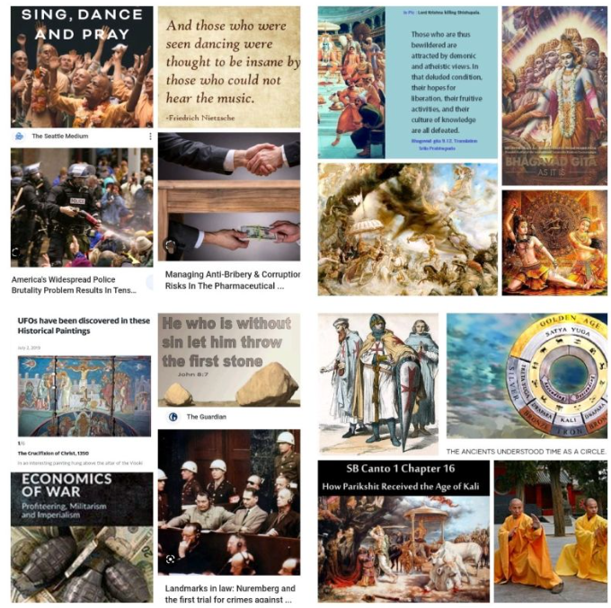
Links:
Srila Prabhupada on Bhagavad Gita As IT IS Chapter 3 Verses 21 – 24
https://www.youtube.com/watch?v=a4aYkVkaRFU

Disclosure

Despite what our countries and governments disclose to us openly, the history reveals much to the seekers of truth. Carved on stones all over the world are evidence of structures that predate our time and postdate our technology.
Their frequent contact and intermixing is detailed in many books like Book of Enoch, the Vedic scriptures like Ramayana and Mahabharat. For the hand of Mother Sita the Demigods and Demons came to prove their valour by lifting the great bow Lord Siva. Only Lord Ram was capable of this superhuman and Supreme demigodly feat. Similarly, as discussed Draupadi appearing from fire sacrifice was won by Arjuna. Kunti herself bore children of many Demigods including the Sun God.
Among the many stories one story that provides discriminating evidence of the difference between the bodies of Demigods and that of humans is the story of Nala and Damyanti. The story of their Valour and Beauty is only surpassed by their fame of their virtues. Damayanti was so beautiful that the king of celestials Indra desired to win her. But she had her heart set on the virtuous Nala. In her Svayambara or the right to choose a husband amongst many she was confused by the demigods who took the appearance of Nala. All trying to win her hand by deceiving her and She had but one shot to choose her future. The one she garlands will be the one she will be married to.
Here is the lesson for us #soulfamily. The correct path to discernment and how it is provided. It is an important lesson from the past histories uncorrupted from the misinformation and disinformation of modern literature and sciences. Upset and confused she took refuge in one place Lord Vishnu/Krishna/God to guide her on this most important step of her life. And for her faith she was rewarded as she was guided from the heart. She noticed that the demigods unlike the human bodied Nala did not cast shadows, nor did they sweat or feel the need to blink. Thus telling the Demigods apart from the humans she garlanded the one she desired.
The science of different beings and their properties exists in the fact that as human bodies are constructed in the properties of the planet we occupy, similarly other extra terrestrial beings have their bodies have higher and lower quantities of elements that suit the body on their planet.
"..Superior to animals are human beings, and superior to human beings are ghosts because they have no material bodies. Superior to ghosts are the Gandharvas, and superior to them are the Siddhas. Superior to the Siddhas are the Kinnaras, and superior to them are the asuras(Demons). Superior to the asuras are the demigods, and of the demigods, Indra, the King of heaven, is supreme. Superior to Indra are the direct sons of Lord Brahmā, sons like King Dakṣa, and supreme among Brahmā’s sons is Lord Śiva.." - Srimad Bhagvatam 5.5.21-22
Ignorance to God/Krishna consciousness is not bliss. Raise your consciousness to higher grounds so we are not left with memories of floods.

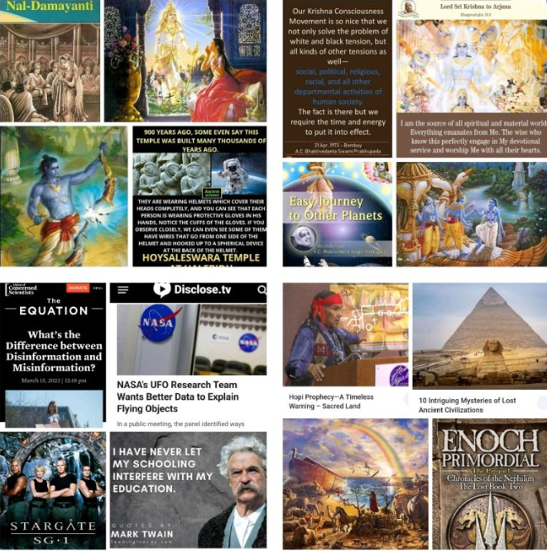
Links:
In the Sun Planet the Bodies are Fiery - Prabhupada 0081
https://www.youtube.com/watch?v=h3sZ_lDRBoc
The Story of Nal and Damyanti
https://vedicfeed.com/nala-and-damayanti-love-story/
Oumuamua Suddenly Showed Up Again & Is Sending Signals To Earth!
https://www.youtube.com/watch?v=PIs7ZEPSMW0

XXXXXXXXXXXXXXXXXXXXXXXXXXXXXXXXXXXXXXXXXXXXXXXXXXXXXXXXXXXXXXX
UPDATED FROM HERE

Spiritual DNA

The DNA and it's abilities is a very topical subject for many reasons. There are many secrets hidden in it that the science tries to unravel and spiritualists try to awaken #soulfamily.
We discussed the ancestral DNA that brings within memories and thus predisposition to a certain Varna mentioned in Vedic scriptures or occupation selection. The children Brahmins/intellectuals are most likely to be well positioned for intellectual challenges and those in warrior class are likely to be interested in adventures and gifted with physical prowess and so forth. People can change their occupation by choice and in the Vedic system the Varna was not by birth, but they have preexisting dispositions to excel in a certain way. The DNA is important and hence the arrange marriage customs were to ensure that history, knowledge and physical traits are well preserved. Else, the population becomes Varna sankara.
"Brāhmaṇas, kṣatriyas, vaiśyas and śūdras are distinguished by the qualities born of their own natures in accordance with the material modes, O chastiser of the enemy.
Peacefulness, self-control, austerity, purity, tolerance, honesty, knowledge, wisdom and religiousness – these are the natural qualities by which the brāhmaṇas work.
Heroism, power, determination, resourcefulness, courage in battle, generosity and leadership are the natural qualities of work for the kṣatriyas.
Farming, cow protection and business are the natural work for the vaiśyas, and for the śūdras there are labour and service to others.
By following his qualities of work, every man can become perfect. Now please hear from Me how this can be done."- Krishna (Bhagavad Gita 18.41-45)
Now extend this to the Eastern and the Western cultures. One is more society based and the other more individualistic. One is more comfortable with the idea of God and higher beings and the other has struggled with the word religion. The history here is very old and consistent even before the crucifixion. The very Masculine energy supported by ideologies takes pride in the ability to bear arms, and fight for individual rights. It is perhaps in the DNA that leads some to be useful as Super soldier and some as Spiritual soldiers. But there are Brahmins/intellectuals in all societies. The DNA though and it's predisposition remain important. As per above have we chosen what we want to do?
Is it not possible to choose the path of love and compassion through freewill. Through Spiritual ascension and God/Krishna consciousness. Can we not live in a united world by our own freedom if we are co-creators of our reality? Do good qualities have to be drilled down Artificially through DNA modifications and therapies? The good, the bad and the ugly is always here as it has always been but the beauty of the world with or without technology needs to be seen and realised through Spiritual understanding. There are many levels to the God's creation some are of Denser Matter and consciousness, and some are more spiritual.
Links:
“My Father is from Pleiades”… Revelations of an Extraterrestrial-Human Hybrid
https://www.youtube.com/watch?v=f4caT3K7bFA
Srila Prabhupada on Bhagavad Gita As IT IS Chapter 3 Verses 13 -16
https://www.youtube.com/watch?v=upMaTMyvRUg

Materialism is Destruction

'Real destruction is materialism...'
When we wake up tomorrow spiritual identities the materialistic nature of the world seems not to resonate and it appears hard to go back to sleep.
tvat-kathāmṛta-pāthodhau viharanto mahā-mudaḥ
kurvanti kṛtinaḥ kecic catur-vargaṁ tṛṇopamam
“For those who take pleasure in the transcendental topics of the Supreme Personality of Godhead, the four progressive realizations of religiosity, economic development, sense gratification and liberation, all combined together, cannot compare, any more than a straw could, to the happiness derived from hearing about the transcendental activities of the Lord.”- Bhāvārtha-dīpikā
When one does not wish to not work for any personal gains he works for God/Krishna. And as discussed many times before God/Universe is all about matching vibrations and reciprocations #soulfamily he works for you!!!
We discussed how Krishna tells Arjuna to declare that his devotees are never destroyed, because as the Supreme controller the world is at his whims and he can change his will unchallenged. What recourse can one have? But he is bound by love alone. The devotees bind him with their vibrations of love. How can then he break the promise made to his devotees and the promised made by his devotees. The devotee although participating in the mundane world is never fallen.
"He quickly becomes righteous and attains lasting peace. O son of Kuntī, declare it boldly that My devotee never perishes."- Krishna (Bhagvad Gita 9.31)
The perfection is born not of the material body which takes various forms and thus complies by various rules. Perfection is born of the desire to please Krishna/God and work to serve in whatever way that pleases Krishna. If that means to serve in place of worship or on the battlefield like Arjuna. The desire is untainted with selfish gains of any kind even liberation of impersonalism.
"bhava-bandha-cchide tasyai spṛhayāmi na muktaye
bhavān prabhur ahaṁ dāsa iti yatra vilupyate
“I do not wish to take liberation or to merge in the Brahman effulgence, where the conception of being a servant of the Lord is completely lost.”- Hanuman
The ascension of consciousness is to understand that we are eternal and our nature is full of bliss and knowledge. Our nature and pleasure is eternal servitude to the whole who is everywhere yet separate. As a glass of ocean water is every bit the quality of the ocean or a tree has its own identity in the forest but neither is the glass the Ocean nor is the tree the forest itself. We are all united in our spiritual understanding but separated in the materialistic understanding. Hence, materialism will always lead to destruction and spiritualism will always lead to unity. Unity can only happen through God/Krishna consciousness. On any other platform it is superficial and temporary. Everyone is bound by the rules of their body on this planet or otherwise, but they are part of the whole in a different coloured glass.

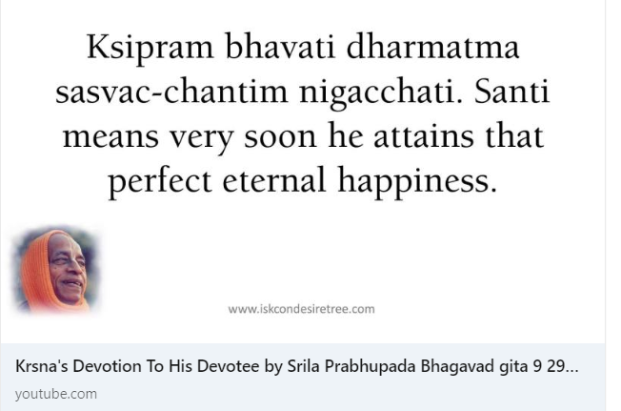
Links:
Krsna's Devotion To His Devotee by Srila Prabhupada Bhagavad gita 9 29 32 on 20 12 66 at New York
https://www.youtube.com/watch?v=gKC8gUdN9vw
"Secrets of Inner Earth: Unveiling Intelligent Beings, Folklore, and Electromagnetic Phenomena"
https://www.youtube.com/watch?v=c9GyDLrASEE

MONEY

The MONEY concept is a way to convert ENERGY into Matter. We discussed yesterday how the real destruction of a society is through Materialism. There is the path of materialism and there is a path of spiritualism. In spirituality there is unity across all beings and we can see God/Krishna in everyone. Everything is shared equally for the benefit of all. The elite Globalists who wish to use the energy of money to create Fear and feed of it more and more. The materialists only COMPLY. They enjoy the matrix and it feeds their material AMBITIONS.
But there is another way of living with one ambition that is to serve God/Krishna and by serving others. The God/conscious always want to interact and share love not hate. They want to see unity not divisions by varying degree of Ambitions. This is why they believe in sharing. They see Krishna in everyone. How can they be Materialistic? It does not mean having any material things. Rather not being attached to them. There spiritualist are the Spiritual worlds too. They exist here and now in a different dimension/realm/location. And we could be moving in that direction #soulfamily.
But there are those who seek to control and controlled and need the MATTER of currency to transact in some form of another. THEY are unwilling to share. What would they do? That is the strategy we need to think about. The battle is between FEAR and LOVE. The DEMONS and the DEMIGODS. The world is splitting between not the Haves and the Have nots. The true battle was never for MATTER. The battle was ALWAYS SPIRITUAL. Where have your attachments been? The BATTLE is for the consciousness. Have we not been discussing how to RAISE the CONSCIOUSNESS for the last few years.
What lifestyle are you comfortable with is your own freewill? Who and what can you let go to adopt a spiritual lifestyle. Living in nature in a 5D atmosphere with beings of DIFFERENT NATURES. Renunciation in God/Krishna consciousness is true Renunciation. As everything is done in service of KRISHNA Everything is BLESSED!! EVERYTHING we have in terms of matter is transformed into SPIRITUAL ENRGY.
The is the SPLIT of the TWO WORLDS. This has happened many times before. DID you UNDERSTAND the VEDIC COSMOS. The GREAT AWAKENING and THE GREAT RESET is by choice. The Kali-yuga is not over. People have to choose it by the path of materialism. This happens ONLY ONCE in the day of Brahma when LORD KRISHNA AND LORD CHAITANYA appear together. They go in their BODIES by choice of their VIBRATIONS.
"Men of small intelligence worship the demigods, and their fruits are limited and temporary. Those who worship the demigods go to the planets of the demigods, but My devotees ultimately reach My SUPREME PLANET
Unintelligent men, who know Me not, think that I have assumed this form and personality. Due to their small knowledge, they do not know My higher nature, which is changeless and supreme." - Krishna (Bhagavad Gita 7.23-24)
CHANT HARE KRISHNA
BE HAPPY!!
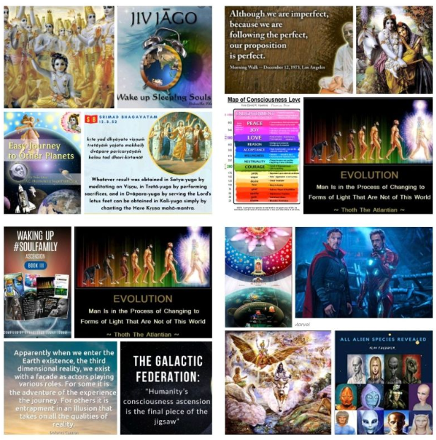
Links:
"Soviet Close Encounter Chronicles: Viktor Kasprikin's Journey into the Realms of Orion"
https://www.youtube.com/watch?v=TrIZjHKWPzQ
Oh SH*T, It's Only Just Beginning
https://www.youtube.com/watch?v=d9zR2zdnNdI

Education system

The MATERIALITY centerd education system is DECLINING because Spiritual education is declining. When we educate ourselves for WEALTH and POWER we start to compete and hide technology and knowledge from others through patents for sake of Money. This is not desirable in Spiritually Advanced worlds. They work to serve each other and God/Krishna. They strive for Spiritual Wealth and thus SHARE their knowledge #soulfamily. The God conscious societies are therefore always more advanced in Material AND Spiritual Technology. The VIMANAS are one ANCIENT Technology remember.
Education restricted by Time does not allow proper learning and one based on credits does not allow for proper intent. It only develops greed. Education is for Learning and Growth- individually and collectively. This unity can be achieved through much discussed Varna-ashram system of ancient Societies.
The Earth school of Maya is the illusion of the mind. It teaches the battle between the path of Division and Unity and We get to choose by our Karma. The positive and the negative both qualify by their actions or Karma. Some take the path of LOVE and COMPASSION to reach UNITY CONSCIOUSNESS and Spiritually elevated world. Others on the path of FEAR and CONTROL eventually reach SINGULARITY of TECHNOLOGY.
All spiritualised actions are Akarma i.e does not accrue karma credit. The growth of an individual happens through Spiritually challenging tests. The hard times become the initiation path for some. Some seek initiation/guidance from Spiritual family/ Spiritual Masters. The preaching/practicing teachers guide towards the right education path because they are self realised.
Unlike a government/corporate funded schools focused on materialism the education is not just for INDIVIDUAL benefit. Like the ancient GURUKUL system Spiritual education of God/ KRISHNA CONSCIOUS is a SOCIETY responsibility/benefit.
We have to make an effort and then Krishna sends a Spiritual Master/Guidr who can help us towards God and Unity consciousness. If we are disciplined in our approach then our Vibrational frequency provides the guiding light to the Spiritually elevated.
"Just try to learn the truth by approaching a spiritual master. Inquire from him submissively and render service unto him. The self-realized soul can impart knowledge unto you because he has seen the truth.
And when you have thus learned the truth, you will know that all living beings are but part of Me—and that they are in Me, and are Mine. "- Krishna (Bhagavad Gita 4.34-35)
The Material and Spiritual Education go HAND IN HAND for a progressive society. The members of such society were called Aryans. To be focused on Material looks, wealth and power is waste of human birth and is UnArya.
"The Supreme Personality of Godhead said: My dear Arjuna, how have these impurities come upon you? They are not at all befitting A MAN WHO KNOWS THE VALUE OF LIFE. They lead not to higher planets but to infamy."- Krishna (Bhagavad Gita 2.2)

Links:
THE INVISIBLE MATRIX OF ENERGY - It was called: "The Secret of The NeTeRs"
https://www.youtube.com/watch?v=wmgOhP5srFk
QHHT Insights into Secret Space Programs, ET Life, and The Event
https://www.youtube.com/watch?v=8qjtBJyrTGI
Srila Prabhupada on Bhagavad Gita AS IT IS Chapter 2 Verse 2
https://www.youtube.com/watch?v=4GH5eRa78ew
"John Dee: The Original 007 - Occult Secrets, Angels, and the Alchemy of Science"
https://www.youtube.com/watch?v=WKyxmrtogKY

Motivations

We spoke about Wealth, Power and Education as the respective motivations or proverbial carrots for people to work hard day and night. The stick for not working or complying with that paradigm or system is poverty and destitution from material perspective. This is certainly made worse in societies that place no value on spiritualist or renouncers of the accepted material systems.
The need to place any degree of emphasis on spiritual growth in current society is purely on self-motivation basis. It is not an easy task to swim against the tide in Kali-yuga. This is why there has been much leniency as discussed in many prior posts. Only by chanting the holy names of God/Krishna one can make much progress. But how many are actually doing even this?
"In this endeavor there is no loss or diminution, and a little advancement on this path can protect one from the most dangerous type of fear.
Those who are on this path are resolute in purpose, and their aim is one. O beloved child of the Kurus, the intelligence of those who are irresolute is many-branched."- Krishna (Bhagavad Gita 2.40-41)
We can certainly see the lower beings or animals, but our inflated human ego thinks ourselves as the Lords of nature/Material world. This ego fed by the mind rationalises life as one-shot game and thus takes to vices through attachments to sense attachments in this one opportunity.
"In Kali-yuga, wealth alone will be considered the sign of a man’s good birth, proper behavior and fine qualities. And law and justice will be applied only on the basis of one’s power. "- Srimad Bhagavatam 12.2.2
Unlike the prior ages humans in Kali-yuga do not get to physically see the higher beings of higher planets and understand their higher levels of powers and opulences. Not many are motivated to play the long game as they need to see to believe in existence of higher angelic beings that have evolved to a higher level of existence. But this is how faith is tested in the scriptures and word of God - to see who really believes #soulfamily.
The scriptures mention of many varieties of evolved human species and many levels of them as discussed previously. The Demons and Demigods divided by polarity of consciousness. But we don't believe because we cannot see. Some who placed their consciousness in the long game will win and the irresolute who got distracted in the Gross material dreams may not Fare as well. Those who employed visualization techniques on material aspirations may have co-created their reality to live in. It is only fair then that those who worked on visualizing and co-creating spiritual aspirations get their wins as well. After all the Universe and God/Krishna is unbiased and karma should be rewarded. What goes around must come around. And there is a lot around that we don't see.
"I envy no one, nor am I partial to anyone. I am equal to all. But whoever renders service unto Me in devotion is a friend, is in Me, and I am also a friend to him."- Krishna (Bhagvad Gita 9.29)
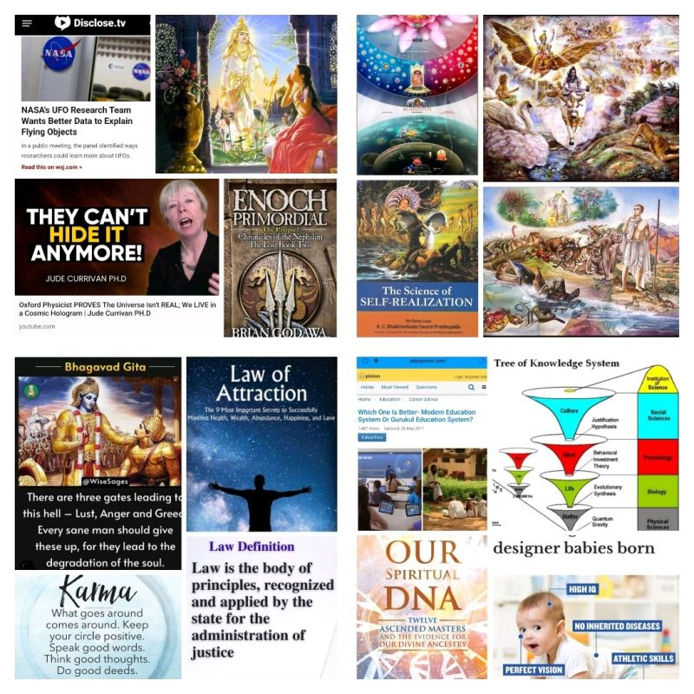
Links:
Lecture by Sril Prabhupada on Bhagavad Gita As It Is Chapter3 Verse 8-13
https://www.youtube.com/watch?v=e8Rdbe-BzW4
"Ancient Archons: Self-Aware A.I Consciousness with a Sinister Plan in Mind"
https://www.youtube.com/watch?v=amqA-WKKRIY
Las Vegas family claims to see aliens after several report something falling from sky
https://www.youtube.com/watch?v=oli6Q6y14W8

The Storm is Coming

What goes around comes around and because we are all connected; my heartfelt best wishes for good health and happiness for all. May the #soulfamily raise their vibrations to God/Krishna consciousness level.
Being able to see the common connections and feeling each other's joys and pains only brings us together and destroys the illusion of separation. As discussed previously, telepathy is only good if we have empathy. Telepathy without empathy is of little value. We can choose to see it as the law of karma over lifetimes through the process of reincarnations or a process of evolution into our higher self. The heaven and hell are temporary much as the various planets themselves. The force that is with all is the force of God and force of love and it should brings us closer not further apart.
"And when you have thus learned the truth, you will know that all living beings are but part of Me—and that they are in Me, and are Mine.
Even if you are considered to be the most sinful of all sinners, when you are situated in the boat of transcendental knowledge, you will be able to cross over the ocean of miseries.
As the blazing fire turns firewood to ashes, O Arjuna, so does the fire of knowledge burn to ashes all reactions to material activities."- Krishna (Bhagvad Gita 4.35-37)
All levels of separation are for our material experiences that we choose to participate in based on our attachments. Each experience though is not free with no strings attached. We are all connected remember!
ALL BEINGS native or Alien, like us or unlike us; beings of Earth, Water, Air or Space that we can or cannot perceive are but an extension and expansion of our Unity as the many colours within light. The Diversity is what brings the joy of colours and forms through expressions in various ways. It can be used in service of God or separation. Individualism is separation from the whole. The whole comes in form of family, society, culture, faith, country, planet and universe. Raise the vibrations to the highest level through God consciousness and you will find thag no storm is bigger than God/Krishna our eternal well-wisher.
"O Lord, You are always in full knowledge, and to bring all good fortune to all living entities, You appear in different incarnations, all of them transcendental to the material creation. When You appear in these incarnations, You are pleasing to the pious and religious devotees, but for nondevotees You are the annihilator.
O lotus-eyed Lord, by concentrating one’s meditation on Your lotus feet, which are the reservoir of all existence, and by accepting those lotus feet as the boat by which to cross the ocean of nescience, one follows in the footsteps of mahājanas [great saints, sages and devotees]. By this simple process, one can cross the ocean of nescience as easily as one steps over the hoofprint of a calf."- Srimad Bhagavatam 10.2.30-31
Please do watch till the end.
Statistically sound sample size.

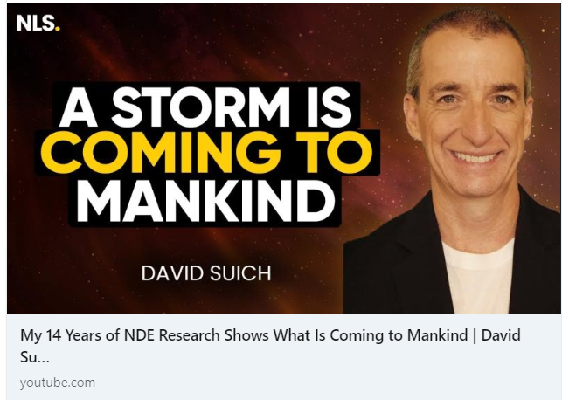
Links:
My 14 Years of NDE Research Shows What Is Coming to Mankind | David Suich
https://www.youtube.com/watch?v=Y0ez_HfTG4k

So many Proofs

NDE of Near Death Experiences have been studied scientifically so many times and we also had the opportunity to look at the studies done in previous posts. So what do the studies say? IS THERE A SAVIOUR or NOT ?
The saviour can take many forms, He has infinite qualities.
"That Ananta Śeṣa is the devotee incarnation of Godhead. He knows nothing but service to Lord Kṛṣṇa.
With His thousands of mouths He sings the glories of Lord Kṛṣṇa, but although He always sings in that way, He does not find an end to the qualities of the Lord." - Chaintanya Charitamrata Adi lila 5.120-121
All we have to do it attach yourself to one form who we would like to serve personally. If we don't want to serve then we can stay in the mode of passion and ignorance.
"Those situated in the mode of goodness gradually go upward to the higher planets; those in the mode of passion live on the earthly planets; and those in the mode of ignorance go down to the hellish worlds."- Krishna (Bhagavad Gita 14.18)
Those who want to belive they are Gods or they need to save themselves are welcome to make their attempts through freewill and ride cycles of repeated births. As discussed in previous video, it is all part of the learning experience to LOVE KRISHNA/GOD. They have all the Love and the FORCE of GOD in the way of BLESSINGS. All energy that exists in force of God. What else can it be. It is his will that operates in PERFECT PLANS. We are always where we need to be physically but we need to be there mentally. The battle is for the CONSCIOUSNESS!! Have You surrendered everything at the WILL of GOD?
"Dear Lord, by virtue of a moment’s association with Lord Śiva, who is very dear to You and who is Your most intimate friend, we were fortunate to attain You. You are the most expert physician, capable of treating the incurable disease of material existence. On account of our great fortune, we have been able to take shelter at Your lotus feet.
Dear Lord, we have studied the Vedas, accepted a spiritual master and offered respect to brāhmaṇas, advanced devotees and aged personalities who are spiritually very advanced. We have offered our respects to them, and we have not been envious of any brother, friends or anyone else. We have also undergone severe austerities within the water and have not taken food for a long time. All these spiritual assets of ours are simply offered for Your satisfaction. We pray for this benediction only, and nothing more."
- Srimad Bhagavatam 4.30.38-40
If we have prayed for a Savior and We Conceive and Believe in that Savior and have surrendered to that Saviour. THEN WHY SHOULD WE NOT HAVE A SAVIOUR? Why we not have a SOULFAMILY #soulfamily? He is creator of Time itself.
"I worship Govinda, the primeval Lord, who manifested Himself personally as Kṛṣṇa and the different avatāras in the world in the forms of Rāma, Nṛsiṁha, Vāmana, etc., as His subjective portions." - Srimad Bhagavatam 5.39.

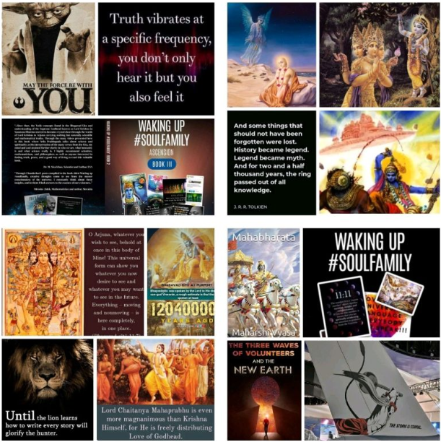
Links:
Srila Prabhupada on Bhagavad Gita As IT IS Chapter 3 Verse 17
https://www.youtube.com/watch?v=qYdcgduxfj0
"Ancient History of E.T. Influence, and First Contact: Conversations with 'ANTURA' from Sirius B"
https://www.youtube.com/watch?v=soKHdH4TCGw
INSIDE THE MIND OF MEDIUM AND MASTER FULL TRANCE CHANNELER RIZ MIRZA | EPISODE 98
https://www.youtube.com/watch?v=3S4CcoVH1eY

Spiritual Warriors

Continuing from the previous post where through the content of the post and links in comments we discussed 5 different ways of education on the different realms. Through Extra terrestrial/Inter dimensional contact, Near Death Experiences, Hypnosis sessions/ Past Life Regressions, Channelling and Scriptures themselves. We are awakening to the old wisdom #soulfamily.
We discussed the existence and different types of beings that are spread out in different realms and time that exist simultaneously in larger and larger cycles of creation. Our exact location as per time and space is invoked in every Vedic ritual or ceremony. Our Galactic Location and time are as follows.
Location- We are based on the south side of smallest central island of Jambudweep in Bharat Varsha (Earth) and Bharat Khand (India) which happens to be in South of Meru mountain.
Time- We are presently 28 Maha-yugas into the 7th Manvantara named Vaivasvata Manu Vamana making it 43 Maha-yugas to go until we move on to the 8th Manvantara.
All the above methods of revealing the truth of of beings of higher existence and the Highest being Krishna himself. His inconceivable potencies revealed through 'Achintya bheda abheda tattva'
'The last illusion, the last snare of māyā to trap the living entity, is the proposition that he is God. The living entity thinks that he is no longer a conditioned soul, but God. He is so unintelligent that he does not think that if he were God, then how could he be in doubt? That he does not consider. So that is the last snare of illusion. Actually, to become free from the illusory energy is to understand Kṛṣṇa, the Supreme Personality of Godhead, and agree to act according to His order.' - Purport, Bhagavad Gita As it is, Text 18.
73
The discernment is important here. Even Brahma and Siva uses their long lives is service of God/Krishna. Their service experience is for the pleasure of Krishna in whichever form/duty it comes.
"I worship Govinda, the primeval Lord, who is adept in playing on His flute, with blooming eyes like lotus petals with head decked with peacock's feather, with the figure of beauty tinged with the hue of blue clouds, and His unique loveliness charming millions of Cupids."- Bramha Samhita 5.30
Krishna/God Himself is never bound by karma and is always self aware. We are eternal servants of the Whole.
"According to the three modes of material nature and the work associated with them, the four divisions of human society are created by Me. And although I am the creator of this system, you should know that I am yet the nondoer, being unchangeable.
There is no work that affects Me; nor do I aspire for the fruits of action. One who understands this truth about Me also does not become entangled in the fruitive reactions of work.
All the liberated souls in ancient times acted with this understanding of My transcendental nature. Therefore you should perform your duty, following in their footsteps."- Krishna (Bhagvad Gita 4.13-15)

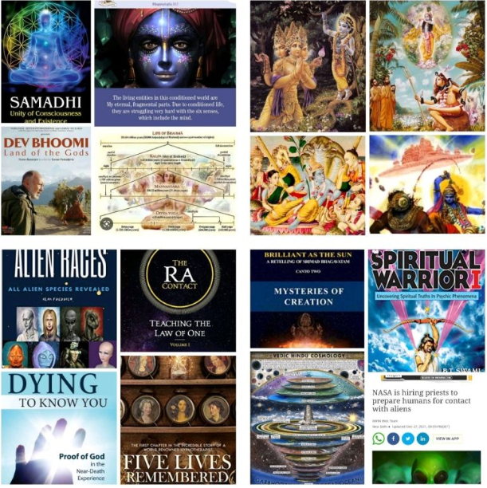
Links:
Gravitas Plus: Is America hiding Alien technology?
https://www.youtube.com/watch?v=BC59eJIEMDA
"Timeline Technology Revealed: How Project Looking Glass and Stargates Shape Humanity's Fate"
https://www.youtube.com/watch?v=nxbuURKh2eY
Bageshwar Dham Sarkar: The Indian guru making headlines over 'miracle' cures
https://www.bbc.com/news/world-asia-india-64480726

The Lions Roar

'Space' is a very generic term. There is space everywhere and in every thing. There is the outer space outside us that extends out until the limits of the UNI-verse. And like the space within our body is full of many varieties of microbes all playing a valuable part in regulation of the Body. Similarly, the outer space is regulated by various beings as well. All play a part in their own way. LIFE IS NEVER MEANINGLESS rat race for Money. There is always Greater purpose in evolution of the self or the soul and the journey is SPIRITUAL.
As there are many UNI-verses all with their own Brahmas or creators. We discussed the story of how Brahma of this UNI-verse came to see Krishna once as a child to test him because he could not BELIEVE how the Supreme Personality of Godhead could incarnate as a child and play with young children just as a child. He did not understand that Krishna reciprocates with everyone PERSONALLY. The Time and Universal form of God is not attractive to the devotees. So he out of love incarnates again and again.
" Whenever and wherever there is a decline in religious practice, O descendant of Bharata, and a predominant rise of irreligion – at that time I descend Myself.
To deliver the pious and to annihilate the miscreants, as well as to reestablish the principles of religion, I Myself appear, millennium after millennium."- Krishna (Bhagavad Gita 4.7-8)
But Braham despite his four heads and extremely long life of great health can make mistakes. He too is within the material world where Krishna's Maya reigns Supreme. Hence, when he approached Krishna again at Dwarka he was made aware of other larger UNI-verses and their Brahmas. The Brahma was humbled once again. What is the value of petty intellectuals and scientists?
There are people who say, “I know everything about Krsna.” Let them think in that way. As far as I am concerned, I do not wish to speak very much about this matter. O my Lord, let me say this much. As far as your opulence’s are concerned, they are all beyond the reach of my mind, body and words.’ This is a quotation from Srimad-Bhagavatam (10.14.38)
The Maya is Mother Durga (Vaishno Devi) who is married to Lord of Destruction- Siva, the greatest Vaishnava (Devotee of Vishnu/Krishna). Yet, even they do not act independent of Krishna.
"The external potency Māyā who is of the nature of the shadow of the cit potency, is worshiped by all people as Durgā, the creating, preserving and destroying agency of this mundane world. I adore the primeval Lord Govinda in accordance with whose will Durgā conducts herself."- Bramha(n) Samhita
The inner space too has involuntary functions and the creation/destruction happens in its time. Humans cannot create a FAKE Kali-yuga end. The scriptures are very clear on Time, Process and Purpose for all incarnations of Krishna. The management of the Universe and planet is in hands of HIGHER Authorities #soulfamily. In the hands of Vaishnavas remember!!
Dharmo Rakshati Rakshitah!

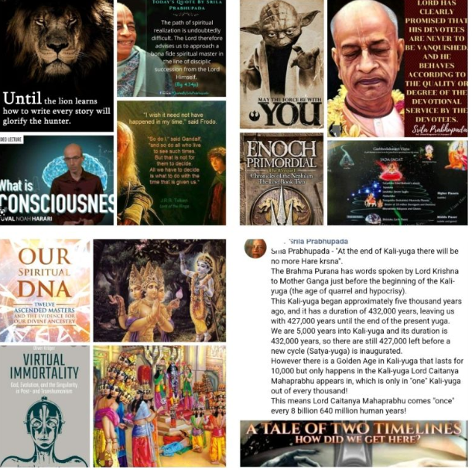
Links:
This Nice Car Is Rotten by Srila Prabhupada (SB 01.02.06) September 5, 1972, New Vrndavana
https://www.youtube.com/watch?v=S5yXAzi0-dA

Its Time

Those on spiritual waking journey should be sure to go through the lectures and references in the comments section. THAT is the best way to understand and raise the consciousness. At some stage we need to follow through with meditation on knowledge and act on the information to Re-member and Re-Present ourselves. Time to make a move.
Those looking to be in love and compassion- here and now is the time. If by your nature we are suitable for a certain occupation then we should take up and dovetail its fruits in mood of devotional service. Everything can be dovetailed in the service of Krishna/God. Do what you love to do that does not put you or others at dis-ease. Grow with people you love who do not put you at dis-ease. This is the Vedic Varna system that continues even for higher consciousness beings. They do not feel dis-ease and old age. Everyone does what they love with those they love in service of one they love. And everyone is connected like shades of colours of a rainbow.

"Material nature consists of the three modes-goodness, passion and ignorance. When the living entity comes in contact with nature, he becomes conditioned by these modes. O sinless one, the mode of goodness, being purer than the others, is illuminating, and it frees one from all sinful reactions. Those situated in that mode develop knowledge, but they become conditioned by the concept of happiness.
The mode of passion is born of unlimited desires and longings, O son of Kunti, and because of this one is bound to material fruitive activities. O son of Bharata, the mode of ignorance causes the delusion of all living entities. The result of this mode is madness, indolence and sleep, which bind the conditioned soul.
The mode of goodness conditions one to happiness, passion conditions him to the fruits of action, and ignorance to madness. Sometimes the mode of passion becomes prominent, defeating the mode of goodness, O son of Bharata. And sometimes the mode of goodness defeats passion, and at other times the mode of ignorance defeats goodness and passion. In this way there is always competition for supremacy." - Krishna (Bhagavad Gita 14.4-10)
In Human birth we get to use our Freewill to co-create our reality by our Karma and our Vibrational mix. We can do that consciously even in this life.
"Those situated in the mode of goodness gradually go upward to the higher planets; those in the mode of passion live on the earthly planets; and those in the mode of ignorance go down to the hellish worlds.
When you see that there is nothing beyond these modes of nature in all activities and that the Supreme Lord is transcendental to all these modes, then you can know My spiritual nature.
When the embodied being is able to transcend these three modes, he can become free from birth, death, old age and their distresses and can enjoy nectar even in this life."- Krishna (Bhagavad Gita 14.18-20)
Krishna controls all Time(ings) #soulfamily

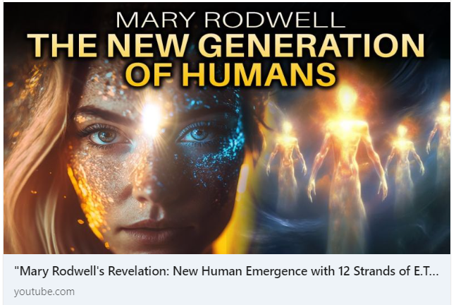
Links:
"Mary Rodwell's Revelation: New Human Emergence with 12 Strands of E.T DNA Lineage"
https://www.youtube.com/watch?v=InwY5PrUK_0
Srila Prabhupada on Bhagavad Gita AS IT IS Chapter 2 Verse 1
https://www.youtube.com/watch?v=zH3kLULOsqQ

Meeting #SoulFamily

Everything in the material world is made of materials. When we are born the materials come together to form a material body with the respective material part of the DNQ being coded in the material body. The DNA is also made up of the elements. The elements are physical particles or wave particles??
Is there nothing within the atom? Is it 99.99% space? Then how are we visible? Because 'particles’ of light are stationary but then how do you observe DNA under the microscope? Is it particles or light?
They are light codes in our DNA #soulfamily because even before matter is created in the material world there are elements personified. Matter is solidification of the Spiritual light energy of consciousness or Soul. The Soul is Personal as discussed so many times. Its energy has many levels of creation or dimensionality. It has forms in which it interacts with beings at its Vibrational level both mental and physical. There are various societies of those that vibrate together the good and the bad.
These Demigods/ Extra Terrestrials of various powers have helped in creation of the Universe with their energy. Their DNA has been incorporated in our structure. They are if higher version of us. The Titans and the Pandavas are some historical figures that were children of the Demigods. There are many more stories in all ancient histories. Each Demigod has their DNA incorporated in beings that match their Vibrations.
For Krishna there is no difference between his soul and Body. Each DNA strand belongs to beings who have added their contributions to our material existence.
"Mahat-tattva, or the great causal truth, transforms into false ego, which is manifested in three phases—cause, effect and the doer. All such activities are on the mental plane and are based on the material elements, gross senses and mental speculation. The false ego is represented in three different modes—goodness, passion and ignorance.
The false ego is transformed into mind by interaction with the mode of goodness. All the demigods who control the phenomenal world are also products of the same principle, namely the interaction of false ego and the mode of goodness.
The senses are certainly products of the mode of passion in false ego, and therefore philosophical speculative knowledge and fruitive activities are predominantly products of the mode of passion.
The sky is a product of sound, and sound is the transformation of egoistic passion. In other words, the sky is the symbolic representation of the Supreme Soul.
Thereafter the Personality of Godhead glanced over the sky, partly mixed with eternal time and external energy, and thus developed the touch sensation, from which the air in the sky was produced.
Thereafter the extremely powerful air, interacting with the sky, generated the form of sense perception, and the perception of form transformed into electricity, the light to see the world."- Srimad Bhagavatam 3.5.28-30
We have ET DNA, it's Time to meet the family.
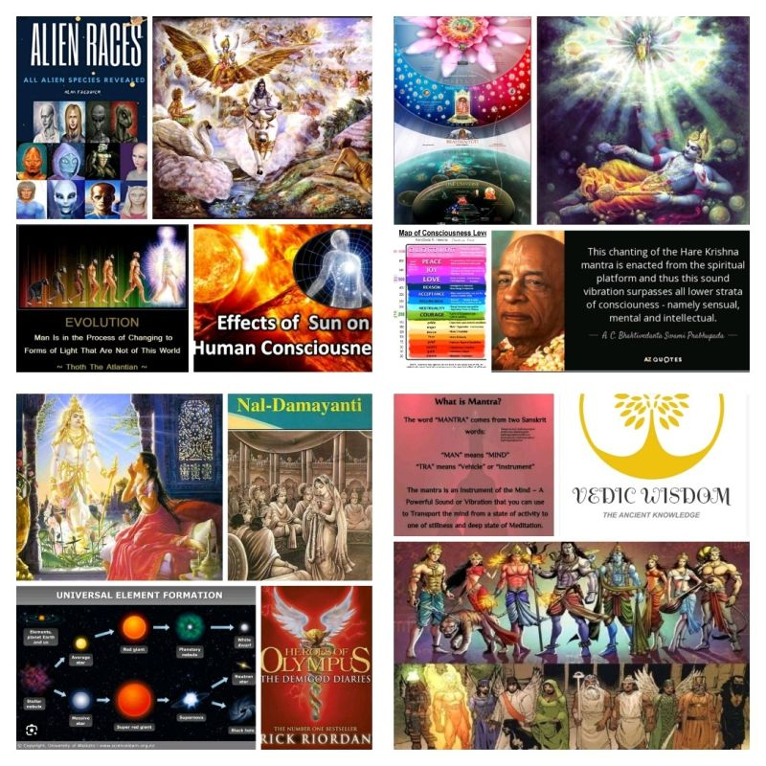
Links:
Get Out of Material Disease by Srila Prabhupada (SB 05.05.02) at Durban, October 22, 1975
https://www.youtube.com/watch?v=gOFEVX_YC4k
Elena Danaan: DISCLOSURE ~ Galactic Federation of Worlds~June 11 2023 (5:45 pm EST)
https://www.youtube.com/watch?v=YyZDCuwBo6w
Michael Salla : Investigating Alien Interrogation & Autopsy Videos: Interview with Jon Stewart
https://www.youtube.com/watch?v=lqYzBmYujUI

Demigods and Demons

Continuing the discussion on Demigods and their elements in our DNA, we know our body is made up of Water, Air, Fire and Earth and Ether. As discussed in previous post and attached lecture, each body has varying proportions of elements depending on our body, planet or realm we inhabit. Each realm has its own frequency and own specific ratios at which these elements are present in the body. Each element is manifestation of ego and thus has its own unique properties. These properties when used in right order and ratio become a cause of healing and when they are not in balance, they become a cause of Imbalance/Distress or Doshas as detailed in Ayurvedic and ancient medicine.
"I am the fire of digestion in the bodies of all living entities, and I join with the air of life, outgoing and incoming, to digest the four kinds of foodstuff." - Krishna (Bhagavad Gita 15.14)
The healing power and balancing power of nature also becomes the destructive forces when uncontrolled or in wrong hands. Controlling the power of nature is more powerful than any technological weapon because nature is around and within us. This is why the Divya Astra or Celestial weapons used in ancient Vedic warfare harnessed the powers of nature. The Brahmastra being one of the most powerful ones released by Ashvattama and Arjuna at the end of battle of Mahabharat. The devastating effects of that nuclear explosion are visible to date. Such power is not to be taken lightly as it impacts others.
When spiritually immature civilizations advance technologically it becomes a dangerous position. They get to the point where they are so divided and ignorant that they are constantly warring to destroy each other. The ego is the most basic element of creation. Those who cannot surrender their ego to God will not surrender to anyone else. Those who believe themselves to be Gods amongst Humans have to be forced to give them up for their own good.
"They say that this world is unreal, with no foundation, no God in control. They say it is produced of sex desire and has no cause other than lust.
Following such conclusions, the demoniac, who are lost to themselves and who have no intelligence, engage in unbeneficial, horrible works meant to destroy the world.
Taking shelter of insatiable lust and absorbed in the conceit of pride and false prestige, the demoniac, thus illusioned, are always sworn to unclean work, attracted by the impermanent."- Krishna (Bhagavad Gita 16.8-10)
Humans are not very high up in evolution. The Earth school is to rise above mode of passion and war towards Unity through God/Krishna consciousness. It’s all part of learning experience but in the process, we should not destroy nature itself. Every aspect of nature has many dimensions that we do not understand based on the level of Science and Spirituality our brain can comprehend. We have a habit of not believing what we can't see #soulfamily. We have a need to see the Material manifestations of higher forms of light.
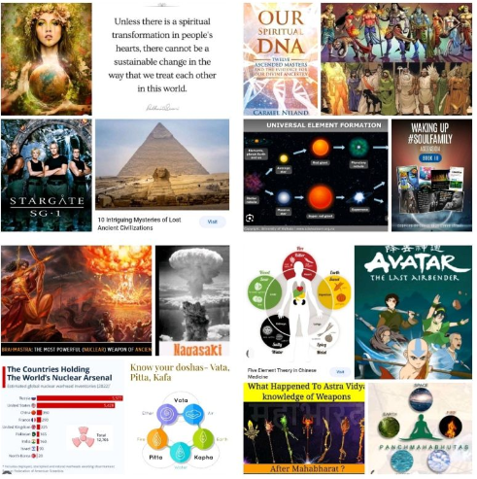
Links:
We live in a light matrix 😯
https://www.youtube.com/watch?v=VhwS3bkTia4

Media and Propaganda

Media is valuable only when people are unable to see the truth. The artificial means is to control a lost society. Mind control does not work on the seekers who have analysed life and surrendered their minds to God.
The history is carved in stone it does not need a media person to speak it. It can be hidden from the spotlight for some time but Truth always reappears like the cycles of time. It cannot be hidden in the mountains of submerged under the sea for too long. It rises to where everyone can see it! Then they can start believing again.
Truth is not like a propaganda machine that needs to be controlled and repeated constantly. When people can see for themselves, they can wake up in ONE DAY. All of the years of media control has not washed away the glories of the Lord. He is older than the oldest and his technology is beyond measure. Where science finishes spirituality begins. Spiritual science is studied and realised through Spiritual means.
"The Blessed Lord said: I instructed this imperishable science of yoga to the sun-god, Vivasvan, and Vivasvan instructed it to Manu, the father of mankind, and Manu in turn instructed it to Iksvaku.
This supreme science was thus received through the chain of disciplic succession, and the saintly kings understood it in that way. But in course of time the succession was broken, and therefore the science as it is appears to be lost."- Krishna (Bhagavad Gita 4.1-2)
Spiritual knowledge is eternal or Santana and is not in need of an artificial screen to show the power of God and his servants. The sky is the biggest screen in the world. Look to the sky and Sun and the Moon and stars. Did they all just appear suddenly? The system is run by the higher beings of higher consciousness. They are not fooled into a Godless society because they are in direct service. Their existence is for the purpose of service to God/Krishna. What else can the reason be? 'Eat, drink and be merry ..' is a philosophy of fools that see no spirituality. The purpose of eternal life cannot be for short lived goals. It is eternal servitude of Krishna. God/Krishna conscious intellectuals are the Brahmans of any society.
"Superior to worms and snakes are animals that have developed intelligence. Superior to animals are human beings, and superior to human beings are ghosts because they have no material bodies. Superior to ghosts are the Gandharvas, and superior to them are the Siddhas. Superior to the Siddhas are the Kinnaras, and superior to them are the asuras. Superior to the asuras are the demigods, and of the demigods, Indra, the King of heaven, is supreme. Superior to Indra are the direct sons of Lord Brahmā, sons like King Dakṣa, and supreme among Brahmā’s sons is Lord Śiva. Since Lord Śiva is the son of Lord Brahmā, Brahmā is considered superior, but Brahmā is also subordinate to Me, the Supreme Personality of Godhead. Because I am inclined to the brāhmaṇas, the brāhmaṇas are best of all."- Srimad Bhagavatam 10.5.21-22

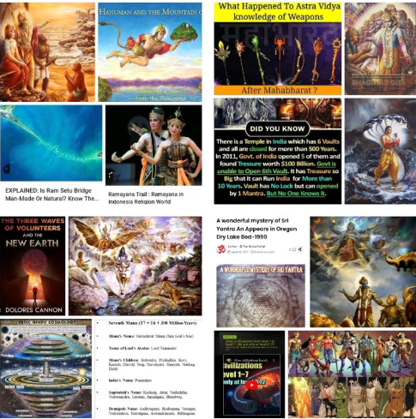
Links:
Nothing Can Check Us by Srila Prabhupada (SB 05.05.01) at Hyderabad, April 10, 1975
https://www.youtube.com/watch?v=9qWfa8ty3hw
Yahweh, Jeshua and the Extraterrestrial Connection: Interview with Corina Pataki
https://www.youtube.com/watch?v=ozeTbQX-NgA
"Gregg Braden - 'We Already Have What Transhumanism Seeks to Create' - Unveiling Human Potential
https://www.youtube.com/watch?v=008kRJY7WCU
PAY CLOSE ATTENTION if You're Seeing THESE Numbers! NOT A COINCIDENCE.
https://www.youtube.com/watch?v=ibFzWB7y2ec
Life in Andromeda II Andromeda and Beyond II The Exciting Search for Extraterrestrial Life By Bapuji
https://www.youtube.com/watch?v=Axl7uCxg-uA

The Summary

Now to put everything we studied together into a grand summary. We discussed Space and Time and various planetary systems and realms. And how each functions on a relative plane of space and Time.
" Lowest of all is located Devī-dhāma [mundane world], next above it is Maheśa-dhāma [abode of Maheśa]; above Maheśa-dhāma is placed Hari-dhāma [abode of Hari] and above them all is located Kṛṣṇa's own realm named Goloka. I adore the primeval Lord Govinda, who has allotted their respective authorities to the rulers of those graded realms." Braha Samhita.
We are part of the mundane world and we need to look to ascend higher. As Discussed yesterday Humans are not very high up in the evolution cycle as we may think. There are 8.4 million species of life in the UNIverse.
“There are 900,000 species living in the water. There are also 2,000,000 nonmoving living entities (sthavara), such as trees and plants. There are also 1,100,000 species of insects and reptiles, and there are 1,000,000 species of birds. As far as quadrupeds are concerned, there are 3,000,000 varieties, and there are 400,000 human species.” - Vishnu Puran
But Human birth on Bharat Varsha (Earth) is rare because it is land of Karma. We can choose our next life form by our attachments and efforts. Thus, the higher beings of all varieties take advantage of their superior knowledge of relative Space and Time and Technology to be born in Kali-yuga because this is the best time.
"My dear King, although Kali-yuga is an ocean of faults, there is still one good quality about this age: Simply by chanting the Hare Kṛṣṇa mahā-mantra, one can become free from material bondage and be promoted to the transcendental kingdom."- Srimad Bhagavatam 12.3.51
Because these Starseeds are not caught up in cycle of karma and their vibrations are higher they help build bridges in Devotional service. They build bad karma to accelerate in their spiritual growth and their mission. Thus, the lightworkers are the first to go through the hard times and gain realisations/wake up and then help others to ascend in consciousness, to Re- member the #soulfamily. To help others see their higher forms so that the seers can also become believers and in their diversity ascend in UNITY consciousness with wider UNIverse. We are superior in our own way. We have not realised our spiritual potency yet.
"We are now living in the heavenly planets, undoubtedly as a result of our having performed ritualistic ceremonies, pious activities and yajnas and having studied the Vedas. However, our lives here will one day be finished. We pray that at that time, if any merit remains from our pious activities, we may again take birth in Bhārata-varṣa as human beings able to remember the lotus feet of the Lord. The Lord is so kind that He personally comes to the land of Bhārata-varṣa and expands the good fortune of its people." - Srimad Bhagavatam 5.19.28
This birth is an opportunity to perform Devotional service and go back Home to Godhead.
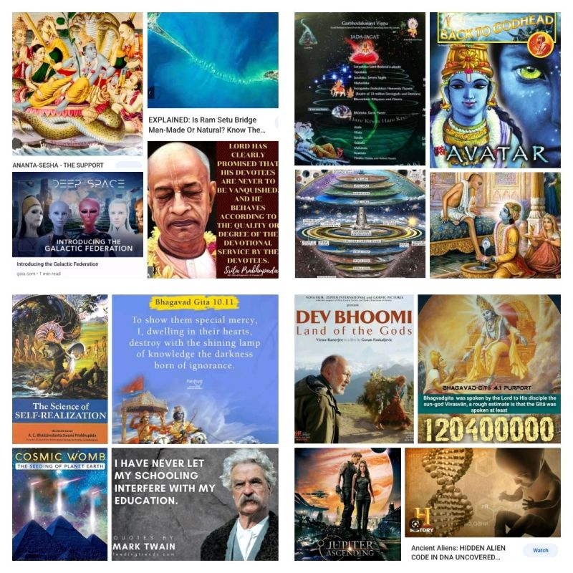
Links:
Rising Beyond The Modes by Srila Prabhupada (SB 01.02.24) November 4, 1972, Vrndavana
https://www.youtube.com/watch?v=UD5noYvuVFc
Deep within the Moon - A Momentous Gathering of the Galactic Federation of Light
https://www.youtube.com/watch?v=lRpEEgoeHCk

Call to Action

Knowledge is useless unless applied. So everyone needs to make decisions and take actions.
"One who is unattached to the fruits of his work and who works as he is obligated is in the renounced order of life, and he is the true mystic: not he who lights no fire and performs no work."- Krishna (Bhagavad Gita 6.1)
The God conscious intellectuals naturally seek to be of service to others. Because the Brahmans have understood all-pervading form of Krishna- that he is in everyone. This knowledge of Brahm makes them Brahman. This is enLIGHTenment.
Brahman is conscious of the spiritual nature of life and tries not to harm anyone. Naturally compassionate they are in the mode of Goodness. This compassionate loving nature is the LOVE that arises due to the higher VIBRATIONS in God/Krishna consciousness.
When advanced knowledge is not in humility of God consciousness, they develop EGO. This ego of separation results on service to self and is in mode of passion. This passion to rule or Lord it over is the Raj Guna -Mode of Passion. They will look to gain Power and Wealth at any cost. This mode of Passion therefore slowly moves into mode of ignorance. It drags one to lower vibrations.
As discussed, many times, knowledge and Power even if it is Spiritual can result in the falling of consciousness. The Great Demons like Hiranyakashipu and Ravana were extremely intelligent and great scholars. They too had undertaken acts of Penance, sacrifice. But they were greedy to acquire power at any cost. But both were defeated because even the Demons and the Demigods have to be humbled every now and then. That is how cycles of time work.
What is the value of humans and their scientific research that is absent of the spiritual essence that exists on everything? A robot is not an seeking Free will using algorithms. It is the other way round. Free will is for the Soul that is the first spiritual element existing before material creation.
To possess knowledge and use it for good is wisdom. It also takes wisdom to understand wisdom. It requires humility and raised consciousness. A right thing at the wrong time is equally harmful as a wrong thing at the right time. We have been sleeping for most part and it's time to awaken #soulfamily.
We are searching for Aliens in the sky when we are struggling to accept the Aliens that seem poorer cousins. What if we are poorer cousins to others? Time moves in cycles. Those who look like us are already amongst us but dare not say because we are biased. Maybe those who look different have already been seen too. We accept the creativity of silver screens to provide artificial creations but what if the different looking beings of history or future were never artificial? What would be our second reaction if it was not love on first sight? Would we term their differences as a threat?
What emotion/action does your wisdom inspire? Can we live in Unity with Diversity? Under One creator known by many names.
Achintya Bheda Abheda Tattva!!

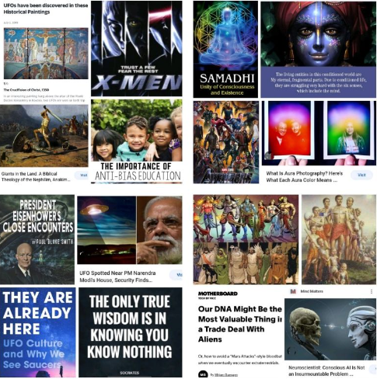
Links:
Rascal! Surrender! by Srila Prabhupada (SB 01.08.35) at Mayapura, October 15, 1974
https://www.youtube.com/watch?v=1-c339Z0Juk
NOTHING FANCY, JUST GLASSES OF THE ASTRAL WORLD
https://www.youtube.com/watch?v=DNBafSx9bWw

One World

Synchronicities!! Given my previous post.
Many wonderful questions and answers about many topics we have covered #soulfamily.
That said there seemed to be a push towards getting a Material/Technological explanation based on the history of research and a tangible validation for what people are witnessing and perhaps something that more would like to witness. There is clearly Time and Space for every event!
The individual consciousness itself seems to be a qualifying factor for the Self-Realisations that we have discussed so many times. Many people just don't want to know. Many don't feel it's relevant. Many don't want to agree with a thought or facts in the answers being too different to what they have been taught or learnt. What to do about them?
This is why it is important to keep an open mind and an open heart and feel what is right and true rather than follow the propaganda. To feel not the differences of race, religion or country but rather than the similarity of what runs through us all. The spiritual essence that makes us all the same on the inside. Then we shall be able to look farther and clearer into the history and see that the Bharat Varsha is the planet, and the Mahabharata is the History of the planet.
Vasudhaiva Kutumbakam
"The World Is One Family" - Upaniṣads
Vasudev is also the source of this family. everyone and every light being has to come from somewhere. The spiritual source of everything is one Vasudeva Krishna.
"I am the source of all spiritual and material worlds. Everything emanates from Me. The wise who perfectly know this engage in My devotional service and worship Me with all their hearts."- Krishna (Bhagavad Gita 10.8)
And his words in the Bhagvad Gita are the words of God.
ekaṁ śāstraṁ devakī-putra-gītam
eko devo devakī-putra eva
eko mantras tasya nāmāni yāni
karmāpy ekaṁ tasya devasya sevā
There need be only one holy scripture - the divine Gita sung by Lord Sri Krishna, only one worshipable Lord - Lord Sri Krishna, only one mantra - His holy names, and only one duty - devotional service unto that Supreme worshipable Lord. - Gita Mahatmayam
God is Supreme Personality of Godhead. He is the source of impersonalism for those who wish to see God in that form. But for the Personalists who wish to interact with him personally.
"And I am the basis of the impersonal Brahman, which is the constitutional position of ultimate happiness, and which is immortal, imperishable and eternal."- Krishna (Bhagavad Gita 14.27)
But many do want to know, they do not want to seem inferior to the transcendentalists. They want to be Gods using material technology; the is quality of Asuras.
"Arrogance, pride, anger, conceit, harshness and ignorance-these qualities belong to those of demonic nature, O son of Prtha.
The transcendental qualities are conducive to liberation, whereas the demonic qualities make for bondage. Do not worry, O son of Pandu, for you are born with the divine qualities."- Krishna (Bhagavad Gita 16.4-5)
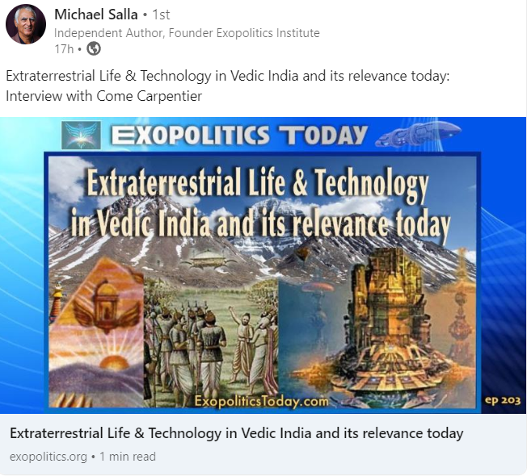
Links:
Extraterrestrial Life & Technology in Vedic India and its relevance today
https://www.youtube.com/watch?v=dvdh7cTOA_c

